New α-glucosidase inhibitory depsidones from the lichen Parmotrema cristiferum (Taylor) Hale

Thuc-Huy Duong, PhD, Department of Chemistry, Ho Chi Minh City University of Education, Ho Chi Minh City, Vietnam
Jirapast Sichaem, PhD, Research Unit in Natural Products Chemistry and Bioactivities, Faculty of Science and Technology, Thammasat University Lampang Campus, Lampang, Thailand

Abstract

Lichens are a complex life form that is a symbiotic partnership of two separate organisms, a fungus and an alga, of which some are unique to lichen symbiosis. Some lichen metabolites have been demonstrated to have antifungal, antibiotic, antioxidant, and insecticidal activities, and certain lichen extracts have been utilized in folk medicines. A previous report on the secondary metabolites of the lichen Parmotrema cristiferum (Taylor) Hale (Parmeliaceae) indicated that it contained cristiferides A-B, 2,4-dihydroxyphthalide, lecanoric acid, orsellinic acid, 5-chloroorsellinic acid, methyl haematommate, and methyl β-orsellinate. In this investigation, a bioactivity-guided investigation of the lichen Parmotrema cristiferum (Taylor) Hale (Parmeliaceae) led to the isolation of two new depsidones, cristifones A and B (1 and 2). The structures of the isolated compounds were identified by spectroscopic methods and comparison with the literature data. Compound 1 showed the initial combined structures of depsidone and depside cores. The two isolated compounds were then evaluated for their α-glucosidase inhibition. Compounds 1 and 2 were confirmed as potent, with IC₅₀ values of 21.5 and 18.4 μM, respectively. Compound 2 was a non-competitive inhibitor against α-glucosidase, as indicated by the intersect in the second quadrant of each respective plot. This study further clarified the chemical components of the lichen P. cristiferum and their α-glucosidase inhibition, which can be useful for the development and utilization of this lichen in the intervention of diabetes.

Image

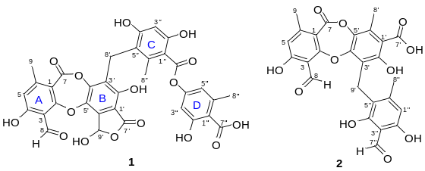

Recent Publications
1. Do TH, Duong TH, Nguyen HT, Nguyen TH, Sichaem J, Nguyen CH, Nguyen HH, Long NP (2022) Biological activities of lichen-derived monoaromatic compounds. Molecules, 27(9), 2871.
2. Duong TH, Tran TMD, Pham NKT, Mai TD, Nguyen HH, Nguyen NH, Sichaem J (2022) Secondary metabolites of the lichen Parmotrema cristiferum. Chemistry of Natural Compounds, 58(5), 862-865.
3. Duong TH, Le Pogam P, Tran TN, Mac DH, Dinh MH, Sichaem J (2020) α-Glucosidase inhibitory depsidones from the lichen Parmotrema tsavoense. Planta Medica, 86(11), 776-781.
4. Duong TH, Nguyen VK, Sichaem J, Tran TN, Do TH, Pham NKT, Nguyen TAT, Mai DT, Nguyen NH, Huynh BLC (2022) Reticulatin, a novel C₄₃-spiroterpenoid from the lichen Parmotrema reticulatum growing in Vietnam. Natural Product Research, 36(14), 3705-3712.
5. Phan HVT, Devi AP, Le HD, Nguyen TT, Nguyen HH, Le TTD, Nguyen TH, Sichaem J, Duong TH (2021) Dilatatone, a new chlorinated compound from Parmotrema dilatatum. Natural Product Research, 35(21), 3608-3612.


Paste your Logo here

Biography

Jirapast Sichaem has completed his PhD at the age of 28 years from Department of Chemistry, Faculty of Science, Chulalongkorn University, Thailand. He is a lecturer at the Faculty of Science and Technology, Thammasat University Lampang Campus, Lampang, Thailand. He has expertise in the field of cytotoxic, antioxidant, and antidiabetic constituents from Thai medicinal plants. He has published more than 90 papers in scientific journals.
Email: Jirapast@tu.ac.th

Presenting author details
Full name: Jirapast Sichaem
Contact number: +(66)932978366
Session name/ number: 4: Natural Products Chemistry
Category: Poster presentation

