Continuous Chromatography Applied to the Purification of Sugars: a Proven Separation Technology with Multiple Industrial Applications
Dr. Marie CHAUVE, Dr. Anne GONIN, Dominique PAILLAT - EURODIA Industrie SAS

[Article translated from French; published in IAA Magazine– July, 2021]

Summary

Low-pressure chromatography is a widely implemented purification technique in the sugar industry. It allows for the separation of complex mixtures with different affinities based on a stationary phase composed of ion exchange resins, and a mobile phase which is generally water. Industrially, it is implemented in columns with volumes that can reach several hundred cubic meters. The real-life performance for the purification of 2G sugars and organic acids and the advantage of coupling chromatography and nanofiltration for the production of high purity fructose will be explained further in this article.

Introduction:
Continuous low-pressure chromatography is widely used for numerous agri-food industrial applications, especially in the production of sugars. For more than 30 years, EURODIA INDUSTRIES SAS (“EURODIA”) has been innovating, developing, and installing industrial chromatography units for the purification or the enrichment of specialty sugars, sugar-alcohols, second generation sugars, organic acids, etc.
This technology offers many benefits, notably its significantly decreased environmental footprint.
The main objective of this article is to summarize the basic principles and key design criteria for successful chromatography systems. These will be illustrated with some performance data for notable applications. In addition, chromatography enables high-quality processes by combining other separation steps, such as nanofiltration.

Basic Principles :

History / Process Principles (2 and 3 fractions)

Fixed-bed chromatography allows for the separation of soluble compounds having distinct affinities with a stationary phase, generally resins. To enhance the separation capability, counter-current chromatography was introduced, in which the mobile phase circulates in a counter-current mode versus the stationary phase.

Simulated Moving Bed (SMB) technology was developed in the 1960’s by Broughton to convert counter- current chromatography into a continuous process without having to physically move the stationary phase. By periodically shifting the injections points for “feed” and “eluent” and the extraction points for “extract” and “raffinate” and by implementing a minimum of eight chambers, it is possible to simulate the equivalent of a counter-current without having to displace the stationary phase. By increasing the number of chambers, it is possible to improve the separation performance.

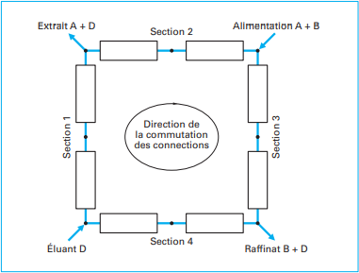

Switching direction for the connections
Raffinate B + D
Eluent D
Feed A + B
Extract A + D
Figure 1: Schematic for the SMB process principles [1]

The ISMB (Improved Simulated Moving Bed) technology was developed in the 1980’s by Nippon Rensui Co. (a subsidiary of Mitsubishi Chemical Aqua Solutions Co., Japan) and is commercialized by EURODIA under the trade names SSAC® (Sugar Specialty Advanced Chromatography) and PSAC® (Polyols Separation Advanced Chromatography): it achieves excellent performance while minimizing the installed number of chambers, leading to lower overall investment costs.

Practically, the feed /extraction phases are de-coupled from the recirculation phases and recirculation is used to move the separation profile from one chamber to the next in a way to continuously have the concentration profile positioned similarly in relation to the chamber inlets and outlets.

Feed

Step 1

Raffinate
Water

Step 2

Step 3

Step 4

Raffinate

Water

Extract

Cycles repeated 4 times by moving the inlet and the outlet to/from each chamber

Chamber 1 2 3 4
Figure 2: Schematic for the SSAC ® / PSAC ® processes
A comparative study for the SMB and SSAC® processes was completed for fructose / glucose separations (Figure 3). With SSAC®, a significantly higher recovery rate was achieved for the same number of chambers. In most SSAC® separation applications, only 4 chambers are required to achieve recovery rates higher than 95%, leading to lower overall investment and operating costs.

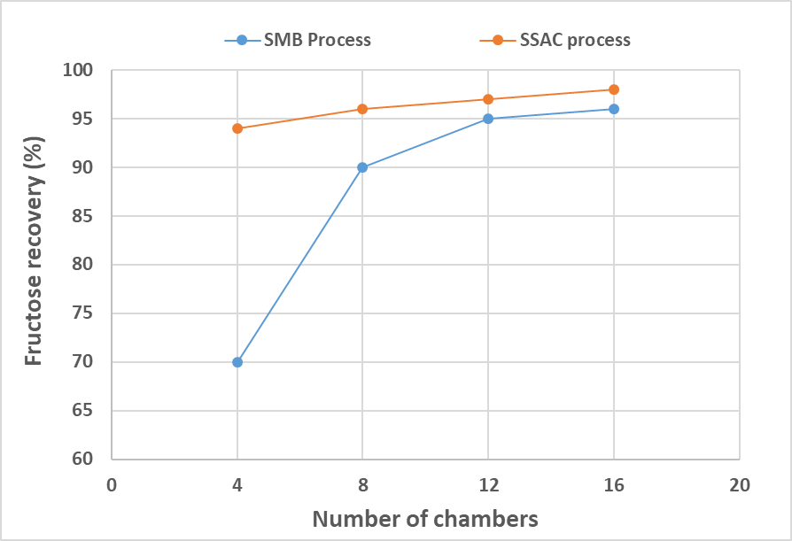
Figure 3: Fructose recovery function of the number of chambers – Comparison of SMB et SSAC® processes [2]

With the NMCI technology, that was also developed by Nippon Rensui Co., it is possible to recover three fractions instead of two with the conventional SMB technology. This system is a non-continuous elution technique in which the separation is performed on the total length of the column (or all the chambers together). The feed is injected at a fixed point at the column inlet and the “extract” and “raffinate” fractions are recovered at the other end of the column. This means that the column length and the feed volume must be adjusted and tuned to the affinity differential between the resin and the compounds that need to be separated.

Step 1 Feed

A B

C
A B C
Fraction B

Step 2 Rec.
(Mixed)
Recirculated

A

C

B

A

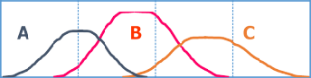Step 3 Eau Fraction A

Step 4 Eau

Step 5 Rec.

Fraction C

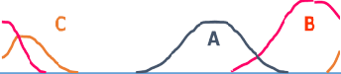(Mixed)

Recirculated

Chamber 1 2 3 4

Resin Selection
Figure 4: Schematic for the NMCI process

The resin selection is critical for the development of chromatographic separations while the relevant separation mechanisms will depend on the resin choice. Typically, the resins used for the separation of sugars are made of a styrene matrix copolymerized with divinyl-benzene (DVB). These are usually cation- exchange resins in the salt form but for some applications, anion-exchange resins can be used.

In general, a spherical form and a uniform distribution of the bead size contribute to improve the separation performance. If the average size of the resin beads vary between 200 and 500 µm, the current trend is to look for the smallest separation beads that are possible for a better separation resolution (maximization of the number of theoretical plates, quest for high-purity products) within the limits of the hydraulic operating conditions (pressure drop issues).

Typically, the separation of sugars or polyols with a similar molecular size is accomplished by resins in the calcium form, while the separation of sugars from non-sugars or the separation of sugars with different molecular weights is accomplished with resins in the sodium or potassium form. The following table summarizes the main industrial applications for the two resin forms.

Separation media | Separation type
Strong cation-exchange resins - Calcium form | Fructose / Glucose Sorbitol / Mannitol Mannose / Glucose  Glucose / Galactose
Strong cation-exchange resins - Monovalent form | Glucose/ Saccharides DP>2 Maltose / Saccharides DP>2  Saccharose/ Fructose and glucose Saccharose starting from molasses

Several mechanisms come into play during a separation with cation-exchange resins.

First, the high-molecular weight compounds cannot enter in the resin pores and are excluded because of their size. The resin has a molecular sifting role; this is a size-exclusion mechanism.

Second, the separation can be based on the formation of electrostatic bonds between the resin functional sites and the compounds to be separated. This is a ligand exchange mechanism. As an example, fructose forms a more stable complex with the calcium than the glucose. Fructose is, therefore, more retained by the resin and can be separated from the glucose.

Finally, the separation can be based on ion-exclusion. Charged compounds cannot enter in the resin pores because of electrostatic repulsions with the charged groups that are grafted on the resin and the counter- ions while non-ionized compounds, such as small sugars, can enter the pores and this makes the separation possible.

During a separation with cation-exchange resins in the sodium or potassium form, the stability of the complexes formed between the sugars is very weak and the separation is mainly due to size- or charge- exclusions.

Anion-exchange resins can sometimes be used for the separation of organic acids. In this case, the separation seems to be based on an acid-base interaction between the organic acids and the resin counter- ions.

Feed Requirements

Chromatography can process feed products with up to 70% DS (dry substance), at temperatures between 20 and 80°C. The feed material must be free of suspended solids. A compromise must be found between viscosity, temperature and pressure drop.

For the separation of sugars, it is required to work with a demineralized feed to avoid the replacement of the resin counter-ion by the dominant cation contained in the feed: this would negatively affect the separation performance.

For the separation of sugars from non-sugars, the concentration of monovalent cations must be much higher compared to divalent cations to avoid a conversion of the resin form.

Finally, the feed cannot contain oxidizing substances to guarantee the stability and lifetime of the resins. Feed and eluant are typically degassed as a pretreatment to minimize the resin oxidation.

Chromatography requires the use of an eluant, in most cases water, that must meet the same specifications as the feed. Generally, it is possible to use condensates from the concentration of the extract and raffinate fractions out of the columns.

Engineering Design Criteria

The columns internal design is very important to ensure a good separation in chromatographic processes. It is critical to have an excellent flow distribution in the columns so that the fluids are in uniform contact with the full resin volume and stable horizontal fronts are moving vertically in a piston flow. To ensure the best distribution at the inlet and collection at the outlet of the columns, special distributors and collectors were developed. These are mechanically robust, easy to maintain and clean, and designed to achieve a symmetrical distribution as well as avoid back-mixing or any abnormal flow channeling.

In addition, the resin volume must be correctly adapted to the column volumes to take into account the volume changes due to fluctuations in the osmotic pressure of the various liquid phases in equilibrium with the resin. A column containing too much resin would cause major pressure drop issues in the system, while a column not filled enough would cause mixing and the disturbance of the horizontal elution fronts.

Since the resin is not used for ion exchange, it does not require regeneration. However, during normal operating conditions, resin fines can be generated, leading to pressure drop issues and disturbing the fluid distribution. It will then be necessary to go through a defining (elutriation) procedure for each resin bed, after transfer to a tank that has been especially designed for this purpose. Depending on the application, this external cleaning procedure might be required one or twice a year.

Scale-up Tools / Sizing

The sizing of a chromatography column goes through a first step where simple elutions are carried out on columns containing at least 300 mL of resin. These tests make it possible to obtain an elution profile to validate the feasibility of the separation. In this development stage, it is possible to study the impact of the shape of the resin, the dry matter content, the temperature, etc. on the elution profile.
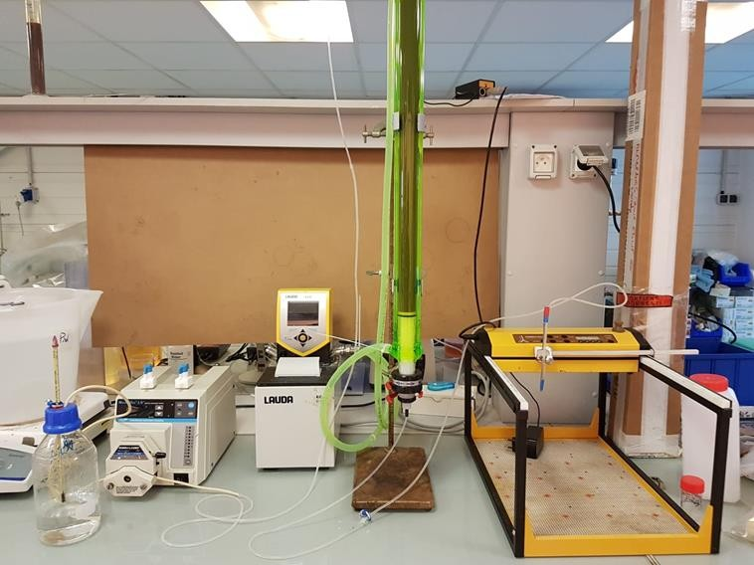

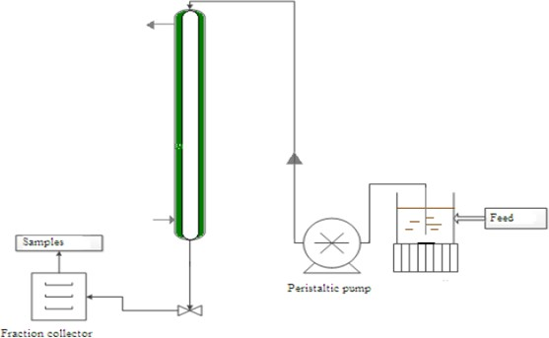Figure 5: Example of elution profile for the glucose / fructose separation
Fructose
Glucose
100
90
80
70
60
50
40
30
20
10
0
0,0
0,2
0,4
0,6
BV
0,8
1,0
1,2
Feed
Samples
Automatic
sampler
Peristaltic pump
Concentration g/L

From a simple elution profile, simulation tools provide accurate predictions of the material balance (recovery rate and achievable purity) and an order of magnitude estimate for the investment and operating costs of the system. They also make it possible to reduce the time required for the piloting stage.

A final piloting stage must be completed with an automated pilot unit to allow for industrial performance guarantees and to produce representative samples of the purified products. Continuous operation for 24 hours a day makes it possible to validate the separation. This piloting is often carried out in two stages, the first consisting in optimizing the separation parameters to obtain the desired performance and the second for a production run without changing the parameters to validate the separation stability. This piloting phase typically lasts between 3-6 weeks, depending on the difficulty of the separation and the number of production runs that are necessary.

Value of Coupling Nanofiltration with Chromatography

Due to the recent developments of improved nanofiltration membranes allowing to work at high temperature (up to 70°C) and with various cut-offs, it is possible to maximize the sugar recovery rate by treating the raffinate with nanofiltration. An example of coupling is shown Figure 6 In this configuration, a nanofiltration step makes it possible to remove highly polymerized sugars and recycling the permeate to the chromatography inlet allowing for an increase of the overall monosaccharide recovery rate.

Feed

Chromatography

Figure 6: Schematic for an example of coupling chromatography with nanofiltration

The nanofiltration performance can be adjusted with either the concentration factor (ratio between the flow rates of feed and retentate) or the diafiltration coefficient (water use).

Chromatography, an Environment-Friendly Process

Working with chromatographic separation, either by charge-exclusion or size-exclusion, leads to the implementation of a clean process. It does not involve regeneration or cleaning steps that consume chemicals and generate effluents. In addition, the required eluant is, most often, water that can be recovered during the products concentration and reused in the process.
It is also worth mentioning that when the feed requirements are met, the replacement rate of resins are very low.

Industrial applications
To illustrate industrial applications of chromatography, three separations involving the principles that have been discussed above are detailed below:
- The production of high-purity fructose and how coupling nanofiltration and chromatography can improve yields,
- Chromatography applied to the separation of sugars from non-sugars for the production of C6 or C5 sugars from the processing of biomass,
- The purification of organic acids produced by fermentation processes.

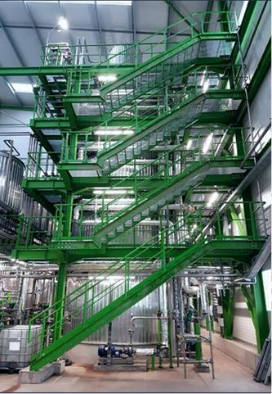

Fructose Enrichment / Benefit of Coupling with Nanofiltration
The use of industrial chromatography for the separation of the fructose and glucose isomers is widely developed worldwide, involving installed systems with very large resin volumes (> 100 m³). Depending on the unit operating parameters and starting from a glucose / fructose mixture obtained by isomerization (fructose ratio between 40 and 48%), the chromatography performance makes it possible to produce enriched fructose syrups containing from 55 to 98% fructose. The resulting raffinate from this separation is a low brix fraction that contains glucose and polysaccharides (DPs). To improve the fructose production yields, this fraction is advantageously recycled upstream to the isomerization to transform the residual glucose into recoverable fructose. However, this recycling leads to an accumulation of DPs in the system and, thus, to an increase of their concentration in the chromatography feed making the separation more difficult. To conserve the high purity of the fructose fraction, a fraction of the raffinate must be purged resulting in significant glucose losses.
The addition of a nanofiltration step to process the chromatography raffinate allows to selectively eliminate the DPs while obtaining a glucose-rich permeate that can be recycled upstream from the isomerization.
For the production of F95, a fructose purity of approximately 96% is required in the chromatography extract. If the chromatography feed is composed of 42% fructose, 52% glucose and 6% DPs, the yield of the chromatography is approximately 42%. The raffinate fraction contains 58% of the initial dry matter with the following distribution: 90.5% DP1 (fructose + glucose) and 9.5% DPs. Adding nanofiltration to treat this raffinate makes it possible to obtain a retentate with a DPs content of 20% minimum and; as a result, purge the same amount of DPs. This way, the loss in DP1 is at least divided by 2.

Chromatography Applied to the Separation of Sugars from Non-Sugars for the Production of C6 or C5 sugars From the Processing of Biomass
Chromatography with cation-exchange resins in the monovalent cation form is a process solution offering many advantages for the purification of sugars from the recovery of the biomass value [4]. This technology makes it possible to eliminate a major fraction of the salts and color without consuming chemicals and generating effluents. Thus, only the final purification requires the use of ion exchange resins. The following table summarizes the performance achieved by chromatography for two types of feed.

 | C5 Purification | C6 Purification
Sugar content in feed | 41% | 88 %
Salt content in feed | 43% | 3%
Sugar content in extract | 87% | 98 %
Sugar content in extract | 99% | 98%
Color elimination rate | 85% | 70%
Salt elimination rate | 95% | 97%
Water consumption (L water / kg DS) | 5.6 | 4.1
Yield (expressed in kg DS / L resin.day) | 0.9 | 1.2

Chromatography for the Purification of Organic Acids from Fermentation Processes
Chromatography with cation-exchange resins in the monovalent cation form can also be applied to the purification of organic acids when they are in their acid form. The process mechanisms allow the separation of the organic acids from the minerals and the residual sugars at the end of the fermentation.
For a feed containing approx. 80 g/L of lactic acid, 50 g/L of salts and 5 g/L of sugar, the chromatography performance is a lactic acid recovery greater than 98%, an elimination of salts greater than 98%, and an elimination of sugars ranging from 65 to 85%, depending on the type of residual sugars in solution. The water consumption is 10 liters of water / kg of processed dry solids. The productivity is 1.3 kg of processed dry solids per liter of resin per day.

Conclusion

Chromatographic separation is a valuable process step that has been widely used for more than 30 years for the purification/enrichment of sugars and derived products.
There is an increasing demand from many markets and industries to determine the overall performance (purity, recovery or energy consumption) of a variety of compounds and molecules. Through encouraging steps in innovation, development and research, EURODIA is leading the industry in providing more compact systems, incorporating smaller-bead separation media (stationary phase), and, in some cases, the combination with other filtration steps, such as nanofiltration allowing for high purities and recoveries of many molecules and compounds.

EURODIA is active as a world leader in chromatography and separation processes. With three implementation platforms in Europe, the USA, and Brazil, EURODIA offers to its partners, project developers, all the tools necessary for the industrialization of innovative and “à la carte” processes, from

simulations, laboratory and pilot tests to industrial scale-ups for turnkey projects with performance guarantees.

References :
- Engineering technique "Adsorption – Processes and application", Reference : J2731 V1
- M.-A. Theoleyre, "Application of ion exchangers and adsorbents in the chemical, food and pharmaceutical industries », (2014)
- Lemaire et al, “Purification of organic acids by chromatography with strong anionic resins: Investigation of uptake mechanisms”, Journal of Chromatography 2, 1458 (2016), 63-69
- Lutin et al, The different technological paths for the valorization of sugars from lignocellulosic biomass
», The journal of agri-food industries, (July-August 2019), 34-36

