BIO-BASED FOAMS' HYGROTHERMAL PROPERTIES IN ENERGY-SAVING BUILDINGS

Raymond kaburi,
Mississippi state university, USA

Abstract (300 word limit)

Bio-based foams for insulating materials generated from ground-up wood and paper pulp were developed using mold foaming. In this paper, the effect of wood fiber content, surface treatment, and particle size on foam density and mechanical properties was investigated. The size and quantity of the wood fiber were found to have a substantial impact on the density, compressive strength, and tensile strength of the bio-based foams. Improved foaming was made possible by lower wood fiber sizes, and among the examples examined, a foam with 29 weight percent of 0.25 mm and smaller wood powder produced the finest mechanical properties. At the ideal processing conditions, the bio-based foam had the following characteristics: a density of 0.907 g/cm-3, a compressive strength of 124.9 kPa, and a tensile strength of 1126.9 kPa. Initially, raising the wood fiber percentage improved the compressive strength, but doing so also increased the wood fiber fraction's tensile strength, which subsequently decreased. Overall, based on their density, physical properties, and mechanical attributes, the biodegradable foams produced here showed promise as effective insulation materials.
Image
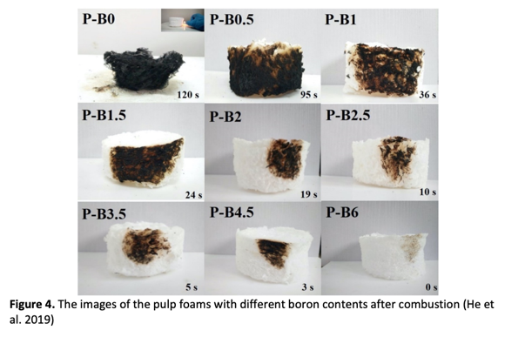
Recent Publications (minimum 5)
- Kaburi, R. (2022). Density and mechanical properties of bio-based foams (Master's thesis, Itä-Suomen yliopisto)..
- Raymond Achengkwoa Kaburi, Kojo Donkor Taale, Victor Antwi; USING HANDS-ON ACTIVITIES TO IMPROVE THE CONCEPTUAL UNDERSTANDING OF SENIOR HIGH SCHOOL STUDENTS IN ELECTRICAL CIRCUITS; Nor. Am. Aca. Res. 2019 : 2(12) : 249-371; https://doi.org/10.5281/zenodo.3593562
- Raymond Achengkwoa Kaburi, Feifei Tao, Agboifo Edmond Omenonye, Ruby Hanson, Lan Yan; Effectiveness of Integrating Hands-On Activities In The Learning of Chemical Bonding in High-School Setting; Nor. Am. Aca. Res. 2019 : 2(12) : 92-106; https://doi.org/10.5281/zenodo.3588654
4.Lv, B., Xu, J., Kang, H., Liang, P., Wang, W., & Tao, F. (2022). Adsorption behavior of magnetic carbon-supported metal nickel for the efficient dye removal from water. International Journal of Environmental Research and Public Health, 19(3), 1682.

 Biography (150 word limit)
Paste your Logo here
Raymond kaburi has his expertise in science education and passion in wood materials science research. I look forward finding new prospective uses for wood materials and promoting bioeconomy-related R&D activities as a researcher and consultant in the Finland based Wood Materials Science group. He has worked and participated in several institutions in China, Europe and Africa.
Email: kaburi.raymond@gmail.com.

Notes/Comments:

Presenting author details
Full name: Raymond Kaburi
Contact number: +358417445104
Mail id: rak262@msstate.edu
Category: (Oral presentation/ Poster presentation)

