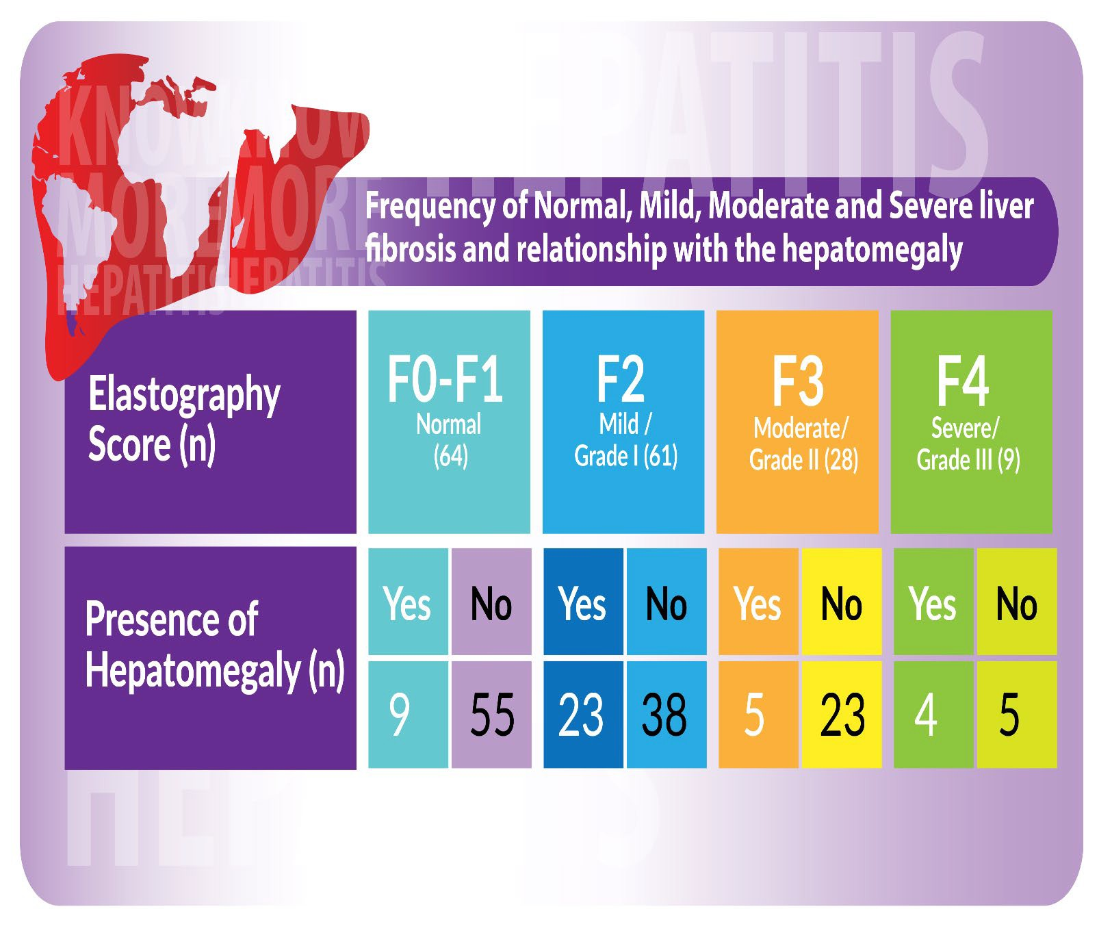
Assessment of Liver Fibrosis with Transient Elastography in NAFLD Patients
Dr. Lajpat Rai, Jinnah Postgraduate Medical Center, Karachi, Pakistan
Dr. Nazish Butt, Jinnah Postgraduate Medical Center, Karachi, Pakistan
Dr. Ali Akbar, Jinnah Postgraduate Medical Center, Karachi, Pakistan
Dr. Hanisha Khemani, Jinnah Postgraduate Medical Center, Karachi, Pakistan

Abstract

Background and Aims: Transient Elastography (TE) is a non‐invasive technique for estimating liver fibrosis. There is limited data about the performance of TE in Pakistani patients with non‐alcoholic fatty liver disease (NAFLD). NAFLD is a global outbreak, it is pivotal that patients with NAFLD should undergo an assessment for their risk of advanced fibrosis, which enhances the risk of hepatocellular carcinoma (HCC) and other complications of cirrhosis. The overall prevalence of NAFLD in Pakistan is 47%. In the present study, we have evaluated the diagnostic accuracy of TE in identifying different degrees of fibrosis in NAFLD adult patients

Method: A Cross-sectional study was undertaken at the Department of Gastroenterology, Jinnah Postgraduate Medical Centre and Medical Unit II, Dow University of Health Sciences Ojha campus Karachi, Pakistan. After obtaining ethical approval, all patients above the age of 18 years, with a diagnosis of NAFLD on the basis of abnormal liver function tests (LFTs) and an ultrasound abdomen consistent with fatty liver were included in the study. All patients with hepatitis, hepatic malignancies, hepatobiliary infections, and biliary tract disease were excluded from the study. Fibrosis score was calculated through Elastography as F0-F1 (5.3-7.1 kPa, Normal); F2 (7.5-8.5 kPa, Mild/Grade-I); F3 (9.5-13.0 kPa, Moderate/Grade-II); and F4 (13.1-18.8 kPa, Severe/Grade-III).

Results: A total of 171 patients were enrolled in the study, from which 69 (40.35%) were male and 102 (59.64%) were female, with a mean age of 37.50 ± 9.74 years. Out of these, 112 (65.49%) belonged to the lower socioeconomic class. One hundred and twenty-two (71.34%) patients had fatty liver on ultrasound and 49 (28.65%) had hepatomegaly with fatty changes. TE revealed 69 (40.35%) patients had a score of F0-F1, 62 (36.25%) F2, 29 (16.95%) F3, and only 11 (6.43%) had a score of F4.

Conclusion: The detection of liver fibrosis at its early stages is crucial in preventing its progression to cirrhosis which is an irreversible process. Reversal of fibrosis is only possible if it is diagnosed as early as possible and managed with appropriate treatment.

Image

Recent Publications
- Butt N, Ali Khan M, Rai L, et al. (June 29, 2021) Perception of Non-Alcoholic Fatty Liver Disease: Real-Life Experience From Pakistan. Cureus 13(6): e16029. doi:10.7759/cureus.
- Rai L, Salam O, Yaqoob U and Zubair U. Case Report: Myocarditis along with fulminant hepatic failure secondary to acute hepatitis E infection. F1000Research 2019
- Factor V Deficiency in an Adolescent: A Case Report Article in International Medical Journal (1994) ·
- Multiple Patent Ductus Arteriosus in an Adult: A Case Report Int J Med Invest 2021, 10(2): 194-198

 Biography

Dr Lajpat Rai has a special interest in advanced endoscopy, transplant hepatology, and emerging treatment of NAFLD. He belongs to a backward area of Balochistan, Pakistan, where has organized multiple free medical OPD camps for liver transplant evaluation and provided Hepatitis B vaccinations to poor needy patients. His main aim is to eradicate viral hepatitis from Pakistan.
Email: lajpat.seetlani@gmail.com

Presenting author details
Full name: DR. LAJPAT RAI
Contact number: 00923003177876
Twitter account: https://twitter.com/lajpat101?s=11&t=KnxvD-eX625C5GwL1dMZ4g
Linked In account: https://www.linkedin.com/in/seetlani101
Session name/ number:
Category: (Oral presentation/ Poster presentation)

