Residents’ preferences for remote health consultation of primary health centers in China: a discrete choice experiment
Hang Xu, MD, Institute of Medical Information, CAMS & PUMC, China Yumeng Cheng, MD, Institute of Medical Information, CAMS & PUMC, China Xiaojing Ma, PhD, Institute of Medical Information, CAMS & PUMC, China

Abstract (300 word limit)
Introduction: Remote health consultation (e-consultation) plays an important role in whole person health, but it is underutilized by Chinese residents. Understanding residents’ preferences for e-consultation at primary health centers (PHCs) is important for policymakers. Methods: A discrete choice experiment (DCE) was conducted in the Beijing municipality of China. According to a literature review and expert consultations, six attributes of PHCs’ e-consultation were determined: frequency, mode, providers, service hours, duration of each service, and out-of-pocket expenses. A mixed logit model was used to analyze the residents’ preferences for each attribute and their levels. Willingness to pay (WTP) and subgroup analysis were also estimated based on the model. The marginal effect method was used for the scenario analysis. Results: The regression results showed that the six attributes had a significant impact on the choice preference of residents (P < 0.05). Residents preferred fixed service providers and these residents had the highest WTP: they were willing to pay CNY 198.77 more per year for fixed providers than for nonfixed providers. Subgroup analysis showed that residents aged 51 years and older, with chronic diseases, and with a high school education or below paid more attention to fixed service providers. Residents without chronic diseases had a much lower demand for services than those with chronic diseases. In the simulation scenario, the optimal combination of attributes and levels was out-of-pocket expenses of CNY 100 per year, service twice per quarter, telephone and online consultation, fixed service providers, normal working hours and after hours, and the duration of each service ≤10 minutes. Conclusions: All attributes had a substantial impact on residents’ preference for PHCs’ e-consultation. There were some differences in the preferences for PHCs’ e-consultation among residents with different demographic characteristics, providing important evidence for the optimization and design of e-consultation service packages.

Image
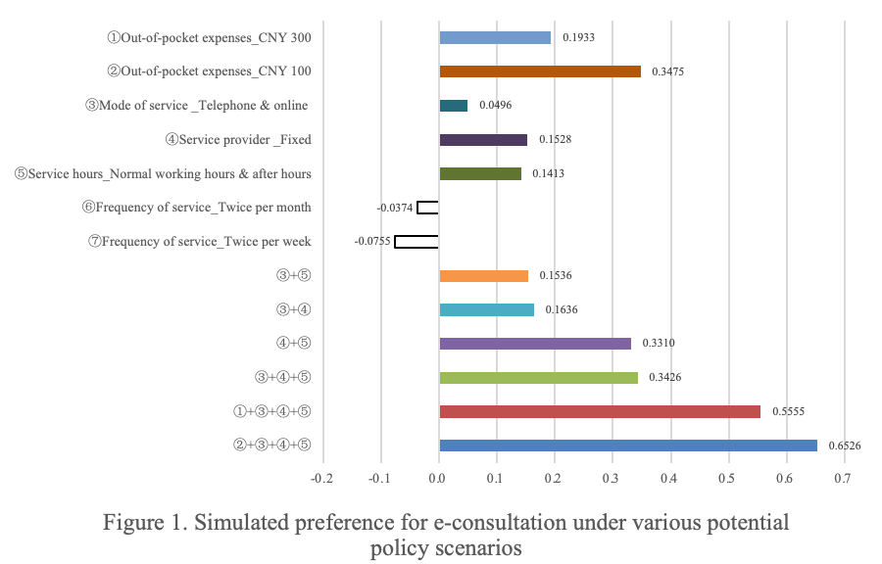
Recent Publications (minimum 5)
- Hang X, Xiaojing M (2022) Study on cognition, preference and utilization of community health management service in Beijing based on the theory of knowledge, belief and practice. Chinese Primary Health Care 36:34-38.
- Yaqian G, JU H, Nana X, Xiaojing M (2022) Worker characteristics and measures associated with patient and visitor violence in the COVID-19 pandemic: a multilevel regression analysis from China. Frontiers in Public Health 10:877843.
- Hang X, Xiaojing M, Tao D (2022) Diffusion of China’s community health management policies: an analysis using diffusion of innovation theory. Chinese General Practice 25:1995-2002.
- Jing W, Hang X, Xiaojing M, et al. (2021) Study on doctors’ work preference under the personnel establishment reform in public hospitals: empirical analysis based on discrete choice experiment. Health Economics Research 38: 63-68.
5. Hang X, Yuheng W, Xiaojing M (2020) Research on the current situation and countermeasures of “Internet+” medical service price management in China. Chinese Health Economics 39:48-51.

Biography (150 word limit)

Hang Xu has expertise in health economics and health policy. Since joining Chinese Academy of Medical Sciences & Peking Union Medical College, he has been engaged in research on health economics and health policy for a long time, mainly focusing on the fields of medical and health services and primary care. In recent years, the team mainly used discrete choice experiments to conduct preference research in the health field, including measuring the work preferences of doctors in public hospitals and the preferences of community residents for health consultation services. These studies are somewhat prospective and innovative in China.
Email: xu.hang@imicams.ac.cn

Notes/Comments:

Presenting author details
Full name: Hang Xu
Contact number: +86-19801281283
Twitter account: None
Linked In account: None
Session name/ number: None
Category: (Oral presentation)

