Water stable, red emitting, carbon nanoparticles stimulate 3D cell invasion via clathrin-mediated endocytic uptake
Udisha Singh^{1#}, Aditya Guduru Teja^{2#}, Shanka Walia^{1#}, Payal Vaswani¹, Sameer Dalvi^{2,3} and Dhiraj Bhatia^{1,3*}
¹Biological Engineering Discipline, Indian Institute of Technology Gandhinagar, Palaj, Gujarat 382355, India
² Chemical Engineering Discipline, Indian Institute of Technology Gandhinagar, Palaj, Gujarat 382355, India
³ Center for Biomedical Engineering, Indian Institute of Technology Gandhinagar, Palaj, Gujarat 382355, India

Abstract
Bright, fluorescent nanoparticles with excitation and emission towards the red end of the spectrum are highly desirable in the field of bioimaging. We present here a new class of organic carbon-based nanoparticles (CNPs) with robust quantum yield and fluorescence towards the red region of the spectrum. Using organic substrates like para-phenylenediamine (PPDA) dispersed in diphenyl ether and reflux conditions, we achieved scalable amounts of CNPs of the average size of 27 nm. These CNPs were readily up taken by different mammalian cells, and we show that they prefer clathrin-mediated endocytosis for their cellular entry route. Not only can these CNPs be specifically uptaken in cells, but they also stimulate cellular processes like cell invasion from 3D spheroid models. We also performed in-vivo studies in zebrafish larvae at different concentration and time point. These new classes of CNPs, which have sizes similar to proteinaceous ligands, hold immense potential for their surface functionalization. They could be explored as promising bioimaging agents for biomedical imaging and intracellular drug delivery.

Image
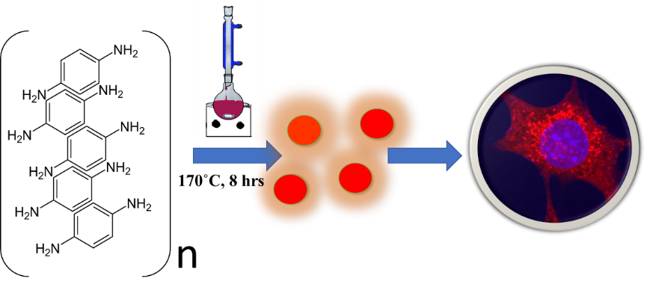
Scheme: Schematic representation of CNPs synthesis using para-phenylenediamine dissolved in diphenyl ether, refluxed at 170ᣞC for 8 h leading to one-step formation of red emitting nanoparticles that could be uptaken by cells for bioimaging applications.

Recent Publications

- Singh, U., Morya, V., Rajwar, A., Chandrasekaran, A. R., Datta, B., Ghoroi, C., & Bhatia, D. (2020). DNA-functionalized nanoparticles for targeted biosensing and biological applications. ACS omega, 5(48), 30767-30774.
- Singh, U., Shah, K., Kansara, K., Kumar, A., & Bhatia, D. D. (2022). Novel class of yellow emitting carbon dots stimulate collective cell migration and 3D uptake in vivo. bioRxiv, 2022-07.
- Hivare, P., Singh, U., Mujmer, K., Gupta, S., & Bhatia, D. (2023). Red emitting fluorescent carbon nanoparticles to track spatio-temporal dynamics of endocytic pathways in model neuroblastoma neurons. Nanoscale, 15(3), 1154-1171.
- Barve, K., Bhatia, D. D., Singh, U., & Yadav, P. (2023). Carbon-based, designer, and programmable fluorescent quantum dots for targeted biological and biomedical applications. Materials Chemistry Frontiers.
- Sri, S., Singh, U., Kumar, R., Lakshmi, G. B. V. S., & Solanki, P. R. (2021). Ignition of photoluminescent intensity of quenched MoS2 quantum dots tetracycline mixture by levofloxacin via photoinduced electron transfer. JCIS Open, 3, 100021.




Udisha Singh is a Ph.D. scholar at Indian Institute of Technology, Gandhinagar, Gujarat. She is currently working in the supervision of Dr. Dhiraj Bhatia as her P.I.
Udisha Singh’s main research fields are synthesis of nanoparticles, especially carbon dots, and their biomedical application. Her PhD research work is more focused on the optical properties of nanoparticles and their use in bioimaging applications as well as study their intake studies by the mammalian cells to get a better idea of applications of these nanoparticles in biological systems.

Email ID: udisha.s@iitgn.ac.in

Presenting author details
Full name: Udisha Singh
Contact number: 9793209848
Twitter account:
Linked In account:
Session name/ number: track 5
Category: Oral presentation

