The association between perceived social support and subclinical trauma and its potential effect on postpartum depression symptoms
Juliana Castro, BA, Mount Sinai, NYC
Dr. Adriana Bruges-Boude, MD, Mount Sinai, NYC

Abstract
Background Pregnancy is a time of physiological and psychological changes. Research has suggested that social support can protect against negative mental health outcomes and help maintain overall well-being during pregnancy and the postpartum period, even following stressful life events. Despite advances in trauma research, most studies to date do not include pregnant persons, and often exclude those who do not meet full post-traumatic stress disorder criteria. We aim to address gaps in the literature by exploring dimensional associations between traumatic life events, perceived social support during pregnancy, and postpartum depression symptoms.
Methods Participants with diverse backgrounds were enrolled in the Generation C-SF cohort (current n=330, target N=500), a New York City-based prospective pregnancy cohort. At 3 months postpartum, participants completed the Trauma History Questionnaire (THQ), the Social Adjustment Scale Self-Report (SAS-SR), and Edinburgh Postnatal Depression Scale (EPDS, M=6.20, SD=4.83). Higher SAS-SR scores indicate greater social functioning impairments. Higher THQ and EPDS scores indicate more trauma and depressive symptoms, respectively. We examined correlations between the THQ, SAS-SR, and EPDS.
Results Total mean THQ scores were positively correlated with overall mean scores from the SAS-SR. The THQ subscales of unwanted physical and sexual experiences were positively correlated with extended family, family unit, and housework subscales from the SAS-SR. EPDS scores were positively correlated with total mean THQ scores and the unwanted physical and sexual experiences subscale (see Table 2 for results).
Conclusion These preliminary findings suggest an association between traumatic life events and perceived impairments in social functioning during pregnancy. Higher scores in unwanted physical or sexual assault were significantly correlated to relationship dissatisfaction with family unit, extended family, and neighbors. These results highlight the relationship between social support and trauma and may inform future research on how an increase in social support may assist with coping after a traumatic event.

Biography

Juliana graduated from Wesleyan University in 2019 with a degree in Psychology. She has been working at Mount Sinai for 2 years coordinating several research studies exploring COVID-19 and women’s mental health during the pandemic, early childhood development, and maternal caregiving behaviors. She has a strong interest and experience working in women’s mental health research and eventually hopes to pursue a degree in Clinical Psychology with a focus on trauma stress disorders.
Email: Juliana.camachocastro@mountsinai.org
Images
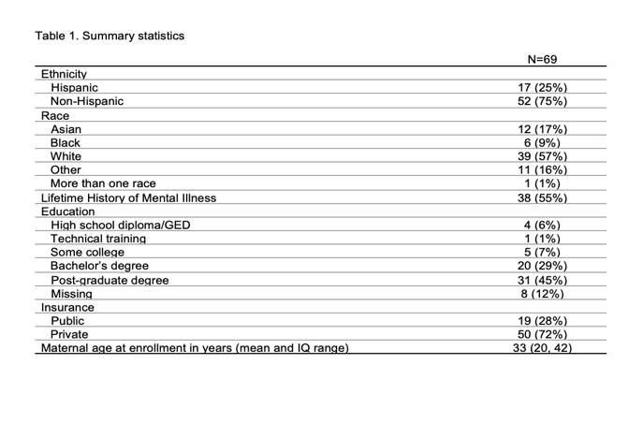
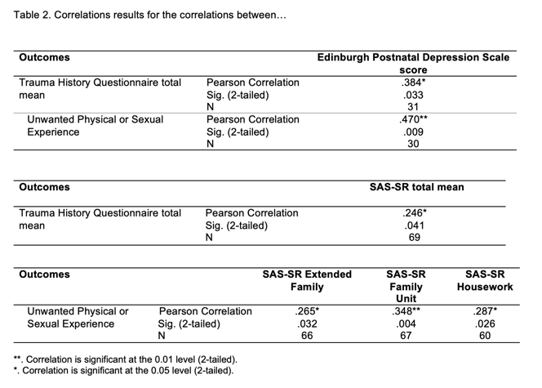
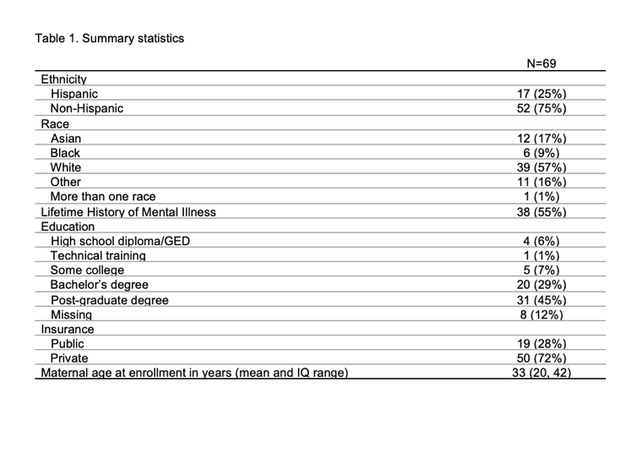
Recent Publications
- Cheng, B., Roberts, N., Zhou, Y., Wang, X., Li, Y., Chen, Y., ... & Wang, J. (2022). Social support mediates the influence of cerebellum functional connectivity strength on postpartum depression and postpartum depression with anxiety. Translational Psychiatry, 12(1), 54.
- Lee, J. S. (2019). Perceived social support functions as a resilience in buffering the impact of trauma exposure on PTSD symptoms via intrusive rumination and entrapment in firefighters. PloS one, 14(8), e0220454.
- Meltzer-Brody, S., Bledsoe-Mansori, S. E., Johnson, N., Killian, C., Hamer, R. M., Jackson, C., ... & Thorp, J. (2013). A prospective study of perinatal depression and trauma history in pregnant minority adolescents. American journal of obstetrics and gynecology, 208(3), 211-e1.
- Pao, C., Guintivano, J., Santos, H., & Meltzer-Brody, S. (2019). Postpartum depression and social support in a racially and ethnically diverse population of women. Archives of women's mental health, 22, 105-114.
- Scoglio, A. A., Reilly, E. D., Girouard, C., Quigley, K. S., Carnes, S., & Kelly, M. M. (2022). Social functioning in individuals with post-traumatic stress disorder: A systematic review. Trauma, Violence, & Abuse, 23(2), 356-371.


Presenting author details
Full name: Juliana Castro
Contact number: 781-690-7897
Linked In account: https://www.linkedin.com/in/juliana-castro-b8b3a0156/
Category: Poster presentation

