Implantable medical devices promote the clinical transformation of optical nanomaterials in biochemical detection
Xindong Wang
Institute of Flexible Electronics Technology of THU, China
Statement of the Problem: The clinical transformation of optical nanomaterials in biochemical detection has been impeded by the limited optical penetration depth in biological tissues, the toxicity and obscure toxicity mechanisms causing biological toxicity, and the lack of long-term monitoring mode for up to months or years. The combination of optical nanomaterials and implantable medical devices has shown great potential in resolving these constraints. Taking the real-time monitoring of reactive oxygen species (ROS) in the blood as an example, we demonstrate the role of implantable medical devices in facilitating the clinical transformation of nanoprobes. Methodology & Theoretical Orientation: The nanoprobes for ROS detection and relevant implantable devices were synthesized and fabricated into an integrated implant. The detection of ROS in vitro was performed. Then, the fabricated devices were implanted in vivo. The validity of ROS monitoring and the toxicity in vivo were evaluated in rabbits. Findings: The synthesized nanoprobes show a positive correlation between the concentration of ROS and the optical signal changes. The in vivo experiments demonstrate superior biocompatibility and low toxicity of the developed implantable devices, and the ROS levels in the blood can be monitored via the fabricated implants. Conclusion & Significance: Innovations that rely exclusively on nanomaterials have shown limited success in the biochemical monitoring of clinically large mammals. The combination of optical nanoprobes and implantable medical devices has been proven to be a valid method in rabbits, showing great potential in the human body.

Image
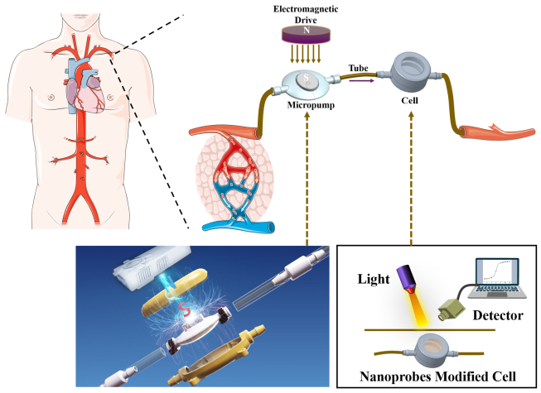
Recent Publications
Xindong Wang, Ji Fu, Chang Jiang, et al. (2023) Specific and Long-Term Luminescent Monitoring of Hydrogen Peroxide in Tumor Metastasis. Advanced Materials https://doi.org/10.1002/adma.202210948
- Xindong Wang, Xinyu Wang, Bo Qu, et al. (2022) A Class of Biocompatible Dye-Protein Complex Optical Nanoprobes. ACS Nano 16(1): 328-339.
- Xindong Wang, Rashid R.Valiev, Tymish Y.Ohulchanskyy, et al. (2017) Dye-sensitized lanthanide-doped upconversion nanoparticles. Chemical Society Reviews 46(14): 4150-4167.
- Xindong Wang, Xiaorong Zhang, Dingxin Huang, et al. (2021) High-Sensitivity Sensing of Divalent Copper Ions at the Single Upconversion Nanoparticle Level. Analytical Chemistry 93(34): 11686-11691.
- Tianxing Ji&, Xinqiang Xu&, Xindong Wang&, et al. (2020) Background-Free Chromatographic Detection of Sepsis Biomarker in Clinical Human Serum through Near-Infrared to Near-Infrared Upconversion Immunolabeling. ACS Nano 14(12):16864-16874.
Biography
Xindong Wang received his doctoral degree in the School of Chemical Engineering and Technology, Harbin Institute of Technology, working primarily on the synthesis, and biological applications of lanthanide-doped nanomaterials. Now, he is an assistant research fellow in the Institute of Flexible Electronics Technology of THU, Zhejiang, China. His research interests are biochemical sensing and disease treatment in the human body via implantable or wearable medical devices.

