Intra-species diversity of Clostridium perfringens: A diverse genetic repertoire reveals an emerging pathogenic potential
Anny Camargo*, MD, Marina Muñoz, PhD, and Juan David Ramírez, PhD
Universidad del Rosario, Colombia

Abstract

The purpose of this study was to determine the intra-species diversity and phylogenetic relationships of C. perfringens, as well as to identify key molecular markers associated with pathogenicity, virulence, and antibiotic markers resistance (AMR) from Whole Genome Analysis (WGA).

In this study, 372 C. perfringens genomes from multiple locations and sources were evaluated. In silico MLST was used for typing and the resulting sequence types (STs) were assigned to clonal complexes (CC). A pangenome analysis was conducted and then a core genome-based phylogenetic tree was created to define phylogroups. Additionally, toxinotypes, other key virulence factors (VF), and AMR were identified using ABRicate.

Most of the C. perfringens genomes analyzed in this analysis were derived from food (n=85) and bird (n=85). A total of 195 STs, some of them shared between sources such as food and human, horses and dogs, as well as environment and birds, were grouped in 25 CCs and distributed along five phylogroups. The 53% of the genomes were allocated to toxinotype A, followed by F (32%), and G (7%). The VF most frequently found was alpha-toxin (100%), followed by sialidase nanH (99%), and alpha-clostripain (99%), while tetA (39.5%) and tetB (36.2%), which mediate tetracycline resistance, were the most common AMR detected.

This analysis showed a better view about the possible spread of this pathogen among hosts, either by direct contact or by contaminated food. Furthermore, our results confirm a great diversity of C. perfringens with many virulence factors that vary among different phylogroups and AMR, especially to tetracyclines, aminoglycosides, and macrolides, which highlight its importance at the public health level as an emerging pathogen.

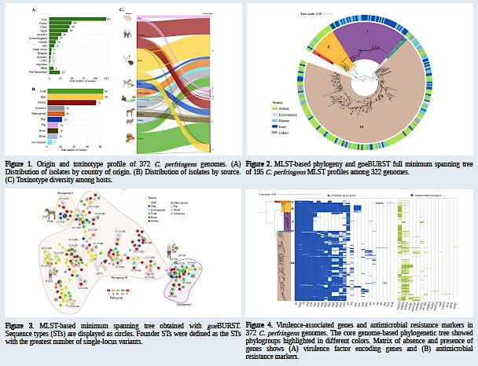

Recent Publications
- Camargo A., ET AL., (2022). Intra-species diversity of Clostridium perfringens: A diverse genetic repertoire reveals its pathogenic potential. Front Microbiol. 2022 Jul 22;13:952081.
- Abdel-Glil, M.Y., et al.,(2021) Comparative in silico genome analysis of Clostridium perfringens unravels stable phylogroups with different genome characteristics and pathogenic potential. 11(1): p. 1-15.

- Guerrero-Araya, E., et al., (2020) FastMLST: A multi-core tool for multilocus sequence typing of draft genome assemblies. Bioinform Biol Insights.
- Kiu, R., et al., (2019)Genomic analysis on broiler-associated Clostridium perfringens strains and exploratory caecal microbiome investigation reveals key factors linked to poultry necrotic enteritis1(1): p. 1-14.
- Rood, J.I., et al., (2018) Expansion of the Clostridium perfringens toxin-based typing scheme. 2018. 53: p. 5-10.

Biography
Anny Camargo is a medical doctor, professor of medicine at the Universidad de Boyacá, researcher at the Centro de Investigaciones en Microbiología y Biotecnología CIMBIUR de la Universidad del Rosario and principal investigator in Colombia. She is currently a PhD student in Biomedical and Biological Sciences at the Universidad del Rosario and is doing a internship at Quadram Institute Biosciences, Norwich. Uk. Her research aims to characterize pathogens of clinical and veterinary importance at the genomic level, in order to contribute to greater knowledge in the promotion and prevention of human health.

Notes/Comments:

Presenting author details
Full name: Anny Camargo Mancipe Contact number: +44 07749509221 Twitter account: @Draannycamargo Linked In account:
Session name/ number: Track 13: Microbial ecology and evolution Category: (Oral presentation/ Poster presentation

