Natural history of HSP56 informed by a common ancient CYP2U1 founder mutation
Raneem H. Alghamdi⁴, Tariq Masoodi², Mohammed Alowain³, Hesham M. Aldhalaan ⁴, Fathiya Al Murshedi⁵, Moeenaldeen Alsayed³, Mohammad Al-Muhaizea ⁴, Sateesh Maddirevula¹, Niema A. Ibrahim¹, Firdous M. Abdulwahab¹, Mais O. Hashem¹ and Fowzan S Alkuraya^{1,6}
^{1,2,3,4} King Faisal Specialist Hospital and Research Center, Saudi Arabia
⁵Sultan Qaboos University Hospital, Muscat, Oman
⁶ Alfaisal University, Riyadh, Saudi Arabia

Abstract (300 word limit)

Biallelic mutations of CYP2U1 are known to cause a complicated form of hereditary spastic paraplegia (SPG56). Only 26 families with SPG56 have been reported to date with 29 variants in CYP2U1. Here, we report 18 additional families (25 patients) all but two are homozygous for a founder Arab variant c.947A>T:p.Asp316Val. This largest cohort to date on SPG56 demonstrates a remarkably consistent phenotypic expression of the founder variant with predictable and universal loss of ambulation but variable degree of loss of speech, intellectual disability and white matter changes. Two families had novel variants in CYP2U1 (c.890T>C:p.Phe297Ser and c.967 997del) and the phenotype was compatible with that seen in the rest of the cohort. Haplotype analysis allowed us to estimate the age of the founder mutation at 1040 years, which makes this as one of the most ancient intellectual disability mutations in Arabia, and explains its high carrier frequency and wide geographic distribution.
Image
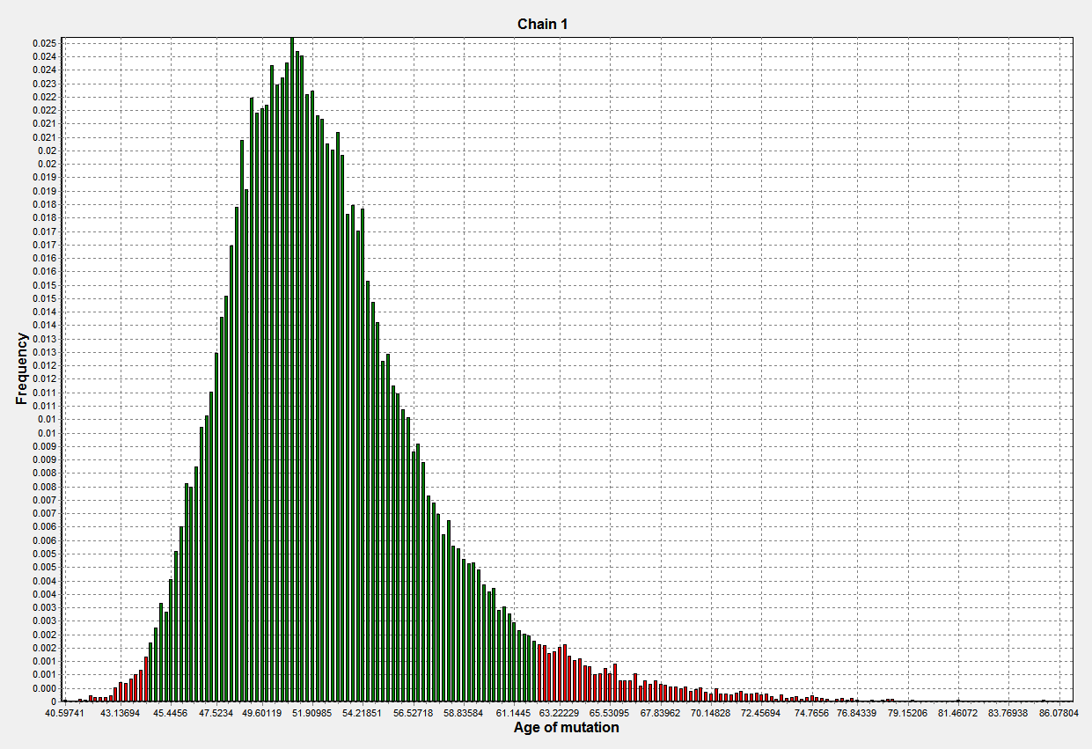

Recent Publications (minimum 5)

- Hensiek A, Kirker S, Reid E: Diagnosis, investigation and management of hereditary spastic paraplegias in the era of next-generation sequencing. Journal of neurology 2015, 262:1601-1612.
- McDermott C, White K, Bushby K, Shaw P: Hereditary spastic paraparesis: a review of new developments. Journal of Neurology, Neurosurgery & Psychiatry 2000, 69:150-160.
- Fink JK: Hereditary spastic paraplegia: clinical principles and genetic advances. In Seminars in neurology. Thieme Medical Publishers; 2014: 293-305.
- Elert-Dobkowska E, Stepniak I, Krysa W, Ziora-Jakutowicz K, Rakowicz M, Sobanska A, Pilch J, Antczak-Marach D, Zaremba J, Sulek A: Next-generation sequencing study reveals the broader variant spectrum of hereditary spastic paraplegia and related phenotypes. neurogenetics 2019, 20:27-38.
- Ruano L, Melo C, Silva MC, Coutinho P: The global epidemiology of hereditary ataxia and spastic paraplegia: a systematic review of prevalence studies. Neuroepidemiology 2014, 42:174-183.
- Chuang SS, Helvig C, Taimi M, Ramshaw HA, Collop AH, Amad M, White JA, Petkovich M, Jones G, Korczak B: CYP2U1, a novel human thymus- and brain-specific cytochrome P450, catalyzes omega- and (omega-1)-hydroxylation of fatty acids. J Biol Chem 2004, 279:6305-6314.
- Tesson C, Nawara M, Salih MA, Rossignol R, Zaki MS, Al Balwi M, Schule R, Mignot C, Obre E, Bouhouche A: Alteration of fatty-acid-metabolizing enzymes affects mitochondrial form and function in hereditary spastic paraplegia. The American Journal of Human Genetics 2012, 91:1051-1064.
- Citterio A, Arnoldi A, Panzeri E, D’Angelo MG, Filosto M, Dilena R, Arrigoni F, Castelli M, Maghini C, Germiniasi C: Mutations in CYP2U1, DDHD2 and GBA2 genes are rare causes of complicated forms of hereditary spastic paraparesis. Journal of neurology 2014, 261:373-381.
- Leonardi L, Ziccardi L, Marcotulli C, Rubegni A, Longobardi A, Serrao M, Storti E, Pierelli F, Tessa A, Parisi V: Pigmentary degenerative maculopathy as prominent phenotype in an Italian SPG56/CYP2U1 family. Journal of neurology 2016, 263:781-783.
- Masciullo M, Tessa A, Perazza S, Santorelli F, Perna A, Silvestri G: Hereditary spastic paraplegia: novel mutations and expansion of the phenotype variability in SPG56. european journal of paediatric neurology 2016, 20:444-448.
- Kariminejad A, Schöls L, Schüle R, Tonekaboni S, Abolhassani A, Fadaee M, Rosti R, Gleeson J: CYP2U1 mutations in two Iranian patients with activity induced dystonia, motor regression and spastic paraplegia. European Journal of Paediatric Neurology 2016, 20:782-787.
- Minase G, Miyatake S, Nabatame S, Arai H, Koshimizu E, Mizuguchi T, Nakashima M, Miyake N, Saitsu H, Miyamoto T: An atypical case of SPG56/CYP2U1-related spastic paraplegia presenting with delayed myelination. Journal of human genetics 2017, 62:997.
- Kumar KR, Wali G, Kamate M, Wali G, Minoche AE, Puttick C, Pinese M, Gayevskiy V, Dinger ME, Roscioli T: Defining the genetic basis of early onset hereditary spastic paraplegia using whole genome sequencing. neurogenetics 2016, 17:265-270.
- Iodice A, Panteghini C, Spagnoli C, Salerno GG, Frattini D, Russo C, Garavaglia B, Fusco C: Long-term follow-up in spastic paraplegia due to SPG56/CYP2U1: age-dependency rather than genetic variability? Journal of neurology 2017, 264:586-588.
- Durand CM, Dhers L, Tesson C, Tessa A, Fouillen L, Jacqueré S, Raymond L, Coupry I, Benard G, Darios F: CYP2U1 activity is altered by missense mutations in hereditary spastic paraplegia 56. Human mutation 2018, 39:140-151.
- Tekezawa Y, Kikuchi A, Haginoya K, et al. Genomic analysis identifies masqueraders of full-term cerebral palsy. Ann Clin Transl Neurol 2018; 5: 538–51.
- Zulfiqar S, Tariq M, Ali Z, et al. Whole exome sequencing identifies novel variant underlying hereditary spastic paraplegia in consanguineous Pakistani families. J Clin Neurosci 2019; 67: 19–23.
- Samaddar, S., Kaur, P., Rajagopal, K.V. et al. Spastic Paraplegia Type 56 in a Young Child. Indian J Pediatr 87, 650–651 (2020)
- Bibi F, Efthymiou S, Bourinaris T, et al. Rare novel CYP2U1 and ZFYVE26 variants identified in two Pakistani families with spastic paraplegia. J Neurol Sci 2020; 411: 116669.
- Sharawat, I. K., Panda, P. K., & Dawman, L. (2021). Spastic Paraplegia-56 due to a Novel CYP2U1 Truncating Mutation in an Indian Boy: A New Report and Literature Review. Journal of pediatric neurosciences, 16(1), 71–74.
- Legrand, A., Pujol C., Durand C.M., Mesnil A., Rubera I., Duranton C., Zuily S., Sousa A.B., Renaud M., Boucher J.L., et al. . 2021. Pseudoxanthoma elasticum overlaps hereditary spastic paraplegia type 56. J. Intern. Med. 289:709–725. 10.1111/joim.13193
- El Matri, K., Falfoul, Y., Habibi, I., Chebil, A., Schorderet, D., & El Matri, L. (2021). Macular Dystrophy with Bilateral Macular Telangiectasia Related to the CYP2U1 Pathogenic Variant Assessed with Multimodal Imaging Including OCT-Angiography. Genes, 12(11), 1795. https://doi.org/10.3390/genes12111795
- Monies D, Abouelhoda M, AlSayed M, Alhassnan Z, Alotaibi M, Kayyali H, Al-Owain M, Shah A, Rahbeeni Z, Al-Muhaizea MA: The landscape of genetic diseases in Saudi Arabia based on the first 1000 diagnostic panels and exomes. Human genetics 2017, 136:921-939.
- Reeve JP, Rannala B: DMLE+: Bayesian linkage disequilibrium gene mapping. Bioinformatics 2002, 18:894-895.
- Abouelhoda M, Sobahy T, El-Kalioby M, Patel N, Shamseldin H, Monies D, Al-Tassan N, Ramzan K, Imtiaz F, Shaheen R: Clinical genomics can facilitate countrywide estimation of autosomal recessive disease burden. Genetics in Medicine 2016, 18:1244.
Biography (150 word limit)

My name is Raneem Alghamdi and I am a Pediatric Neurology Resident currently working at King Faisal Specialist Hospital & Research Center, Riyadh, Saudi Arabia. I am the current Deputy Chief Resident and the Quality Chief of Pediatric Neurology Trainees. I have a strong interest in epilepsy and neurogenetics and I have ongoing research publications in both fields.

