Drug interactions :Identification
NESRINE HAGUI ,HOSPITAL PHARMACIST ,CENTER OF INJURIES AND BURNT,TUNISIA

Abstract

Statement of the Problem: The risk for drug-drug interactions and related adverse side effects increases with the number of simultaneously administered drugs.
Drug interactions potentiate or oppose the therapeutic of one co-administered drugs.
Objective : The aim of this study is to identify and prevent drug-drug interactions in the unit of anesthesia reanimation Methodology & Theoretical Orientation : To identify drug-drug interactions, a study was achieved in the anesthesia reanimation unit where interactions of 56 aticles were analysed then a poster was established including diferent types of interactions and distribuated to all the units of the center.
Findings : The study concluded to 8 contraintrindication (1.25%), 297 cautions (46.4%), 163 precautions employement (25.46%)
and 172 associations not recommanded (26.87%)
Conclusion & Significance: To prevent an eventual interaction a poster has been established and distribuated in
each unit of the center.
The identification and prevention of drug-drug interactions represent pivotal steps to improve drug therapy,, and to increase the patients' quality of life.

Biography :
Nesrine Hagui hospital pharmacist .She has performed manage the unit of pharmacy forb over 9 years.She values integrity and passion as aspects that will build better cooperation with doctors.inorderb to. Create new pathways fo rimproving healthcare and wellbeing. She has built this model afeter performing in clinical pharmacy as a correspondent of pharmacovigilance in the center of injuries and burnt.
Emai : haguinesrine@ymail.com NESRINE HAGUI
+21696575582
haguinesrine@ymail.com Poster presentation

and prevention

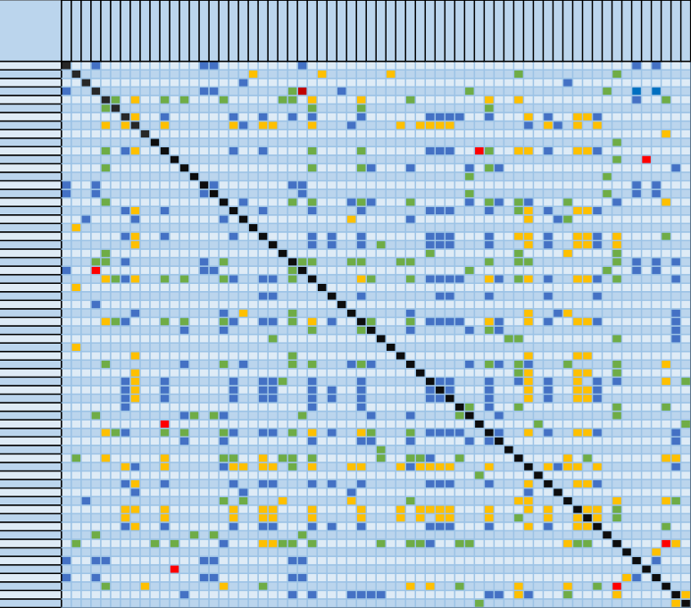Image

ACICLOVIR
ACIDE VALPROIQUE ALTEPLASE AMIKACINE MIODARONE AZITHROMYCINE BACLOFENE BACTRIM BUDESONIDE CANCIDAS CATAPRESSAN CERNEVIT CIPROFLOXACINE CLINDAMYCINE COLI GENTA COLIMYCINE DEXAMETHASONE DIAZEPAM ENOXAPARINE ERTAPENEM FENTANYL
FERREUX FUMARATE FLUCONAZOLE FUROSEMIDE ENTAMICINE HALOPERIDOL MIPENEM
PRATROPIUM BROMURE KETAMINE KETOPROFENE LARGACTIL LEVOFLOXACINE LEVOTHYROXINE MEROPENEM METFORMINE METHYLPREDNISOLONE METRONIDAZOLE MIDAZOLAM
MORPHINE EFOPAM NICARDIPINE NIMBEX NORADRENALINE OZINAN OFLOXACINE OMEPRAZOLE PHENYTOINE PIROXICAM PROPOFOL REMIFENTANIL RINGER LACT RIVAROXABAN RIVOTRIL STEROGYL SUFENTANIL SUXAMETHONIUM TAVER TAZOCILLINE TEICOPLANINE TIGECYCLINE VANCOMYCINE VORICONAZOLE ZOLOFT
ZYVOXID
ACICLOVIR
ACIDE VALPROIQUE
ALTEPLASE
AMIKACINE
AMIODARONE
AZITHROMYCINE
BACLOFENE
BACTRIM
BUDESONIDE
CANCIDAS
CATAPRESSAN
CERNEVIT
CIPROFLOXACINE
CLINDAMYCINE
COLI GENTA
COLIMYCINE
DEXAMETHASONE
DIAZEPAM
ENOXAPARINE
ERTAPENEM
FENTANYL
FERREUX FUMARATE
FLUCONAZOLE
FUROSEMIDE
GENTAMICINE
HALOPERIDOL
IMIPENEM
IPRATROPIUM BROMURE
KETAMINE
KETOPROFENE
LARGACTIL
LEVOFLOXACINE
LEVOTHYROXINE
MEROPENEM
METFORMINE
METHYLPREDNISOLONE
METRONIDAZOLE
MIDAZOLAM
MORPHINE
NEFOPAM
NICARDIPINE
NIMBEX
NORADRENALINE
NOZINAN
OFLOXACINE
OMEPRAZOLE
PHENYTOINE
PIROXICAM
PROPOFOL
REMIFENTANIL
RINGER LACT
RIVAROXABAN
RIVOTRIL
STEROGYL
SUFENTANIL
SUXAMETHONIUM
TAVER
TAZOCILLINE
TEICOPLANINE
TIGECYCLINE
VANCOMYCINE
VORICONAZOLE
ZOLOFT
ZYVOXID

A

G

N

N

Figure 1 : The table of drug interactions
Association | color
Contraindication
not recommended
precautions emplyment
caution

Publications

- European Medicines Agency. https://www.ema. europa.eu/en/documents/report/2021-annualreport-eudravigilance-european- parliamentcouncil-commission_en.pdf
- Sardella M, Belcher G, Lungu C, et al. Monitoring the manufacturing and quality of medicines: a fundamental task of pharmacovigilance.
- Regulation (EU) No 536/2014 of the European Parliament and of the Council of 16 April 2014 on clinical trials on medicinal products for human use, and repealing Directive 2001/20/EC.
- The rules governing medicinal products in the European Union VOLUME 10 – Guidance documents applying to clinical trials Clinical Trials Regulation (EU) 5. European Medicines Agency. Benefit-risk methodology project Work package 1 report: description of the current practice of benefit-risk assessment for centralised procedure products in the EU regulatory network

