Nano medicine: A Novel Model based Coulomb Explosion for the Study of Nano-particles of Gold in the Treatment of Breast Cancer

Zahid Hasan (Ph. D Scholar)

Assistant Professor, NCBA&E

Main Campus Lahore, Pakistan

Abstract

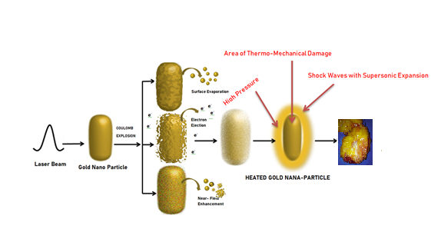
Nanotechnologist and medical researchers are still involved in a fighting against a high number of serious and complex diseases like breast cancer. Breast cancer remains a significant global medical issue among all ages of women and need to serious attention in this direction for research, investment, and effective and safely treatment. Traditional treatments including surgery, radiation therapy, chemotherapy, targeted therapy, and hormone therapy are not have effective results and have many limitations.
In this research work, coulomb explosion model is proposed to design “Heat control system” that will work as heat therapy for the treatment of the fatal cancer cells at molecular and Nano atomic level on the bases of “See and Treat” using Nano heat sensors and Nano Cameras. For controlling the intensity of heat we used the magical properties of coated Gold Nano- Particles with less than 100nm in our proposed research work. The gold nanoparticles are irradiated with a laser beam to initiate Coulomb explosion. The resulting explosion generates a high-energy shockwaves, which causes damage to the cancer cells and leads to their destruction by controlling the intensity of heat to induce hyperthermia, which involves heating the cancerous tissue to a temperature between 41-45°C to selectively kill the cancer cells. The heat control system has several advantages over traditional cancer treatments such as chemotherapy or radiation therapy. Firstly, hyperthermia can selectively target cancer cells, leaving healthy tissue unharmed. Secondly, it can be combined with other cancer treatments to enhance their effectiveness. Finally, it is a non-invasive procedure that is well-tolerated by patients.
Moreover we used the finite element method to simulate the temperature distribution in the breast tissue during the treatment. This proposed model will be evaluated on the Thermo Phoresis Nt. The numerical results obtained in graphical form and show how Nano-particles of Gold preserve their energy as well as how they can be used in the treatment of cancer cells. The results are obtained by using MATLAB simulation.




Image

Figure 1: Shows the entire working of Coulomb Explosion Model, how the shock waves with supersonic expansion are created from heated gold nanoparticles

References
- Eversole, D., Subramanian, K., Harrison, R. K., Bourgeois, F., Yuksel, A., & Ben-Yakar, A. (2020). Femtosecond Plasmonic Laser Nanosurgery (fs-PLN) mediated by molecularly targeted gold nanospheres at ultra-low pulse fluences. Scientific Reports, 10(1), 1-16.
- Heilig Xue, Y., Liu, C., Andrews, G., Wang, J., & Ge, Y. (2022). Recent advances in carbon quantum dots for virus detection, as well as inhibition and treatment of viral infection. Nano Convergence, 9(1), 15.
- Omran, B. A. (2020). Nanobiotechnology: a multidisciplinary field of science (pp. 145-184). Cham: Springer.
- Gutierrez, C., & Flonth, V. Plasmonic multiphoton photothermal therapy using AuNP-iPSMA in prostate cancer cells

- Salih, M. A. M. (2020). Innovative self-assembling nanodelivery systems to combat bacterial infections (Doctoral dissertation).
Paste your Logo here

Biography

Mr. Zahid Hasan is a Ph.D scholar belongs to Lahore Pakistan. He is assistant professor in well reputed charter university (NCBA&E) in main campus of Lahore Pakistan. His area of research is Nano robotic applications for diagnosis of chronic diseases and treatment. In 2019 he has physically attended Nanotech conference in Paris France and achieved good performance award. He interested to use Nano technologies applications in life science by using numerical methods. Recently he is working on blood cancer research with the combine efforts of Ontologies, machine learning nanotechnology and emerging technology of Internet of medical things (IOMT) and cloud computing approaches. He has expertise in innovative evaluation and passion in improving the medical challenges and wellbeing of humanity. He has developed novel model that aim to improve healthcare by taking into account the perspectives and need of all stakeholders. The proposed model appears to be particularly responsive to the context in which it is being applied, as it takes into account the specific circumstances and needs of the healthcare system being evaluated. This could potentially make it more effective in improving healthcare outcomes compared to more traditional evaluation approaches.

Notes/Comments:
Presenting author details
Full name: Zahid Hasan
Contact number: +923234304174
Twitter account: https://twitter.com/ZahidHa04753067
Linked In account: linkedin.com/in/zahid-hasan-282b9123b
Session name/ number:
Category: (Oral presentation)

