Identification of prognostic and predictive biomarkers in high-dimensional data with PPLasso
Wencan Zhu
MRC Laboratory of Molecular Biology, UK
Abstract
In clinical trials, identification of prognostic and predictive biomarkers has become essential to precision medicine. Prognostic biomarkers can be useful for the prevention of the occurrence of the disease, and predictive biomarkers can be used to identify patients with potential benefit from the treatment. Previous research was mainly focused on clinical characteristics, and the use of genomic data in such an area is hardly studied. A new method is required to simultaneously select prognostic and predictive biomarkers in high dimensional genomic data where biomarkers are highly correlated. We propose a novel approach called PPLasso, that integrates prognostic and predictive effects into one statistical model. PPLasso also takes into account the correlations between biomarkers that can alter the biomarker selection accuracy. Our method consists in transforming the design matrix to remove the correlations between the biomarkers before applying the generalized Lasso. In a comprehensive numerical evaluation, we show that PPLasso outperforms the traditional Lasso and other extensions on both prognostic and predictive biomarker identification in various scenarios. Finally, our method is applied to publicly available transcriptomic and proteomic data.

Image
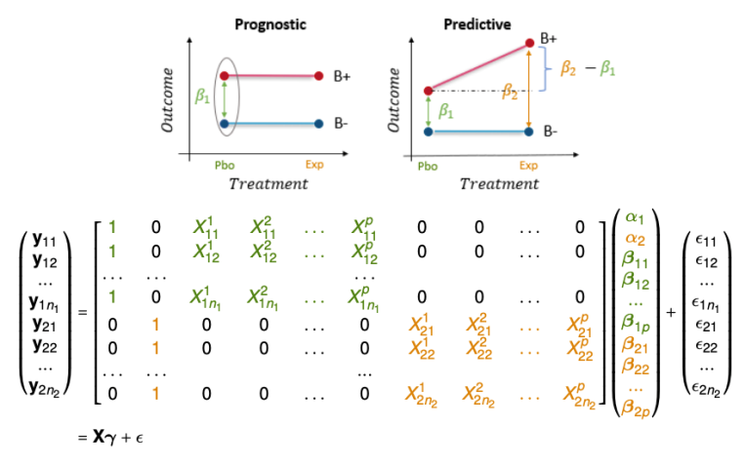
Fig 1. ANCOVA (Analysis of Covariance) model for the identification of prognostic and predictive biomarkers in clinical trials.
Recent Publications:
Zhu, W., Lévy-Leduc, C., & Ternès, N. (2021). A variable selection approach for highly correlated predictors in high-dimensional genomic data. Bioinformatics, 37(16), 2238–2244.
Zhu, W., Lévy-Leduc, C., & Ternès, N. (2022). Identification of prognostic and predictive biomarkers in high-dimensional data with PPLasso. BMC Bioinformatics, 24(25).
Liu, F., Zhu, W., Shoaito, H., Chissey, A., Degrelle, S. A., & Fournier, T. (2020). Mining of combined human placental gene expression data across pregnancy, applied to PPAR signaling pathway. Placenta, 99, 157–165.
Liu, F., Rouault, C., Guesnon, M., Zhu, W., Clément, K., Degrelle, S. A., & Fournier, T. (2020). Comparative Study of PPARγ Targets in Human Extravillous and Villous Cytotrophoblasts. PPAR research, 9210748.
Liu, F., Simasotchi, C., Vibert, F., Zhu, W., Gil, S., Degrelle, S. A., & Fournier, T. (2021). Age and Sex-Related Changes in Human First-Trimester Placenta Transcriptome and Insights into Adaptative Responses to Increased Oxygen. International journal of molecular sciences, 22(6), 2901.

Biography:
Wencan Zhu has her expertise in developing and evaluating new machine learning based algorithms to support the development of precision medicine. Particularly, here research interest lies on the identification of biomarkers (genes, proteins etc.) that are associated to the response to the treatment. With such biomarkers successfully identified, the treatment administration can then be optimized according to the molecular make-up of each patient. Owning a background in mathematics, she aims to find better mathematical modeling to help the data analysis.

