Ethically sourced materials with Nanobio-technology towards affordable health
Santanu Dhara
School of Medical Science and Technology, Indian Institute of Technology Kharagpur, India

Abstract

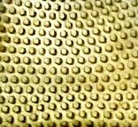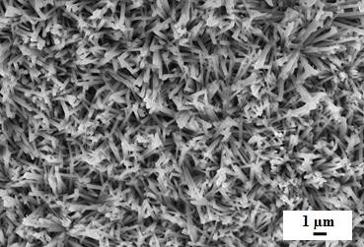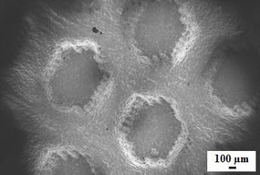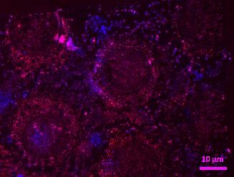BioMaterials and Tissue Engineering (BMTE) was formed in the year 2007 at School of Medical Science and Technology with the main emphasis on product development research based on fundamental understanding of cell–material interactions and in vivo response with preclinical model. BMTE is working on the development of customized implants through various top-down and bottom-up fabrication techniques. Primarily, the group is developing permanent implants for rehabilitation and biodegradable implants for tissue regeneration (Fig. 1 & Fig. 2).

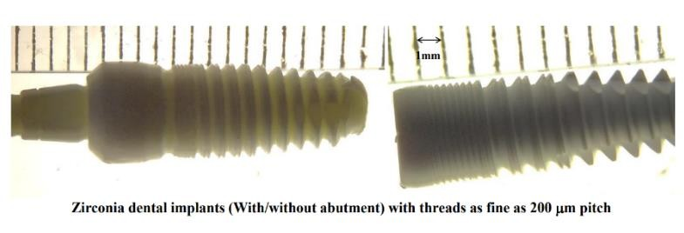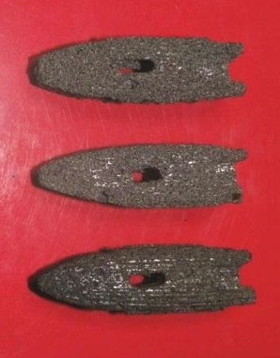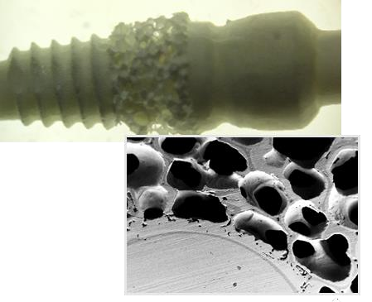Fig. 1: (a) Ti6Al4V micro-texture for tissue integration (b) Micro-texture at higher magnification (c) Nano-rods for bacteria static activity (d) Cellular adhesion and proliferation

Fig. 2: Dental implants (a) CAD Design; Different dental implants compositions (b) Alumina,
(c) Alumina –zirconia composites with variable screw pitches (d) spinal spacer of Ti6Al4V

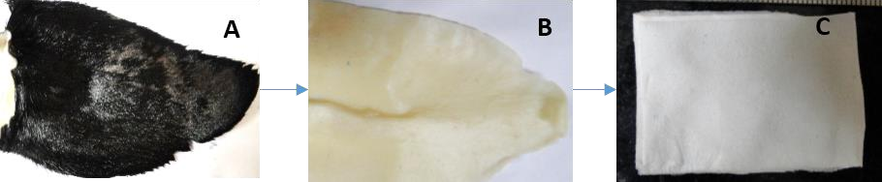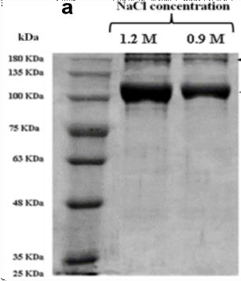In this context, metal and ceramic-based permanent implants like mandible, dental crown, cortical bone etc. are manufactured by near net shape fabrication (direct casting and green state machining) approach. Bio-activation/ surface modification of implants for biological fixation is another important area of research. Different kinetically driven processes like microwave irradiation and electrospinning are utilized for quantum dots and nano/microfibrous mat fabrication for live-cell and tissue imaging, tissue regeneration, wound healing applications (Fig. 3).
c

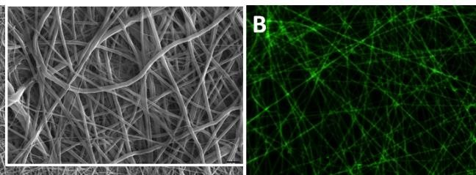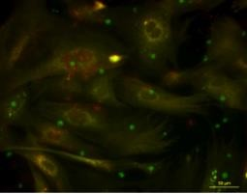
A
C

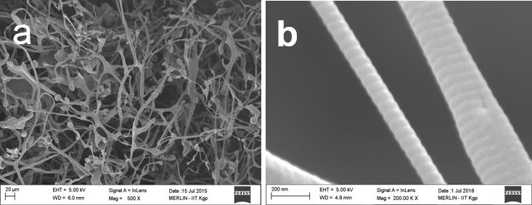

Fig. 3 The first row (A, B, and C) Electrospun nanofibers, Fluorescence activity of nanofiber and live cells for different healthcare applications; The second row (A, B and C) Capra-ear at different processing stages as decellularized extracellular matrix analogous to cartilage tissue components; The third row (a, b, and c) Collagen type II meshwork with other extracellular matrix components, Collagen II at higher magnification and SDS page of collagen II showing the molecular weight of ~ 150 KDa.
Under the regenerative medicine approach, this group is developing biodegradable/bioactive materials with nano-micro architecture for skin, bone and cartilage tissue engineering. Different factors like scaffold architecture, chemistry, dynamic and static conditions are studied

to improve cell-material interactions toward stem cell differentiation into native tissue phenotypes. Also, the group is exploring diverse natural resources for isolation of bioactive molecules, biopolymers and materials for better healthcare delivery. The group has activities from materials development, the study of cell biology and biochemical assays in vitro and in vivo towards final product development. Some of the products are already used for clinical case studies and some of them and in the intermediate stage of technology transfer.

References:

- P. P. Maity, D. Dutta, S. Ganguly, K. Kapat, K. Dixit, A. Roy Chowdhury, R. Samanta, N. C. Das, P. Datta, A. K. Das & S. Dhara, ‘Isolation and mass spectrometry based hydroxyproline mapping of type II collagen derived from Capra hircus ear cartilage’, Communications Biology 2(146) pp. 1-11, 2019 DOI: 10.1038/s42003-019-0394-6
- P. K. Srivas, K. Kapat, B. Das, P. Pal, P. Guha Ray, S. Dhara, ‘Hierarchical surface morphology on Ti6Al4V via patterning and hydrothermal treatment towards improving cellular response’, Applied Surface Science, 478, pp. 806-817, 2019
- S. Mohanty, P. K Srivas, S. Dhara, ‘Reverse Engineering Approach for Customized Dental and Maxillofacial Implants of Alumina Fibre Reinforced Composite’, Materials Today: Proceedings, MATPR7653, 11(2) pp. 753-760, 2019
- K. Kapat, A. P. Rameshbabu, P. P. Maity, A. Mandal, K. Bankoti, J. Dutta, D. K. Das, G. Dey, M. Mandal, S. Dhara, ‘Osteochondral Defects Healing Using Extracellular Matrix Mimetic Phosphate/Sulfate Decorated GAGs-Agarose Gel and Quantitative Micro-CT Evaluation’, ACS Biomaterials Science & Engineering 5 (1), pp. 149-164 (2018)
- K. Kapat, P. P. Maity, A. P. Rameshbabu, P. K. Srivas, P. Majumdar and S. Dhara, ‘Simultaneous Hydrothermal Bioactivation with Nano-topographic Modulation of Porous Titanium Alloy towards Enhanced Osteogenic and Antimicrobial Responses’, J. Mat. Chem B, B 6 (18), pp. 2877-2893 (2018)

Biography
Santanu Dhara PhD is a Professor at School of Medical Science and Technology, Indian Institute of Technology Kharagpur, India. BioMaterials and Tissue Engineering (BMTE) was established by Dr. Dhara in the year 2007 soon after joining SMST as faculty.

