Congenital Gastric diverticulum in antrum

Dr Ramesh R Avula, post graduate, Department of Gastroenterology, Andhra Medical College, Visakhapatnam, ramesh1072m@gmail.com, 8885483014
Dr LRS Girinadh, Head of the department, Department of Gastroenterology, Andhra Medical College, Visakhapatnam
Dr Vamsi D Yadav, Assistant professor, Department of Gastroenterology, Andhra Medical College, Visakhapatnam

ABSTRACT
INTRODUCTION: Gastric diverticula are outpouchings of gastric wall. They are rare anatomical abnormalities with prevalence of 0.02 to 0.04%. They are usually found in fundus during routine endoscopy. We herein present a rare case of gastric diverticulum in prepyloric region.

CASE PRESENTATION: A 40-year-old male patient presented with right upper quadrant pain for last 5 days, increasing postprandially. On evaluation, patient was found to have choledocholithiasis with cholelithiasis. No associated findings of cholecystitis were found. An Endoscopic Retrograde Chlangio-pancreatography guided bile duct stone retrieval was planned prior to cholecystectomy. Routine screening upper gastrointestinal endoscopy showed 3 cms x 3cms gastric wall outpouching in the prepyloric area, associated with few erosions. Patient did not have any symptoms/signs of gastric outlet obstruction, suspicious ulcers or intra-abdominal infections. Radiologic investigations did not reveal any adhesions around the diverticulum indicating it to be congenital in nature and unlikely to be the cause of present symptoms in the patient. Biopsy from diverticulum showed non specific inflammation. Hence, further treatment was directed towards gall stone disease and gastric diverticulum was managed conservatively.
CONCLUSION: Gastric diverticula, least common type of gastrointestinal diverticula, are mostly congenital (70%) and usually found in fundus. Acquired gastric diverticula are usually found in antrum. Our patient had a congenital gastric diverticulum in antrum, an extremely rare finding. Most gastric diverticula can be managed conservatively like in this patient. However symptomatic large gastric diverticula might require surgical excision.

Keywords: gastric diverticulum, gastrointestinal diverticula, congenital, acquired
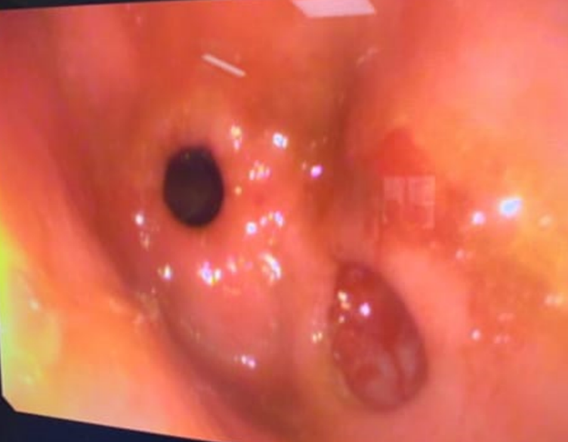
Figure 1Congenital gastric diverticulum near pyloric opening

