Clinical Rationale and Rehabilitation Guidelines for Post Biologic Therapy
Eric S. Honbo
Harvard University Clinical & Teaching, USA

Abstract (300 word limit)
Orthobiologic therapies such as platelet-rich plasma have been increasingly studied as a treatment for several musculoskeletal and orthopedic injuries Involving tendons, ligaments, muscles, the intervertebral disc, and synovial joints. In the United States, platelet-rich plasma was first used in 1987 to control wound healing after cardiac surgery. Over the last decade, there has been a significant increase in the utilization of orthobiologic therapies and cell-based therapies by orthopedic, musculoskeletal, and sports medicine physicians. Despite promising clinical results and the widespread use of PRP to treat musculoskeletal and orthopedic injuries, its use remains controversial due to the heterogeneity in study designs, lack of reporting standardization, and evidence of publication bias2, .. The use of orthobiologic modalities such as platelet-rich plasma in orthopedics and sports medicine to deliver high concentrations of naturally occurring biologically active growth factors and proteins to the site of injury is very promising and continues to evolve. Early protection and tissue specific progressive loading are critical components to successful outcomes following orthobiologic intervention. Each tissue heals and responds differently. Ligament, tendon, muscle, and articular cartilage each have unique healing properties that require tissue specific loading. The authors have found using a criteria-based loading and exercise progression guided by dynamic imaging when appropriate to further advance the goal-oriented rehabilitation program. Each patient and injured tissue are unique and require specific intervention and rehabilitation.

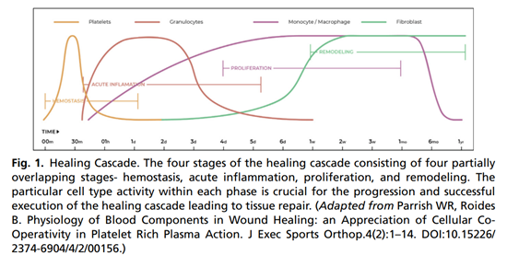
Biography
Dr. Eric Honbo has been practicing orthopedic physical therapy and sports medicine since 1997. Eric serves as a consultant to the Chinese Olympic Committee, provides direct treatment interventions to Olympic athletes, and gives clinical lectures to the National Team medical training staff. In 2015, he served as a Team Physical Therapist for the Chinese National Track & Field Team. He is also an Adjunct Clinical Instructor in the USC BKN & Orthopedic PT Residency and Spine Rehabilitation Fellowship program in Beijing, China. Eric received his Physical Therapy Doctoral degree from Massachusetts General Hospital IHP (Harvard University Clinical & Teaching affiliated).

