The correlation between cluster seizures and findings of magnetic resonance imaging in drug refractory epilepsy patients

Seyed Navid Naghibi , MD,Neurologist, Fellowship Of Epilepsy, Iran , Isfahan

Abstract

Epilepsy is one of the most common neurological disorders around the world, and about a quarter of all epilepsy patients are women of reproductive age, so managing epilepsy in women of reproductive age is extremely important.

Neuroendocrinological differences between men and women affect epilepsy and epilepsy itself in women and Men are associated with sex-related complications. On the other hand, in women, issues related to fertility, marriage, Pregnancy, breastfeeding, bone health, etc. are very important points that should always be considered by the treating physician.

Although the majority of women with epilepsy will have a normal and safe pregnancy, in order to have a safe pregnancy in women with epilepsy, pre-pregnancy care should include trying to fully control seizures with the minimum dose and number of antiseizure medications (ASMs) and choosing the medication with the least side effects on the mother and the fetus, choose the appropriate contraceptive method and use folic acid supplements.

During pregnancy, the monitoring of the serum level of many antiseizure medications should be done regularly, and proper screening should be done in terms of teratogenic effects of antiseizure medications, in cooperation with a perinatologist. In the vast majority of pregnant women with epilepsy, the choice of delivery method is based on obstetric criteria.

In the absolute majority of cases, the benefits of breastfeeding for the baby and the mother are much greater than the risk of drug transfer through breast milk, so breastfeeding is recommended in most cases. however, the baby should be carefully monitored for signs of drug poisoning.

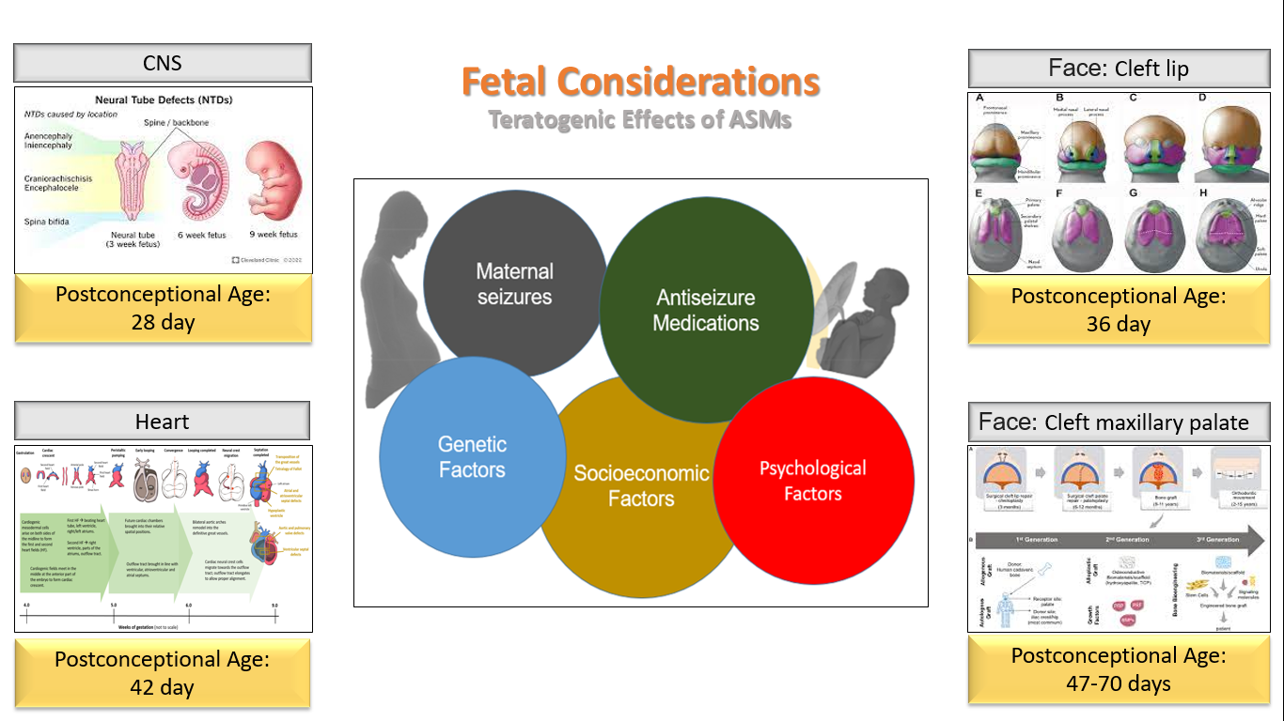

Figure 1. Relative Timing and Developmental Pathology of Certain Major Congenital Malformations
References
- Tomson T, Battino D, Perucca E. The remarkable story of valproic acid. Lancet Neurol 2016;15(2):141.
- Meador KJ. Cognitive effects of epilepsy and its treatments, Chapter 93. In: Wyllie E, Cascino GD, Gidal BE, et al, editors. Wyllie’s treatment of epilepsy: principles & practice. 7th Edition. Philadelphia: Lippincott Williams & Wilkins; 2020.p. 1058–63.
- Kellogg MA, Meador KJ. Neurodevelopmental effects of antiepileptic drugs. Neurochem Res 2017;42(7):2065–70.
- Tomson T, Battino D, Bonizzoni E, et al. Comparative risk of major congenital malformations with eight different antiepileptic drugs: a prospective cohort study of the EURAP registry. Lancet Neurol 2018;17(6):530–8.
- Christensen J, Trabjerg BB, Sun Y, et al. Prenatal exposure to valproate and risk of congenital malformations-Could we have known earlier? A population-based cohort study. Epilepsia 2021;62(12):2981–93.



Biography (150 word limit)
Seyed Navid Naghibi
Doctor of Medicine : Ahvaz Jundishapur University of Medical Sciences (1998-2006). Ranked 31th in the national enterance exam 1998 and member of National Organization for Development of Exceptional Talents (NODET) .Resindent of Neurology at Ahvaz Jundishapur University of Medical Sciences (2006-2010) .
Fellowship of Epilepsy at Isfahan University of medical science (2017-2018) .
Email: navidnaghibi.neuro@gmail.com

Notes/Comments:

