Case report: A rare case of hemoperitoneum secondary to a ruptured ovarian pregnancy superimposed by a bleeding corpus luteum cyst.

Grace HS Cheah, MBBS, MRCOG, MMED, Obstetrics & Gynecology, KK Women and Children’s Hospital, Singapore

Jiayi Liu, MBBS, MRCOG, MMED, Obstetrics & Gynecology, KK Women and Children’s Hospital, Singapore

Abstract
A 17-year-old patient presented to the emergency department with an acute abdomen and elevated serum beta-human chorionic gonadotropin levels. She underwent a surgical laparoscopy for a suspected ruptured ectopic pregnancy. Intraoperatively, she was noted to have both a ruptured hemorrhagic corpus luteal cyst, as well as products of conception, arising from the same ovary. Histology confirmed an ovarian ectopic pregnancy with a concomitant ruptured corpus luteal cyst. Her postoperative recovery was uneventful.

Both hemorrhagic ovarian cysts, as well as ectopic pregnancies, are frequent causes of acute pelvic pain in women of childbearing age, and their similarities in clinical signs and symptoms pose a diagnostic dilemma for any gynecologist. Additionally, ovarian pregnancies are a rare form of ectopic gestation that compounded the challenges in this patient’s diagnosis and management. In any woman presenting with acute abdominal pain, an adnexal mass, and ultrasound features of hemoperitoneum, it is important to consider ruptured corpus luteal cysts, as well as ruptured ovarian ectopic pregnancies, as a rare but differential diagnosis.

Ultimately, the mainstay of diagnosis and treatment is a diagnostic laparoscopy, which has shown to be a reliable, safe and feasible management strategy without compromising on patient safety nor ovarian function in the long run.

Images
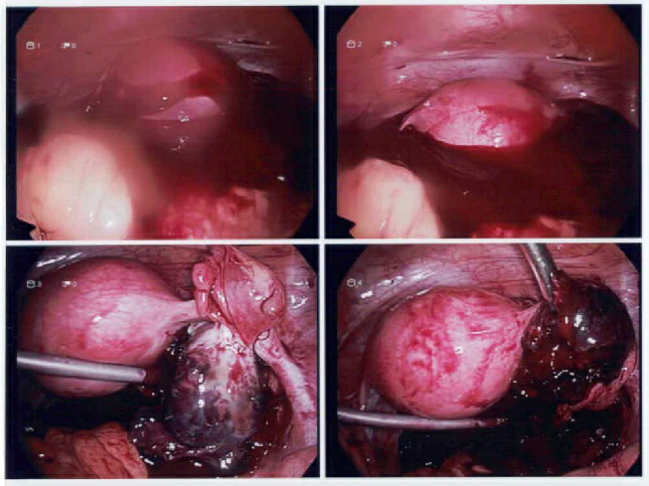
Figure 1. Laparoscopy images (a, b) Significant hemoperitoneum noted on entry. (c) Ruptured ovarian ectopic pregnancy. (d) Ruptured and bleeding corpus luteal cyst
References
- Hallatt JG, Steele CH, Snyder M. Ruptured corpus luteum with hemoperitoneum: A study of 173 surgical cases. American Journal of Obstetrics and Gynecology. 1984 May;149(1):5–9.
- Marcus SF, Brinsden PR. Primary ovarian pregnancy after in vitro fertilization and embryo transfer: report of seven cases. Fertility and Sterility. 1993 Jul;60(1):167–9.
- Hertzberg BS, Kliewer MA, Paulson EK. Ovarian cyst rupture causing hemoperitoneum: imaging features and the potential for misdiagnosis. Abdom Imaging. 1999 May;24(3):304–8.
- Nadarajah S, Sim LN, Loh SF. Laparoscopic Management of an Ovarian Pregnancy. Singapore Med J. 2002;43(2):95–6.
- Ziyauddin F. A Primary Ovarian Pregnancy with a Contralateral Ruptured Corpus Luteum: A Case Report. JCDR [Internet]. 2012 [cited 2023 Feb 26]; Available from: http://www.jcdr.net/article_fulltext.asp?issn=0973-709x&year=2012&volume=6&issue=10&page=1772&issn=0973-709x&id=2609
- Babacan A, Gun I, Bodur S. Hemoperitoneum from corpus luteum cyst rupture in pregnancy of unknown location. Eastern Journal of Medicine. 2015;

Biography

At the time of writing, Grace Cheah is a fourth-year resident in the Singhealth Obstetrics & Gynecology programme in Singapore. She is passionate about obstetrics and gynecology and is looking for innovative ways to improve her acumen in clinical healthcare. Being placed in one of the largest OBGYN clusters in Singapore and the leading training centre in the field of O&G, she has had the opportunity to witness a myriad of clinical cases in both obstetrics and gynecology alike. The above case was written up with the intention of highlighting its rarity, clinical complexity, and the management principles, which the authors found to be a noteworthy learning experience with multiple key takeaways.
Email: grace.cheah@mohh.com.sg

Notes/Comments:

Presenting author details
Full name: Grace Cheah Hui Shi
Contact number: 97535134
Twitter account: NIL
Linked In account: NIL
Session name/ number: Obstetrics & Gynecology
Category: (Oral presentation/ Poster presentation)

