Assessment of Long-Term Visual Outcomes in Aphakic Children Wearing Scleral Contact Lenses
Veronika Yehezkeli
Meir Medical Center, Israel

Abstract (300 word limit)
Background: Timely management of aphakic children is critical for rehabilitation of adequate visual gain. This study aims to evaluate the long-term efficacy of scleral contact lenses in terms of visual outcomes, complications, and compliance in aphakic children.

Methods: Retrospective data review of children with congenital or acquired cataract, or subluxated crystalline lenses, who underwent lensectomy from 2004 to 2018 and who used scleral contact lenses for refractive correction. Collected data from the follow up period included recorded aphakic refraction and visual acuity, complications following scleral contact lens wear documented in the clinic and ophthalmic emergency room and compliance to lens wear according to parental feedback on every visit in the clinic.

Results : A total of 50 eyes of 35 patients were included. Of these, congenital cataract compromised 45 cases. Mean follow up was 66.32±39.5 months (range 6-139). Final visual acuity better than 20/200 was seen in 76% of cases, with final best corrected visual acuity (BCVA) of 20/40 or better achieved in seventeen eyes (34%). Rate of amblyopia was 50%. Strabismus developed in 56% of children, and those had less favourable visual outcomes (0.43±0.4 LogMAR without strabismus and 0.8±0.5 LogMAR with strabismus, p=0.015). No corneal infections were documented during the follow up. Main adverse effect on the ocular surface was superficial punctate keratopathy (n=16). Compliance was good in 48 children (96%)- except for two cases, the scleral lenses were tolerated well by all children.

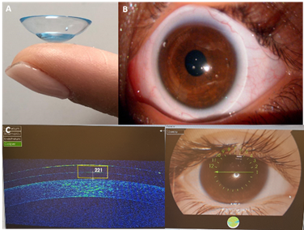
Conclusion: Scleral contact lenses are an effective means of visual rehabilitation in aphakic children after lensectomy and may be used long-term with good compliance of wear, excellent visual outcomes, and tolerable adverse events.
Biography
Dr. Veronika Yehezkeli is a senior resident in ophthalmology department in Meir medical center in Israel, with a particular interest in pediatric ophthalmology , visual functioning and congenital cataract.

