Diesel fuels from thermal gasification of agricultural waste
Nadezhda Krop¹, Vítor Matos¹, Eveline Andrade¹, Luís Calado¹, Roberta Panizio^{1,} Catarina Nobre¹, Paulo Brito¹

¹VALORIZA – Research Centre for Endogenous Resource Valorization, Polytechnic Institute of Portalegre, Campus Politécnico 11, 7300-555 Portalegre, Portugal.

Abstract

The Alentejo region (Portugal) is known for its agricultural production. This intensive production is associated with high waste generation, making biomass wastes an attractive option as feedstock for energy production. Gasification is one of the most significant technologies in biomass conversion. It is a process that takes place at high temperatures (700-1200 °C), having as a main product a combustible gas called syngas. Syngas (which is largely composed by CO, H2, CO2, CH4, etc.) can be used in diesel engines. When the diesel engine is not modified, syngas can be used during the engine’s ignition phase. On the other hand, the engine can be converted into DDF (Diesel Dual Fuel) mode and syngas can either be used together with diesel fuel or as a substitute. The SynDiesel project intends to analyze and determine the techno-economic feasibility of using biomass wastes, particularly those of agricultural and agro-industrial origin, for syngas production, and syngas use in DDF engines. The results obtained so far, indicate that Alentejo’s most promising biomass waste samples in terms of quantity and chemical characterization are olive tree prunings, common wheat, durum wheat, barley, oats, triticale, fava beans and lupine. To produce syngas, gasification operating conditions are being optimized in a range of 600 – 700 °C. As of now, typical cold gas efficiency for the studied biomass waste samples were in the range of 62 – 74 %, giving good prospects on syngas quality (20 % CO, 17 % H2). Before using the syngas in the DDF engine, syngas cleaning procedures will be studied and implemented to comply with emission regulation, particularly 50 mg/Nm3 in the case of particles, and 100 mg/Nm3 for tars. Overall, this project will increase participation of agro-industrial biomass in the energy mix, namely mobility and electric energy. Moreover, these technologies will undoubtedly contribute to the decarbonization process, since using a part of agricultural waste can achieve reductions up to 35% in diesel consumption of agricultural machines.

Acknowledgments: This research was funded by Fundação para a Ciência e a Tecnologia, I.P. (Portuguese Foundation for Science and Technology) under the project UIDB/05064/2020 (VALORIZA – Research Centre for Endogenous Resource Valorization) and project ALT20-03-0145-FEDER-039485 - SynDiesel.: Fuels for diesel engines from dedicated waste and crop thermal gasification, co-financed by the ERDF, through the Regional Operational Program of Alentejo.
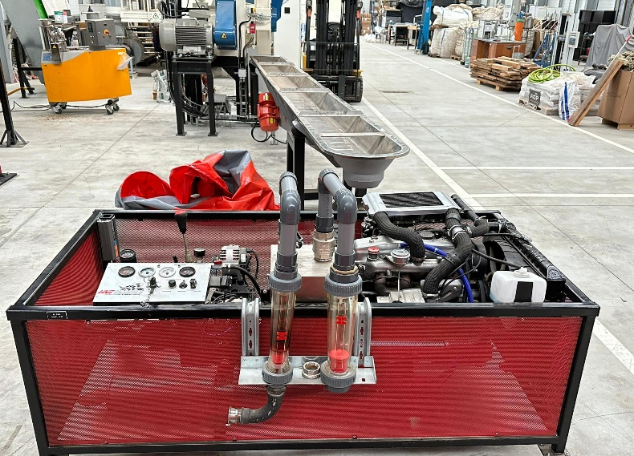
Figure 1. Dual Diesel Fuel Engine at IPPortalegre’s facilities.
Recent Publications
- Calado, L., Panizio, R., Assis, A., Nobre, C., Alves, O., Lourinho, G., Brito, P. "Pre-Feasibility Study of a Multi-Product Biorefinery for the Production of Essential Oils and Biomethane". C (2022): https://doi.org/10.3390/c9010002.
- Santos, S., Assis, A., Gomes, L., Nobre, C., Brito, P. "Waste Gasification Technologies: A Brief Overview". Waste (2022): https://www.mdpi.com/2813-0391/1/1/11.
- Alves, O., Calado, L., Panizio, R., Nobre, C., Monteiro, E., Brito, P., Gonçalves, M. "Gasification of Solid Recovered Fuels with Variable Fractions of Polymeric Materials". Energies (2022): https://doi.org/10.3390/en15218139.~
- Panizio, R., Hermoso-Orzáez, M., Calado, L., Calado, H., Goncalves, M., Brito, P. “Co-carbonization of a mixture of waste insulation electric cables (WIEC) and lignocellulosic waste, for the removal of chlorine: Biochar properties and their behaviors.” Fuel, 320 (2022). https://doi:10.1016/j.fuel.2022.123932
- Lozano-Miralles, J., Hermoso-Orzáes, M., Brito, P. "LCA Streetlight Study for Circular Economic to Local Scale". Proceedings (2021): 10.3390/proceedings2020052006

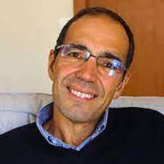 Biography
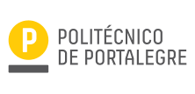
Paulo Brito has a degree in Chemical Engineering (IST, Portugal), a MSc in Corrosion Science and Engineering (UMIST, UK), an MBA (INDEGISCTE) and a PhD in Chemical Engineering focused on Electrochemistry (IST, Portugal). He is a Coordinating Professor with Tenure and Aggregation at IPPortalegre’s Technology and Management School (ESTG), and coordinates VALORIZA (Research Center for Endogenous Resource Valorization). His main research interests are related with bioenergy, waste management and thermochemical valorization, materials’ corrosion, galvanic energy production, and production of renewable gases (hydrogen and methane) from thermochemical processes. He has published more than 200 works in papers, books, and proceedings (http://orcid.org/0000-0002-2581-4460).
Email: pbrito@ipportalegre.pt

Presenting author details
Full name: Paulo Sérgio Duque de Brito
Contact number: n.a.
Twitter account: n.a.
Linked In account:n.a.
Session name/ number: Track 5 – Biomass feedstocks for renewable energy generation
Category: (Oral presentation/ Poster presentation): Oral presentation

