Potential of acorn wastes as feedstock for thermal gasification
Luís Calado¹, Catarina Nobre¹, Paulo Brito¹

¹VALORIZA – Research Centre for Endogenous Resource Valorization, Polytechnic Institute of Portalegre, Campus Politécnico 11, 7300-555 Portalegre, Portugal.

Abstract

Acorns are very abundant in Europe, where they are mostly used for animal feed or left behind in the fields. In Portugal, 55% of the acorns (especially in the North and Alentejo regions) are wasted. Of the average annual production of 400,000 tons per year, about 84,000 tons are used for fattening pigs. Due to their physical-chemical composition and relative abundance, acorn wastes are a very interesting feedstock to use in energy recovery technologies, particularly thermal conversion processes aiming at producing renewable gases (e.g., hydrogen).

The present study aimed to investigate the gasification potential of acorn wastes. Firstly, the acorn wastes were cleaned in a mechanical process using sieves and dried in a rotary dryer. These processes made it possible to remove the acorn husk and separate the crumb from the by-products (acorn husks, lignocellulosic components, and leaves) through their density. The drying process reduced 25 wt.% moisture content from the feedstock. Acorn wastes were then characterized (ultimate and thermogravimetric analysis) and subjected to gasification (600, 650 and 700 °C) to understand the influence of temperature on syngas quality, namely in H2 production. The results showed that increasing temperature increases the syngas heating value from 5.2 to 5.6 MJ/m3. The H2 concentration also increased from 15.5 to 17.6 vol.%. The highest cold gas efficiency (CGE) was obtained at the highest testing temperature with a value of 68,5 %. Overall, these tests indicate that acorn wastes can be used as feedstock in gasification, yielding considerable amounts of H2. Further testing varying other operational parameters (e.g, feeding rate, ER) is still needed to validate this approach, as well as a techno-economic assessment to study the feasibility of these wastes in syngas and subsequent H₂ production.

Acknowledgments: This research was funded by Fundação para a Ciência e a Tecnologia, I.P. (Portuguese Foundation for Science and Technology) under the project UIDB/05064/2020 (VALORIZA – Research Centre for Endogenous Resource Valorization) and project Landfood funded by Fundacíon La Caixa, call Promove PV20-00050.
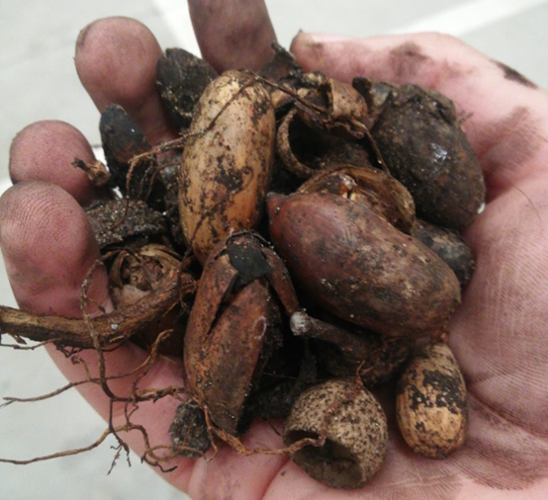
Figure 1. Acorn wastes used in this work.
Recent Publications

- Calado, L., Panizio, R., Assis, A., Nobre, C., Alves, O., Lourinho, G., Brito, P. "Pre-Feasibility Study of a Multi-Product Biorefinery for the Production of Essential Oils and Biomethane". C (2022): https://doi.org/10.3390/c9010002.
- Santos, S., Assis, A., Gomes, L., Nobre, C., Brito, P. "Waste Gasification Technologies: A Brief Overview". Waste (2022): https://www.mdpi.com/2813-0391/1/1/11.
- Alves, O., Calado, L., Panizio, R., Nobre, C., Monteiro, E., Brito, P., Gonçalves, M. "Gasification of Solid Recovered Fuels with Variable Fractions of Polymeric Materials". Energies (2022): https://doi.org/10.3390/en15218139.~
- Alves, O., Garcia, B., Rijo, B., Lourinho, G., Nobre, C. "Market Opportunities in Portugal for the Water-and-Waste Sector Using Sludge Gasification". Energies 15 6600 (2022): https://doi.org/10.3390/en15186600
- Longo, A., Nobre, C., Sen, A., Panizio, R., Brito, Paulo, P., Gonçalves, M. "Torrefaction Upgrading of Heterogenous Wastes Containing Cork and Chlorinated Polymers". Environments 9 99 (2022): https://doi.org/10.3390/environments9080099.

 Biography
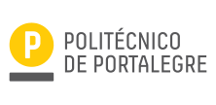
Catarina Nobre is an auxiliary researcher at VALORIZA@IPPortalegre. She has a degree in Biochemistry (FCT-UAlg), a MSc in Energy and Bioenergy (FCT-NOVA), and a PhD in Energy and Bioenergy (FCT-NOVA). Her main research interests focus on thermochemical conversion processes applied to lignocellulosic biomass waste, municipal solid waste and waste-derived fuels, production of liquid biofuels, and more recently, in the production of renewable gases (hydrogen and biomethane). As a result of her research activities, she has contributed to about 60 publications, including scientific articles, book chapters, conference papers, theses, abstracts, and posters (more details at http://orcid.org/0000-0001-5733-902X).
Email: catarina.nobre@ipportalegre.pt

Presenting author details
Full name: Catarina Pereira Nobre
Contact number: n.a.
Twitter account: n.a.
Linked In account: https://www.linkedin.com/in/catarina-nobre-5027655b/
Session name/ number: Track 5 – Biomass feedstocks for renewable energy generation
Category: (Oral presentation/ Poster presentation): Oral presentation

