Visualisation of unconjugated bilirubin in the brain based on CEST magnetic resonance imaging
Lin Yang, PhD, Department of Radiology, The Second Affiliated Hospital, Shantou University Medical College, Shantou 515041, Guangdong, China.
Yan Lin, PhD, Department of Radiology, The Second Affiliated Hospital, Shantou University Medical College, Shantou 515041, Guangdong, China.
Renhua Wu, PhD, Department of Radiology, The Second Affiliated Hospital, Shantou University Medical College, Shantou 515041, Guangdong, China.

Abstract (300 word limit)

Currently, no medical imaging is available for in vivo bilirubin detection. We developed a method for non-invasive imaging of unconjugated bilirubin in the brain based on chemical exchange saturation transfer imaging (CEST) magnetic resonance imaging, which allows visualisation of the distribution of unconjugated bilirubin by proton exchange between imino and bulk water, which we named Bilirubin CEST imaging (Bil-CEST). We first optimized the imaging parameters for Bil-CEST. In vitro images of bilirubin solutions with different concentrations and pH and other brain metabolites (glutamate, γ-aminobutyric acid, glucose and creatine) were collected to investigate the imaging characteristics and specificity of Bil-CEST, respectively. T1WI, T2WI and Bil-CEST maps of the rat brain were collected at baseline and dynamically after injection of the bilirubin solution or vehicle into the lateral ventricles of SD rats. Finally, the model was validated by a water maze and pathological staining. In vitro, the Bil-CEST effect was observed at approximately 5.5 ppm downfield from bulk water, this effect increased with an increase in the B1 amplitude and decreased after the B1 amplitude reached 6.0 μT; and the effects were proportional to bilirubin concentration. In vivo, Bil-CEST imaging showed a progressive enhancement after lateral ventricular injection of bilirubin, with changes significantly earlier than T1WI and T2WI. In contrast, no significant imaging changes were seen in the vehicle group. Bil-CEST makes it possible to image bilirubin directly. Our findings suggest that Bil-CEST has the potential to be a clinically valuable and cost-effective biomarker for early diagnosis and treatment assessment of bilirubin encephalopathy.
Image
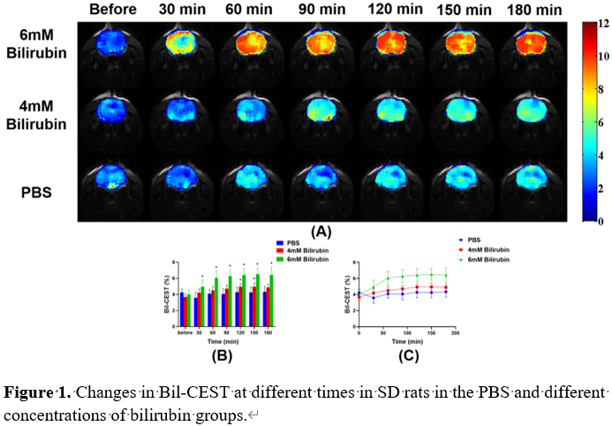
Recent Publications (minimum 5)
- Huang H (2017) Bilirubin neurotoxicity is associated with proteasome inhibition. Cell Death Dis 8(6):e2877.
- Walker-Samuel S (2013) In vivo imaging of glucose uptake and metabolism in tumors. Nat Med 19(8):1067-72.
- Cai K, Haris M, Singh A (2012) Magnetic resonance imaging of glutamate. Nat Med 18(2):302-6.
- Chen H, Liang L, Xu H (2020) Short Term Exposure to Bilirubin Induces Encephalopathy Similar to Alzheimer's Disease in Late Life. J Alzheimers Dis 73(1):277-295.
- Qaisiya M, Brischetto C, Jašprová J (2017) Bilirubin-induced ER stress contributes to the inflammatory response and apoptosis in neuronal cells. Arch Toxicol 91(4):1847-1858.


Biography (150 word limit)
Lin Yang received the M.M. degree in Medical Imaging and Nuclear Medicine from Shantou University Medical College, China, in 2022. She is currently working toward the M.D. degree in the Department of Radiology at Shantou University Medical College, China. Her research interests include magnetic resonance imaging and spectroscopy, diffusion kurtosis imaging, and Quantitative susceptibility mapping.
Email: yanglin2019fuer@163.com

Notes/Comments:
Presenting author details
Full name: Lin Yang
Contact number: 86 754 88915674
Linked In account:
Session name/ number:
Category: Oral presentation

