Biodiversity and Citizenship in an Argumentative Socioscientific Process
Anne Caroline de Freitas *; Larissa Aine do Nascimento; Rafael Gil de Castro; Marcelo Tadeu Mitotane; Pedro Reis
University of São Paulo Interunit Graduate Program in Sciences Teaching, Brazil

Abstract
Statement of the problem: Socio-environmental issues become evident in countries with megadiversity. Brazil finds itself in this context, adding to the fact that it has severe socioeconomic inequalities, of which we highlight the lack of environmental justice (1). Institutions that aim to raise awareness of biodiversity management are at the center of discussions about the importance of citizenship in this, since these are of great importance in creating more sustainable interactions with the environment (2). Among these institutions, the school stands out (3). However, studies point out that little of this relationship among topics is effectively applied in pedagogical practice (4). Although there are curricular proposals aimed at critical citizenship, many didactic actions end up in content and technical proposals (5). The aim is to identify concepts of biodiversity and citizenship present in arguments developed by high school students in a socioscientific discussion.

Methodology & theoretical orientation: The research participants were nine students from a rural and public school in Brazil. We designed and implemented a Focus Group on the disappearance of bees and its consequences. The participants’ speeches were structured in arguments and analyzed from categories regarding the dimensions of citizenship and biodiversity.
Findings: We identified the relationship among all categories in the arguments listed. It was possible to observe that the students positioned themselves in the argumentative process, and, in addition, they traced relationships between the concept of biodiversity and the concept of citizenship (Figure 1).
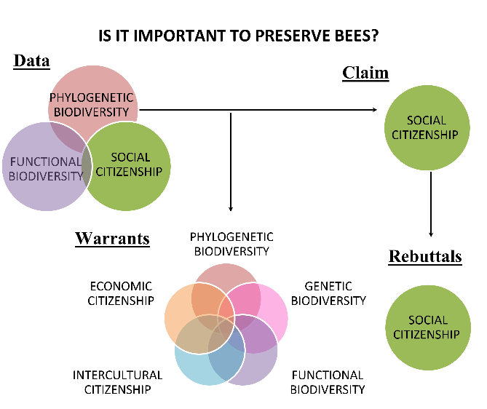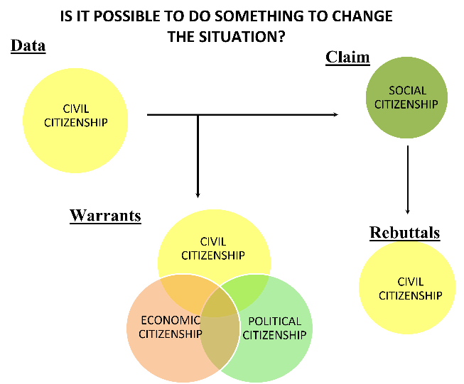

Figure 1. Main arguments made by the students.
Conclusion: However, we observed that these students are not full citizens since they identify several obstacles to active participation in social transformation actions. The results corroborate researches that defend argumentation on socioscientific issues as a tool to recognize and discuss domains of the exercise of citizenship. When students understand the biological and social aspects involved, as well as actions to change, they feel a sense of belonging and then consciously participate in the practices and decision-making that involve these issues. Thus, limiting scientific teaching to concepts unrelated to an evident and purposeful socioscientific discussion is insufficient if the objective is education for citizenship based on presuppositions of environmental justice.
References
- Joly C., et al. Contribuições Para o Diálogo Intersetorial: A Construção do Diagnóstico Brasileiro Sobre Biodiversidade e Serviços Ecossistêmicos. 2016. Available online: https://www.bpbes.net.br/wp-content/uploads/2018/08/Dialogos_BPBES.pdf (accessed on 16 January 2022).
- Wyborn, C., et al. An agenda for research and action toward diverse and just futures for life on Earth. Consersation Biology. 2021, 35, 1086–1097.
- Reis, P. Environmental Citizenship & Youth Activism. In Conceptualizing Environmental Citizenship for 21st Century Education Series “Environmental Discourses in Science Education”; Hadjichambis, A.C., Reis, P., Paraskeva-Hadjichambi, D., Čincera, J., Pauw, J.B.-D., Gericke, N., Knippels, M.-C., Eds.; Springer: Cham, Switzerland, 2020; pp. 139–148.
- Levinson, R. Science education and democratic participation: An uneasy congruence? Stud. Sci. Educ. 2010, 46, 69–119.
- Déjardin, I. P. Cidadania em uma perspectiva multidimensional: Diálogos contemporâneos. Rev. Direito Ambient. E Soc. 2019, 2, 215–247.

Biography
PhD student in Science/Biology Teaching at the University of São Paulo (USP). Master in Science/Biology Teaching from USP; Degree and Bachelor in Biological Sciences from USP. MBA in School Management by ESALQ-USP; Pedagogue from the University of Franca (UNIFRAN). Participates in the actions of the extension and research project Cajuí: co-production, sustainability, and education for biodiversity; Participated as a scholarship holder in the Teaching Initiation Program (PIBID). He was a member of the entity Enactus Brasil FEA-USP-RP, responsible for Environmental Education activities. His study interests are: teaching for citizenship; biodiversity education; co-production of knowledge; traditional socio-environmental knowledge; biology/science teaching; inquiry-based teaching; environmental education; argumentation; teacher training.

