Predictors of microalbuminuria and its relationship with glycemic control among Type 2 diabetic patients of Jazan Armed Forces Hospital, southwestern Saudi Arabia
Hassan Ali Abdelwahid, Jazan Armed Forces Hospital, KSA
Hesham Mohamed Dahlan, Jazan Armed Forces Hospital, KSA
Gassem Maoudhah Mojemamy, Jazan Armed Forces Hospital, KSA
Gasem Hussein Darraj, Jazan Armed Forces Hospital, KSA

Statement of the Problem: Diabetic kidney disease (DKD) is highly prevalent among patients with diabetes mellitus. It affects approximately 20% of diabetic patients, who are believed to be more than 400 million individuals. The objectives of the present work were to assess patterns of albuminuria and determine microalbuminuria predictors among patients living with type 2 diabetes (T2D) who attended the family medicine department of Jazan Armed Forces Hospital.
Methodology: A case-control design was used and included two groups (n, 202/group), one with microalbuminuria and the other with a normal urine albumin/creatinine ratio (ACR). Data regarding patient history, glycosylated hemoglobin (HbA1c), lipid profile, renal function tests, ACR, ASCVD (atherosclerotic cardiovascular disease) risk, etc., were collected.
Findings: The prevalence rates of microalbuminuria and macroalbuminuria were 26.4% and 3.9%, respectively. HbA1c was significantly higher in patients with microalbuminuria (9.3 ±2.2; P˂0.001) and macroalbuminuria (10.5±2.3; P˂0.001) than in those with normal ACR (8.3 ±1.9%). The predictors of microalbuminuria were poor glycemic control with HbA1c ≥ 7% {OR, 2.5 (95% C. I, 1.5-4.2)}; hypertension {(OR, 1.8 (95% C. I, 1.2-2.8)}; estimated glomerular filtration rate (eGFR) of ˂90 mL/min/1.73 m2 {OR, 2.2 (95% C. I, 1.4-3.6}; smoking {OR, 1.3 (95% C. I, 0.7-2.6}; and body mass index {OR, 1.05 (95% C. I, 1.01-1.09}.
Conclusion: Microalbuminuria is highly prevalent among patients with type 2 diabetes and is associated with poor glycemic control and hypertension, necessitating aggressive and timely screening and treatment.

Image
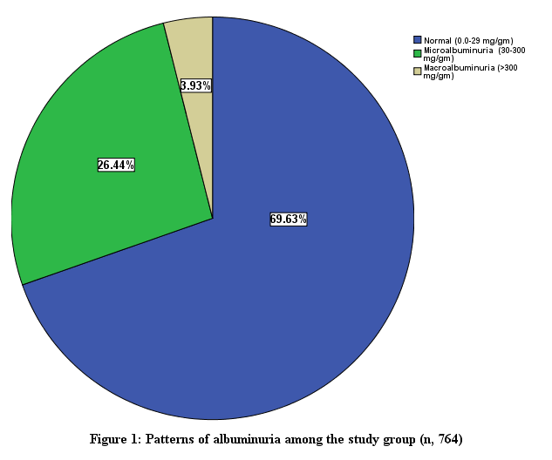
Recent Publications (minimum 5)
- Abdelwahid HA, Dahlan HM, Mojemamy GM, Darraj GH. Predictors of microalbuminuria and its relationship with glycemic control among Type 2 diabetic patients of Jazan Armed Forces Hospital, southwestern Saudi Arabia. BMC Endocr Disord. 2022 Dec 8;22(1):307. doi: 10.1186/s12902-022-01232-y. PMID: 36482350; PMCID: PMC9733223..
- Abdelwahid, Hassan A.; Erwi, Saud M.; Alahmari, Firas S.; Ibrahim, Amani A. K.; Dahlan, Hesham M. Pattern and predictors of glycemic control among type 2 diabetics in Armed Forces Hospital of Jizan, southwestern Saudi Arabia. Middle East Journal of Family Medicine . 2017, 15 (1), 14-22.

- Abdelwahid HA, Zekry OA (2012) The Role of Multiple Micronutrients in Treatment of Iron Deficient Anemic Children. Family Med Medical Sci Res 1:102. doi:10.4172/2327-4972.1000102.

Biography (150 word limit)

Doctor Hesham Mohamed Dahlan, Consultant and head of Family Medicine, Jazan Armed Forces Hospital (JAFH), Saudi Arabia. Dr. He is interested in management of chronic diseases, Obesity, Epidemiology, Health education, research and adult learning. Doctor Hesham is a member of Institutional Research Board of JAFH. He is certified with Saudi and Arab Boards in family medicine.
Email: dr.dahlan@gmail.com

Notes/Comments:

Presenting author details
Full name: Hesham Mohamed Dahlan
Contact number: 00966556007447
Twitter account:
Linked In account:
Session name/ number: Innovating nursing through research and practice
Category: (Oral presentation)

