Improvements in the Integrated Disease Surveillance and Response (IDSR) system for malaria surveillance in mainland Tanzania,2013-2021

Joseph J. Joseph, Akros, Tanzania

Abstract (300 word limit)
Tanzania has made remarkable progress in reducing malaria burden and aims to transition from malaria control to sub-national elimination. In 2013, electronic weekly and monthly reporting systems using the District Health Information System-2 were introduced. Weekly reporting was implemented through the Integrated Disease Surveillance and Response (eIDSR) system using mobile phones and progressively scaled-up from 67 health facilities (HFs) in 2013 to >7,000 HFs (100%) by 2020. This study aimed to describe the implementation of eIDSR and compare the accuracy of malaria indicators between weekly and monthly data to ascertain its usefulness for malaria outbreak detection. The indicators included were number of patients tested for malaria, number of confirmed malaria cases, and number treated presumptively for malaria (clinical cases). The analysis described the trend of reporting, testing, test positivity, and incidence per 1000 population. Comparisons of weekly and monthly reporting rates and incidence were performed for 2020 and 2021 and were stratified by malaria epidemiological strata (parasite prevalence: very low <1%, low 1≤5 %, moderate 5≤30%, and high >30%). Between 2020 and 2021, overall weekly reporting rates increased from 90.2% to 93.9%, while monthly reporting rates were 98.9% in 2020 and 98.7% in 2021. Confirmed malaria incidence from weekly data was 87.0 per 1000, which was 17.5% lower than monthly data in 2020, and 66.3 per 1000, which was 12.4% lower in 2021. For 2020 and 2021, incidences were the same across weekly and monthly data in the very low strata. Weekly reporting improved steadily over time, while reporting rates and malaria incidence were lower compared to monthly. Nonetheless, the concurrence of weekly and monthly annual reporting rates and incidence in very low strata suggests that eIDSR could be useful for early outbreak detection, and could reliably be expanded for CBS in very low epidemiological strata.

Image
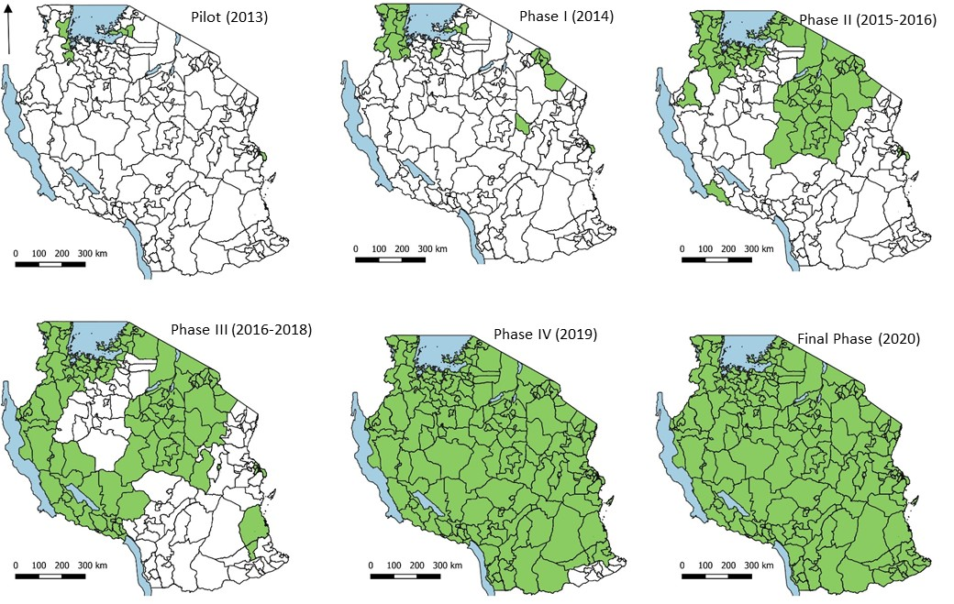
Figure 1:Phases of eIDSR scale-up in mainland Tanzania, 2013 to January 2020
Recent Publications (minimum 5)
- Joseph, J.J., Mkali, H.R., Reaves, E.J. et al. Improvements in malaria surveillance through the electronic Integrated Disease Surveillance and Response (eIDSR) system in mainland Tanzania, 2013–2021. Malar J 21, 321 (2022). https://doi.org/10.1186/s12936-022-04353-w
- Mkali, H.R., Reaves, E.J., Lalji, S.M. et al. Risk factors associated with malaria infection identified through reactive case detection in Zanzibar, 2012–2019. Malar J 20, 485 (2021).https://doi.org/10.1186/s12936-021-04025-1
- Bisanzio, D., Lalji, S., Mkali, H. R., Al-mafazy , A-W., Joseph, J. J., et l (2021). Spatio-temporal dynamics of malaria in Zanzibar. American Journal of Tropical Medicine and Hygiene, 105(5), 212.

 Biography (150-word limit)
Joseph J. Joseph, BSc, MSc has expertise in disease surveillance, monitoring and evaluation and a passion to improve health and well-being. He currently works for Akros as Senior Data Scientist (SDS), supporting the National Malaria Control Programme in Tanzania. He primarily focusses on improving the malaria surveillance system, improving the quality and use of data for decision making. He provides support in digitizing the micro-stratification framework, linking to Health Management Information System (HMIS)/District Health Information System (DHIS2). He facilitated the implementation of malaria case-based surveillance in Zanzibar and parts of mainland Tanzania. Joseph is part of core team who implemented the DHIS2 and other health information systems in Tanzania such as Health Facility registry (HFR).

Email: jjjkimaro90@gmail.com

Notes/Comments:

Presenting author details
Full name: Joseph Joachim Joseph
Contact number: +255756 713 713 / WhatsApp: +255 788442657
Twitter account: sir_jozeh
Linked In account: Joseph Joachim Joseph
Session name/ number:
Category: (Oral presentation/ Poster presentation)

