THE ENDOSCOPIC COMBO TECHNIQUE: Long-term outcomes in treating patients with primary achalasia
Bedewy E ¹, El Gendi A ², Kamel M ³
¹ Tropical medicine Department, Faculty of Medicine, Alexandria University, Egypt, ² General surgery Department, Faculty of Medicine, Alexandria University, Egypt, ³ General surgery department, Medical Research Institute, Alexandria University, Egypt
Department(s) and institution(s)
¹ Tropical Medicine Department, Faculty of Medicine, Alexandria University, Egypt; ² Pathology Department, Faculty of Medicine, Alexandria University, Egypt;³ Alexandria Fever hospital, Alexandria, Egypt;
Addresses: Al Kartoum Square, Al Azarita, Tropical Medicine and Hygiene Department, Faculty of medicine, Alexandria, Egypt, PO: 21526

Running title: POSSIBLE PREDICTIVE VALUE OF EP-CAM EXPRESSION FOR DEVELOPMENT OF HCC IN CHRONIC HCV INDUCED CIRRHOSIS

Contributors

Assistant Professor/ Essam Bedewy
Assistant Professor, Tropical Medicine Department, Faculty of Medicine, University of Alexandria, Egypt
Email: essambedewy75@gmail.com
Phone: +201100771111

Professor/ Ahmed El Gendi
Professor, General surgery Department, Faculty of Medicine, University of Alexandria, Egypt
Email: draelgendi@gmail.com

Assistant Professor/ Mohamed Kamel
Professor, General Surgery Department, Medical research Institute, University of Alexandria, Egypt
Email: mohamedsamir12@yahoo.com

Corresponding Author:
Ass. Professor/ Essam Bedewy
Assistant Professor, Tropical Medicine Department, Faculty of Medicine, University of Alexandria, Egypt
Address: Al Kartoum Square, Al Azarita, Tropical Medicine and Hygiene Department, Faculty of medicine, Alexandria, Egypt, PO: 21526
Email: essambedewy75@gmail.com
Phone: +201100771111

Conflict of interest and funding: Non

Introduction:
Achalasia is a primary esophageal motility disorder characterized by the absence of esophageal peristalsis and impaired relaxation of the lower esophageal sphincter (LES) in response to swallowing. The annual incidence of achalasia is approximately 1.6 per 100,000 individuals worldwide and prevalence of 10 cases per 100,000 individuals. Patients present usually with progressive dysphagia to solids and liquids, regurgitation, heart burn, chest pain and weight loss. High resolution Manometry (HRM) is the gold standard test for diagnosis while upper esophagogastroduodenoscopy (EGD) is necessary to rule out tumors of the GEJ or fundus mimicking achalasia. ⁽¹⁾
Initial therapy is either graded pneumatic dilation (PD) or laparoscopic surgical myotomy with partial fundoplication in patients fit for surgery, endoscopic intra-sphincteric Botulinum toxin injection is recommended for patients not candidates for PD or surgery ⁽²⁾. Peroral endoscopic myotomy (POEM) could become an alternative to surgical myotomy because of the potential advantages when compared to Heller myotomy as it minimizes the postoperative pain, longer myotomy could be done, anti-reflux surgery is rarely needed because it is done without dissection at the level of GEJ and shorter hospitalization period ⁽³⁾. However, it is a very demanding procedure having a long learning curve, a very skilled endoscopist is required and surgical revision in recurrent dysphagia could be really challenging due to the adhesions between the sub mucosal and longitudinal muscular layers. ⁽³⁾
The combined injection of Botulinum toxin combined with pneumatic dilation wasn’t thoroughly investigated in the literature, however the studied conducted regarding this technique recommended its usage and its superiority over the monotherapy procedure.
Aim:
Evaluating combined single step endoscopic procedure of Botulinum toxin injection, pneumatic dilation and mechanical dilation by retroflexed scope (COMBO) as a suggested effective treatment for achalasia
Patients and Methods:
The study included 44 Egyptian patients suffering from achalasia of the cardia (AC). Diagnosis of AC was suspected by history taking, clinical manifestation mainly dysphagia to liquids and solids, regurgitation, choking sensation and loss of weight, confirmation was followed by Radiology in the form of Barium oral swallow and Confirmatory CT Contrast with esophageal study was done only if needed to exclude any suspected esophageal stricture (only in 2 patients and was confirmed to be Achalasia).
All patients included in this study will receive a medical treatment in the form of nitroglycerine at least for 3 weeks and those who will not show improvement to medical treatment, will be subjected to COMBO method.
The suggested COMBO technique is done in single endoscopic setting three-steps procedure:
- Injection of 100 Units Botulinum toxin type A (Botox-Allergan), 25 units circumferentially in anterior, posterior and lateral esophageal wall. (Figure 1 & 2)
- Wait about 1-2min and pass the scope to the stomach and then graded dilatation using Achalasia balloon over guide wire starting from 35 mm to be followed 3 min later by 40 mm balloon dilation, time of inflation should not less than 1 min. (Figure 3 & 4)
- Inspecting the cardia carefully after balloon dilatation then retroflexion of the scope and inspecting the cardia and rinse it thoroughly with water then approaching the cardia carefully with the scope retro-flexed with right axis deviation by using the right –left knop of the scope and trying to gently insinuate the scope to the esophagus through the cardia but only 2/3 of the retroflexed portion (the maximum circumference of the semi-circular part) of the scope and not the entire endoscopic shaft so the semi-circular portion of the retroflexed part is kept dilating the cardia for about 30 seconds with rotating the scope in a gentle way 180 ºC gently during this period using hand and body rotation to rotate the scope and repeat it at least three time. (The action is not allowed if there is a difficulty insinuating the retroflexed scope through the cardia). (Figure 5 & 6)
Finally good endoscopic inspection of the dilated lower esophageal sphincter must be done for detecting any complications mainly bleeding or perforation, so we recommended better rinsing with methylene blue to exclude any area of perforation that was done for all cases after dilatation. (Figure 7,8,9)
All patients post-endoscopically were discharged after 2 hours observation, allowed for clear fluid drinking after 4 hours for 24 hours then semisolid fluid for the next 48 hours and then normal eating but avoiding spicy or fatty meal for at least one month.
Topical fluticasone 2 puff on ½ glass of water twice daily one hour before breakfast & before sleep for 2 months then twice weekly, and continue on Nitroglycerine 2.5 mg twice daily for rest of their life with rifaximin 550 mg once daily.
Results:
All included patients were naïve patients without previous endoscopic or surgical treatment for AC, except one case was complicated Post Heller laparoscopic myotomy which was done 15 years ago and encountered uncontrolled operative bleeding and controlled intra-operatively, 6 months later she developed severe dysphagia more to solid but also to fluids and CT with barium study revealed severe lower iatrogenic esophageal stricture, this stricture was very tight and multiple endoscopic sessions failed to pass the scope beyond the stricture except after pneumatic dilatation reaching up to 20 mm by CRE balloon. However the condition was recurrent within few days from the dilatation without any improvement and surgical consultation recommended repeated dilatation sessions, as the risk of operation was high and for surgical difficulty of the procedure.
All patients received medical treatment for Achalasia before proceeding to COMBO in the form of nitroglycerine at least for 3 weeks and COMBO was used for those who did not show significant improvement of medical treatment
44 patients showed no improvement to medical treatment out of 53 patients and those who were subjected to COMBO endoscopic method to treat achalasia.
The Combo endoscopic method showed a very good and satisfactory response in 42/44 of patients (response rate 95.5%) form the first session with a follow up period ranging from at least 48 weeks to maximum of 240 weeks.
All Patients showed significant improvement of almost all the clinical symptoms especially dysphagia, regurgitation, choking, loss of weight and postprandial vomiting even the patient who experienced iatrogenic post Heller myotomy (follow up 50 weeks), 8/44 (18.1%) patients still experienced infrequent non-annoying dysphagia, 12/44 (27.2%) suffered intermittent heart burn and mild regurge. (Table A)
No complications were reported during or after the procedure as perforation or bleeding.
The age of the patients included in this study was ranging from 16 years to 81 years (Mean= 48.5, SD= 45.96), regarding sex, 39 patients were male and 5 patients were female (mean=22, SD=17), Follow up period ranged from 240 weeks – 48 weeks (mean=144, SD= 135.7), (Table 2), five years Follow up was encountered in 26/44 (59%), 10/44 patients (22.7%) encountered four years follow up period, three years follow up was 3/44 (6.8%), whereas as a follow up of at least 48 weeks was for 5/44 patients (11.3%).
The most common associated comorbidities among the studied patients were diabetes mellitus 7/44 (15.9%), ischemic heart diseases 16/44 (36.3%), these comorbidities didn’t influence the response for the treatment.
One male patient aged 45 years old without associated comorbidities showed mild recurrence of dysphagia and vomiting 96 weeks from COMBO procedure and follow up CT barium swallow documented ease flow of barium and endoscopy was passed with minimal resistance and was subjected to only Retro-flexed scope endoscopic dilatation and showed no recurrence till now (40 weeks)
Only one patient did not experienced any significant improvement to the procedure and recurrence was 14 days after the procedure, but the most noted observation that this patient was the youngest patient included in this study (16 years old) and referred to surgery after Manometry that showed it is type 3 Achalasia, which is the type frequently encountering resistance to the treatment.
Discussion:
The novel steps in this study was the add on of a novel step of mechanical dilatation with relatively larger diameter retroflexed scope, which offers more mechanical tension of the esophageal smooth muscle and hence more tearing effects, resulting in a very satisfactory dilatation with response rate almost reaching 95%, especially if it is done in the same endoscopic setting (combined by injection and dilatation) versus sequential (injection followed by dilatation in another setting or as mono-endoscopic procedure.
The novel technique for using the cardia stretching by retroflexed scope after Botulinum and dilatation technique showed promising effects as the rigid stretchy and relatively larger diameter force dilatation cause effective tearing of circular esophageal smooth muscle fibers and followed by maintaining this endoscopic dilatation by medical treatment in the form of nitroglycerine twice daily resulted in good therapeutic results with a relatively long follow up period.
Studying the combined effect of both injection and balloon dilation to so somewhat was not thoroughly evaluated in the literature. Zhu et al ⁽⁴⁾ in 2010 conducted a clinical study on this combination endoscopic therapy and found that efficiency of the combined Botulinum administration and small balloon dilation is superior to the single modality approach ⁽⁴⁾, these findings are in accordance with the results in this study. The difference between both studies were that although the number of this study was about half the patient of Zhu study, but the follow up in this study was for 5 years and minimum period 48 weeks but in Zhu study, it was only 2 years duration, with response rate reaching about 95.4% compared to 56.6 % in the Zhu study. ⁽⁴⁾ In addition the way of the endoscopic handling was quite different, as in this work we did the procedure as a single 3 step wise procedure while in Zhu et al study, the sequential way was applied by injecting Botulinum followed 15 days later by small sized balloon dilation not like this study where 40 mm balloon dilatation was done followed by mechanical retroflexed scope dilatation.
Also Kroupa et al ⁽⁵⁾, showed the significance of the combined injection and dilatation for treating AC patients with a number of patient almost the same of the present study with response rate almost 72% and they also used the sequential technique initiated by injection and followed by dilation 8 days later. ⁽⁵⁾
In addition Jameshorani et al ⁽⁶⁾, documented in their study long term efficacy of combined technique i(injection and dilatation) on 196 Iranian patients suffering from achalasia with response rate almost near to this study which was about 90% over a follow up period reaching nine years. ⁽⁶⁾
So Accordingly to these studies which were performed before this study, it seemed that the combined injection of Botulinum with balloon dilatation yielded better response rate among patients suffering from achalasia compared to monotherapy alone and this present work confirmed this significance.
Moreover, the way of treating the patient post endoscopy by medical treatment in the form of nitroglycerine to maintain the response rate of dilatation for a relatively long duration of follow up reaching in some cases 240 weeks. Also keeping in mind that modulation of the role of gut flora by Rifaximin was very beneficial without encountered any drug side effects during the follow up period, this should attract the attention of the importance of gut flora in Achalasia pathogenesis and the exact role should be investigated in future studies. The usage of topical fluticasone after the procedure for at least 4-8 weeks and then sporadically aided significantly to let the patients responded well with long follow up period, probably due to its anti-inflammatory effects.
This encourage us for implementation of this COMBO procedure as future promising endoscopic modalities to treat achalasia either step before PEOM or surgical procedure or at least for those who are not fit for major risky procedure as the complications were almost low and the procedure is safe as it is a one day procedure with short time duration.
Conclusion: COMBO endoscopic technique could be suggested as a novel and effective method for treating achalasia as a stepwise way before proceeding to more risky invasive methods as POEM or surgical procedure or in high risky patients at least.
References:
- Dhyanesh A, Brian M, and Michael F. An Overview of Achalasia and Its Subtypes. Gastroenterol Hepatol (N Y). 2017 Jul; 13(7): 411–421

Dhyanesh A, Hannah P., Jerry S, Michael F. Idiopathic (primary) achalasia: a review. Orphanet J Rare Dis. 2015; 10: 89
- Tantau M, Crisan D. Peroral endoscopic myotomy: Time to change our opinion regarding the treatment of achalasia. World J gastrointest Endosc: 2015 Mar 16; 7(3): 237–246
- Qiang Zhu,Jiyong Liu,Chongmei Yang. Clinical study on combined therapy of botulinum toxin injection and small balloon dilation in patients with esophageal achalasia. Dig Surg. 2009 Feb; 26(6): 493-8.
- R Kroupa, A Hep, V Valek, J Dolina et al. Combined treatment of achalasia—Botulinum toxin injection followed by pneumatic dilatation: Long-term results, September 2009.Diseases of the Esophagus 23(2): 100-5.
- Jameshorani M, Anushiravani A, Fazlollahi N, Amani M, Mikaeli J. Long-Term Ef cacy of Combined Treatment in Idiopathic Achalasia Patients. Japanese journal of gastroenterology and Hepatology, 2019; V2 (3): 1-3.

Figures:

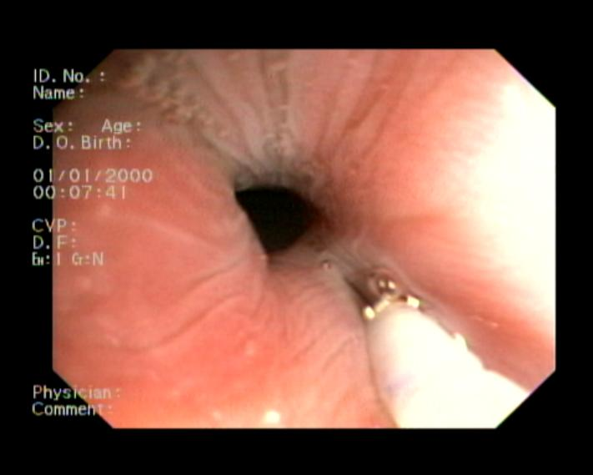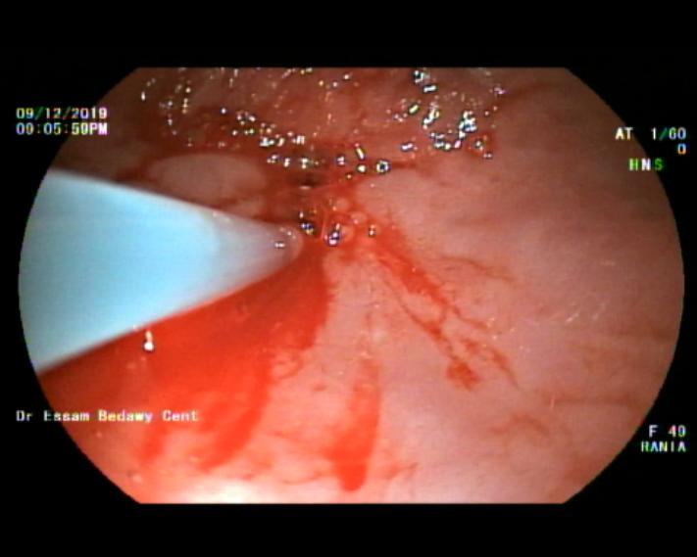

Fig. 1&2: demonstrate injection of 100 units of Botulinum A toxins 25 U in a four quadrant fashion deep in the esophageal muscle (note that there was no sub mucosal elevation denoting deep intramuscular injection)

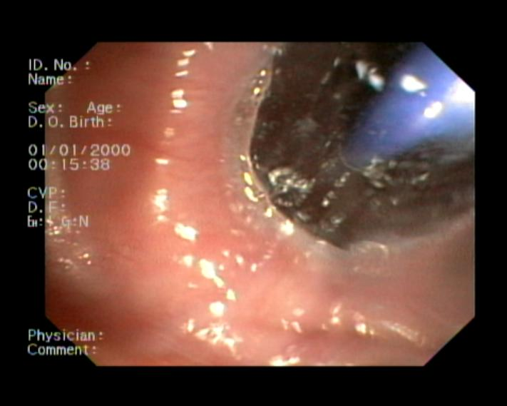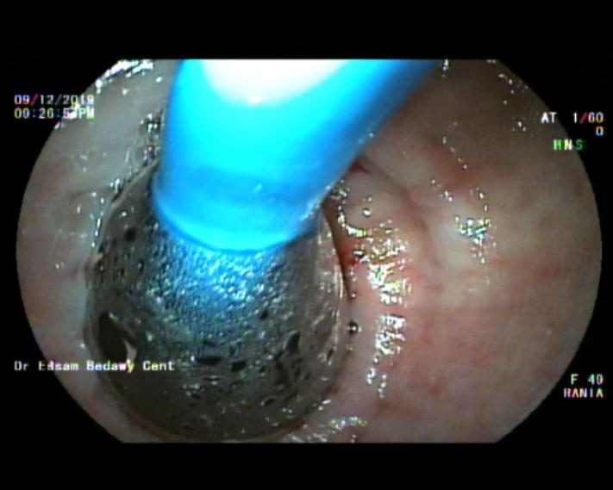

Fig. 3&4: illustrate the second step in COMBO technique that is the dilation procedure by achalasia balloon graded gradually to reach 40 mm diameter

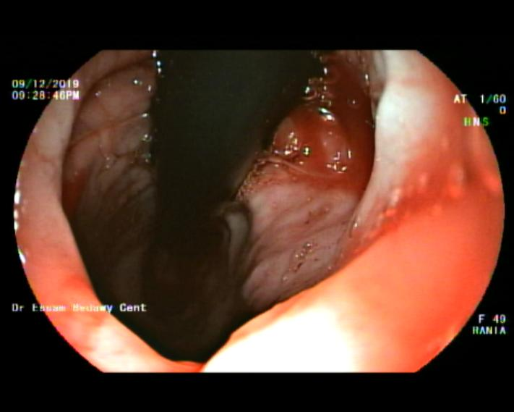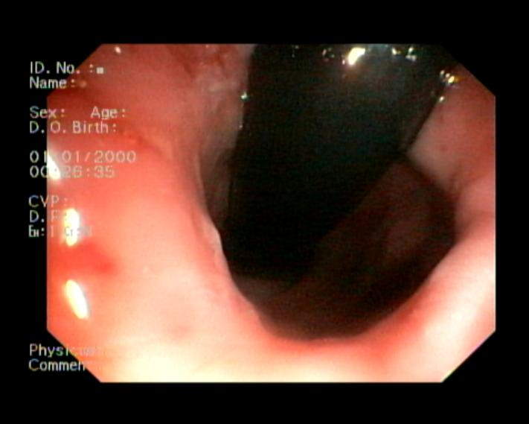

Fig. 5&6: showed the novel third added step in COMBO technique that is mechanical dilation procedure by the rotating the retroflexed scope which is done in 3 cycle sequence each cycle last 30 seconds with 30 seconds between each cycle (note the adequate adjustment of the maximum diameter of the circumference of the C shaped part of the scope without trying not to push the whole c shaped part inside the esophageal lumen)
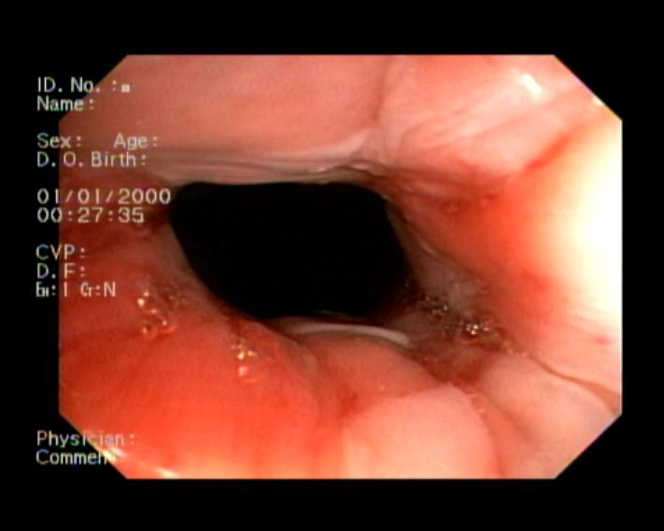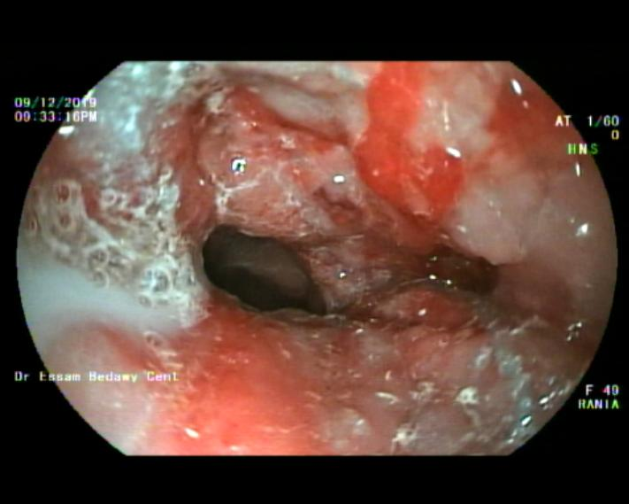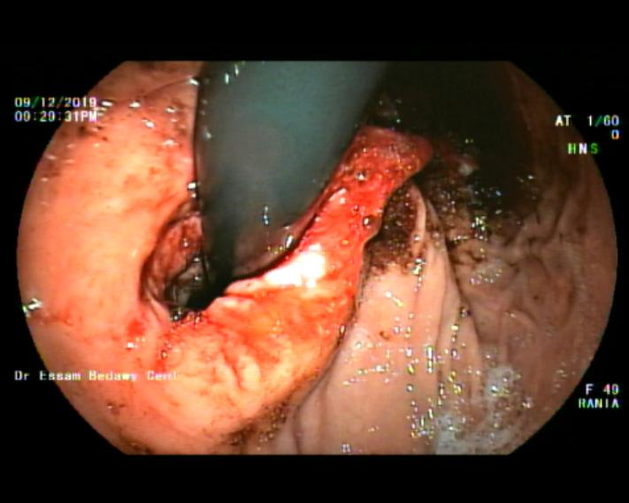

(Fig. 7,8 & 9): illustration of the good dilation of the cardia Post-COMBO (7) -rinsing of the dilated cardia by methylene blue to exclude any site of Post-COMBO perforations (8)- Retroflexion position to ascertain adequate dilatation process with roomy space observed between the scope of the lower esophageal sphincter with checking of any bleeding spot (9).

Tables:

Symptoms | Number of patients  Before COMBO | Number of patients showed full improved  After COMBO | Percentage
Dysphagia | 44 | 36 | 81.8%
Choking sensation | 41 | 41 | 100%
Regurgitations & heart burn | 44 | 32 | 72.7%
Postprandial vomiting | 44 | 44 | 100%
Loss of weight | 44 | 44 | 100%

Table A: showing the number and percentage of the patients treated by COMBO technique before and after the procedure

Variable | Range | Mean | Standard Deviation  SD
Age | 16-81 | 48.5 | 45.9
Sex | 39 male  5 female | 22 | 17
Follow up period | 240weeks-48weeks | 144 | 135.7

Table B: showed the demographic pattern and follow up period of the studied group as regards Age, Sex and follow up period of the study

