Prognostic effect of excessive chemotherapy cycles for stage II and III gastric cancer patients after D2 + gastrectomy
Yi-Fan Li and Wen-Bing Zhang
Shanxi Cancer Hospital, China
Abstract
AIM
To determine whether excessive chemotherapy cycles provide extra survival benefits, reduce recurrence rate, and improve survival rate in patients with stage II or III gastric cancer.
METHODS
We analyzed and summarized 412 patients with stage II gastric cancer and 902 patients with stage III gastric cancer who received D2 gastrectomy plus adjuvant chemotherapy or neoadjuvant chemotherapy. Analysis and comparison at a ratio of 1:1 is aimed at reducing realistic baseline differences (n = 97 in each group of stage II, n = 242 in each group of stage III). Progression-free survival, overall survival and recurrence were the main outcome indicators.
RESULTS
When the propensity score was matched, the baseline features of stage II and III gastric cancer patients were similar between the two groups. After a series of investigations, Kaplan-Meier found that the progression-free survival and overall survival of stage II and III gastric cancer patients were consistent between the two groups. The local metastasis rate (P = 0.002), total recurrence rate (P < 0.001) and distant metastasis rate (P = 0.001) in the ≥ 9 cycle group of stage III gastric cancer were statistically lower than those in the < 9 cycle group. The interaction analysis by Cox proportional hazard regression model showed that intestinal type, proximal gastrectomy, and ≥ 6 cm maximum diameter of tumor had a higher risk of total mortality in the < 9 cycles group.
CONCLUSION
Overall, ≥ 9 chemotherapy cycles is not recommended for patients with stage II and stage III gastric cancer because it has an insignificant role in the prognosis of gastric cancer. However, for patients with stage III gastric cancer, ≥ 9 cycles of chemotherapy was shown to significantly decrease recurrence.

Image
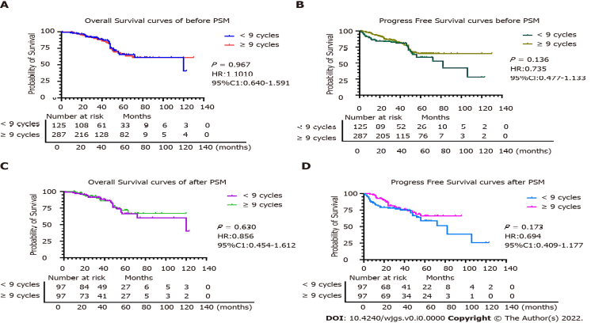
Figure 2 Comparison of overall survival and progression-free survival before and after propensity score matching in stage II gastric
cancer patients. A: Comparison of overall survival between the two groups based on chemotherapy cycles before propensity score matching (PSM); B: Comparison of progression-free survival between the two groups based on chemotherapy cycles before PSM; C and D: Comparison of overall survival (C) and progression-free survival (D) between the two groups based on chemotherapy cycles after PSM.
Recent Publications
1. Li Y, Zhao H. Postoperative recurrence of gastric cancer depends on whether the chemotherapy cycle was more than 9 cycles: Based on a retrospective and observational study of follow-up within 3 years of 843 patients. Medicine (Baltimore). 2022 Feb 4;101(5):e28620.
2. Li Y, Zhang X. Prognostic nomograms for gastric carcinoma after surgery to assist decision-making for postoperative treatment with chemotherapy cycles <9 or chemotherapy cycles ≥9. Front Surg. 2022 Aug 26;9:916483.
3. Li YF, Zhang WB, Gao YY. Prognostic effect of excessive chemotherapy cycles for stage II and III gastric cancer patients after D2 + gastrectomy. World J Gastrointest Surg 2023; 15(1): 32-48.
Biography:
Yi-Fan Li has her expertise in management and passion in improving the prognosis and quality of life of patients of gastric cancer. Member of Shanxi Anti-Cancer Association, Member of China Anti-Cancer Association, Member of gastric Cancer Committee of Chinese Anti-Cancer Association, Member of Targeted Therapy Committee of Chinese Anti-Cancer Association, Member of Precision Therapy Committee of the Chinese Anti-Cancer Association, Member of Liver pathology Committee of Chinese Anti-Cancer Association, Member of the Pancreatic Lesion Committee of the Chinese Anti-Cancer Association, Member of the International Gastric Cancer Association (IGCA), Member of the International Liver Cancer Association (ILCA), Member of the European Society Medical Oncology (ESMO).
Notes/Comments:
The Authors restrospectively evaluated 412 patients in stage II and 902 patient in stage III gastric cancer who underwent D2+gastrectomy plus adjuvant chemotherapy or neo-adjuvant chemotherapy. The aim of this study was to affirm wether excessive chemotherapy cycles have extra survival benefits on stage II-III gastric cancer. The Authors pointed out that intestinal-type, proximal gastrectomy, maximum diameter of tumor (>= 6cm) had higher risk of total mortality in group of chemotherapy cycle >= 9 and disease progression in group of chemotherapy cycles <9. Chemotherapy cycles >= 9 is unnecessary for patients with stage II and III gastric cancer, owing to its insignificant role in prognosis in gastric cancer. Chemotherapy cycles >=9 has a major part to play in avoiding recurrence of patients with stage III, except for the role in stage II. It is a very interesting manuscript. Background, Methods, and Results are good. Discussion sound well. Complete the references.

