Stabilization of elongated polyglutamine tracts by a helical peptide derived from N-terminal huntingtin

Ratnika Sethi, PhD, Ipsita Roy, PhD, National Institute of Pharmaceutical Education and Research, S.A.S. Nagar, Punjab, India

Abstract (300 word limit)

In Huntington's disease, the length of the polyglutamine tract in the mutant protein correlates positively with the formation of aggregates and disease symptoms and severity of the disease. Some disease-modifying factors exist. However, no organized study has been carried out to investigate the effect of polyglutamine length in the mutant protein on the efficacy of a therapeutic strategy. We had shown earlier that the helical peptide arising out of the N-terminal stretch of normal huntingtin is able to inhibit aggregation of a number of proteins, including luciferase, α-synuclein, p53, and Rnq1. In this work, we show that polyglutamine stretches of differing lengths, namely 51Q, 72Q, and 103Q, form a mixture of aggregates at different rates, with the rate increasing in a polyQ length-dependent manner. The helical peptide is able to inhibit the rate of aggregation. The extent of inhibition was different when measuring either total aggregation or only fibrillar aggregates, suggesting that the helical peptide with benign polyQ stretch alters the aggregation landscape of different elongated polyQ lengths differently. Our results suggest that designing a therapeutic approach to inhibit protein aggregation must take note of polyQ length of the protein.
Image
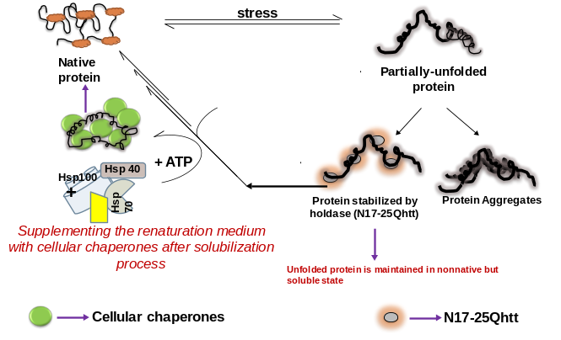
Recent Publications (minimum 5)

- The role of the glycerol transporter channel Fps1p in cellular proteostasis during enhanced proteotoxic stress - Appl Microbiol Biotechnol 106 (2022), 6169-6180. (I.F. 4.8)
- Stabilization of elongated polyglutamine tracts by a helical peptide derived from N‐terminal huntingtin. IUBMB life. 72 (2020), 1528-1536. (I.F. 3.2)
- Discrete roles of trehalose and Hsp104 in inhibition of protein aggregation in yeast cells. FEMS J. 18 (2018), foy058. (I.F. 2.9)
- Does N terminal huntingtin function as a ‘holdase’ for inhibiting cellular protein aggregation? FEBS J. 285 (2018), 1791-1811. (I.F. 5.54)
- Nicotine slows down oligomerisation of alpha-synuclein and ameliorates cytotoxicity in a yeast model of Parkinson's disease. BBA- Mol Basis Dis. 1863 (2017), 1454-1463. (I.F. 5.34).
- Challenges with osmolytes as inhibitors of protein aggregation: Can nucleic acid aptamers provide an answer? Int J Biol Macromol. 100 (2017), 75-88. (I.F. 6.953)
- Cellular toxicity of yeast prion protein Rnq1 can be modulated by N-terminal wild type huntingtin. Arch Biochem Biophys. 590 (2016), 82-89. (I.F. 4.013)
- Biological evaluation of small molecule inhibitors of Mtb-ASADH enzyme. Lett Drug Des Discov. 13 (2016), 587590. (I.F. 1.17)

Biography (150 word limit)

Ratnika Sethi is a research professional with 6+ years of in-depth experience driving change and growth within the health and pharmaceutical industry in the field of biotechnology & pharmacology. Outstanding hands-on research skills in neurobiology, oncology, and translational precision therapeutics. She has published 8 peer-reviewed international publications in high impact factor journals in the same domain of study.
Email: ratnikasethi@gmail.com

Presenting author details
Full name: Dr Ratnika Sethi
Contact number: +919988337835
Twitter account:
Linked In account: https://www.linkedin.com/in/ratnikasethi/
Session name/ number:
Category: Oral presentation

