Airway from Dental Perspective

Every patient deserves to understand their oral condition and has the information on how to best achieve their oral health and aesthetic goals for a healthy smile; this could be achieved by establishing normal oral rest posture. Their primary focus add to teeth is how occlusion “static and dynamic”, Jaws, soft tissues behave, and head positioned. The human body is a complex organism made up of many overlapping systems. When one of those systems has a defect, pain and abnormalities can affect other bodily systems and make life more of a challenge. Every dentist has to be involved in screen for sleep disorder breathing as a comprehensive medical and dental history to recognize symptoms such as sleepiness, choking, snoring or witnessed apnea and an evaluation of risk factors such as obesity, craniofacial dystrophy, or hypertension. Now we all really looking into mouth of countless individual number with airway problems but crosses undiagnosed. We organized will on compressive examination of dentition caries, wear, gingiva… etc. However, we should look deeper to another thing that is one of the controlling factor of dental health and possibly life threatening. On checking, the airway we should gate rid of one of the false questions “are you a mouth breather”. To help establishing oral and possibly general body health we should look for Normal physiologic breathing and normal oral rest posture. This could be achieved by bringing the teeth and the lips together, elevate the tongue to rest in the palate and initiate the nasal breath.

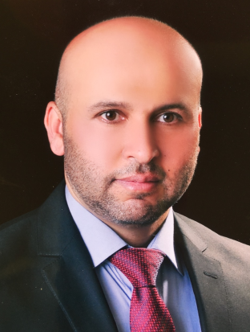
Mustafa M. H. Alsultan
Head of Dental Department, Alhadba University College
Mosul/Iraq
mustafaalsultanortho@gmail.com
+9647738496708
+9647718814088

Date of Birth – 20.07.1977
Citizenship – Iraq

PhD, Dental Science/ Orthodontics, June 24, 2015
University of Mosul – Mosul, Iraq
- Thesis Title: Influence of curcumin, cissus quadrangularis, virgin coconut oil, nigella sativa on bone response around orthodontic implant in rabbit tibia
- Supervisor: Assist. Prof. Dr. Ali Rajih Al-khateb (University of Mosul, Iraq)
- Scientific reviewer: Assist. Prof. Dr. Nawfel Abdulmalek Zakaria (University of Mosul, Iraq)
MSc, Orthodontics, June 22, 2005
University of Mosul – Mosul, Iraq
- Thesis Title: Cranial base parameters effect on the nasomaxillary complex in class II division 1 malocclusion (Three dimensional cephalometric study)
- Supervisor: Professor Dr. Khudair Adai Salman Aljumaili (University of Mosul, Iraq)
- Scientific reviewer: Assist. Prof. Dr. Nada Amjed Alsaegh (University of Mosul, Iraq)

BDS Honors (Bachelor of Dental Medicine and Oral Surgery with Honors), June 22, 2000
University of Mosul – Mosul, Iraq
- Ranking: 1st among the graduates
Grade: 80.470

