Parenting styles and preschool children's behaviour in a Saudi Arabian postgraduate dental setting

Maram Alagla , A. Al-Hussyeen &L. Alhowaish

Abstract (300 word limit)

Background: The parenting style is shifting universally. Children lack the skills needed to deal with life stressful situations like those present in dental setting. Previous studies showed a correlation between parenting style and the child’s dental behaviour. No studies have been performed in the Kingdom of Saudi Arabia (KSA) to relate parenting style to child’s dental behaviour. The purpose of this study is to correlate parenting styles with the dental behaviour of their children, in Riyadh, KSA.

Methodology: Two hundred and eighty-two healthy preschool children aged 3–6 years were recruited in their first dental visit, to a postgraduate Paediatric Dentistry Clinics of the Dental University Hospital at KSU, Riyadh, KSA. The Parenting Styles and Dimensions Questionnaire was completed by the primary caregiver/parents. The behaviour of the children was evaluated after dental prophylaxis and fluoride application in the dental chair using Frankl behavior rating scale. Family and child demographic data were evaluated through a questionnaire.

Results: Two hundred and eighty-two healthy Saudi children participated in the study with their parents. Two parenting styles were identified among Saudi parents including authoritative (94%, n = 265) and permissive parenting styles (6%, n = 17). Most of the children behaved positively (n = 205, 72.7%). Significant correlations were detected between parenting style and parent’s dental anxiety (P value 0.02) but not significantly correlated to a child’s dental behaviuor.

Conclusion: In the KSU sample studied, two parenting styles were identified among Saudi parents, authoritative and permissive parenting styles. Parenting style was correlated to parental dental anxiety and had an influence on a child’s dental behaviour. Clinically, interesting correlations were identified regarding factors affecting child/s first dental visit behaviour.

Image

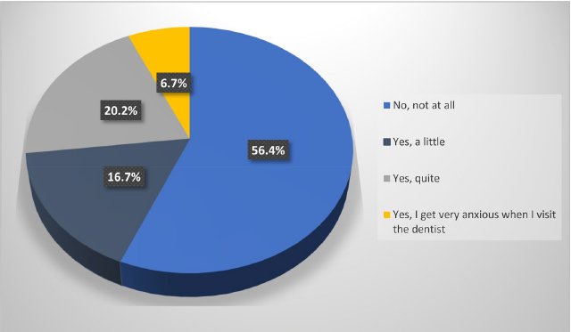
Dental anxiety question responses of parents (n=282)

Recent Publications (minimum 5)
- Alagla M, Al-Hussyeen A, Alhowaish L. Parenting styles and preschool children's behaviour in a Saudi Arabian postgraduate dental setting. Eur Arch Paediatr Dent. 2021 Apr;22(2):163-173. doi: 10.1007/s40368-020-00540-y. Epub 2020 Jun 8. PMID: 32514699
- Alagla MA, Al Hussyeen A, Alhowaish L. Do Parenting Styles Affect Children's Oral Health in Saudi Arabia? Cureus. 2019 Oct 26;11(10):e6002. doi: 10.7759/cureus.6002. PMID: 31807389; PMCID: PMC6876921.
- AlSadhan SA, Al-Jobair AM, Bafaqeeh M, Abusharifa H, Alagla M. Dental and medical health status and oral health knowledge among visually impaired and sighted female schoolchildren in Riyadh: a comparative study. BMC Oral Health. 2017 Dec 19;17(1):154. doi: 10.1186/s12903-017-0446-6. PMID: 29258491; PMCID: PMC5735896

Biography (150 word limit)
Maram Alagla is a consultant pediatric dentist who earned a doctorate degree in dental science and pediatric dentistry proficiency certificate. M.alagla is interested in child behavior and parenting style that have been evolving recently. Another interest is improvements in prevention and dental public health programs. Currently M.alagla is working as an assistant professor at Prince Sattam Bin Abdulaziz University, KSA.

Email: m.alagla@hotmail.com

Presenting author details
Full name: Maram Abdulaziz Alagla
Contact number: +966566309050
Mail id: M.alagla@hotmail.com
Category: Oral Presentation

