Pfeiffer Syndrome. A middle face distraction treatment by a modified Lefort III technique.
Dr. Andres Salazar, DDS, Maxillofacial Surgeon. Colombia.
Dr. Andres Duque, DDS, Craneomaxillofacial Surgeon. Colombia.
Dr. Jaime Jimenez, DDS, Maxillofacial Surgeon. Colombia.

Abstract

Pfeiffer syndrome. Discovered by Arthur Pfeiffer in 1964, with a prevalence of 1:100,000. It is characterized by the clinical presentation of craniosynostosis, hypoplasia of the middle third of the face, syndactyly of the hands and feet. It usually presents with a bilateral coronal synostosis associated with one or more sutures. The dysmorphic skull presents with a transverse magnification greater than anteroposterior, reflecting an enlarged frontal region, depressed midface with a small nose and low nasal bridge with moderate to severe ocular propotosis with the presence of ocular hypertelorism. Cohen classified it in 1993 into 3 types: type I is a mild skeletal craniofacial disorder with normal neurological development; Type II is a pansynostosis-type craniofacial disorder, with severe proptosis, skeletal abnormalities in stiff fingers and elbows, and limited delayed neurological development; Type III is the same as Type II without pansynostosis. Genetics is associated with the FGFR2 gene mutation in 95% of cases and is represented by types II and III, while the FGFR1 gene mutation is found in 5% represented by type I.

The treatment of these patients is the correction of the present signs and symptoms, for which initially the cranial correction of the synostoses is performed by means of cranioplasty at one year of life, followed by distraction or craniofacial advances at 6 to 8 years of life, later management of sequelae in facial projection, especially in nasal management. The emphasis on ocular proptosis is important since surgical treatment is focused on reconstructing the orbital continent.

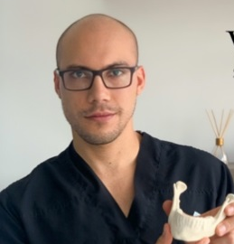
Treatment is always multidisciplinary, involving neurosurgery, craniomaxillofacial surgery, otorhinolaryngology, oculoplasty, internal medicine.
Image

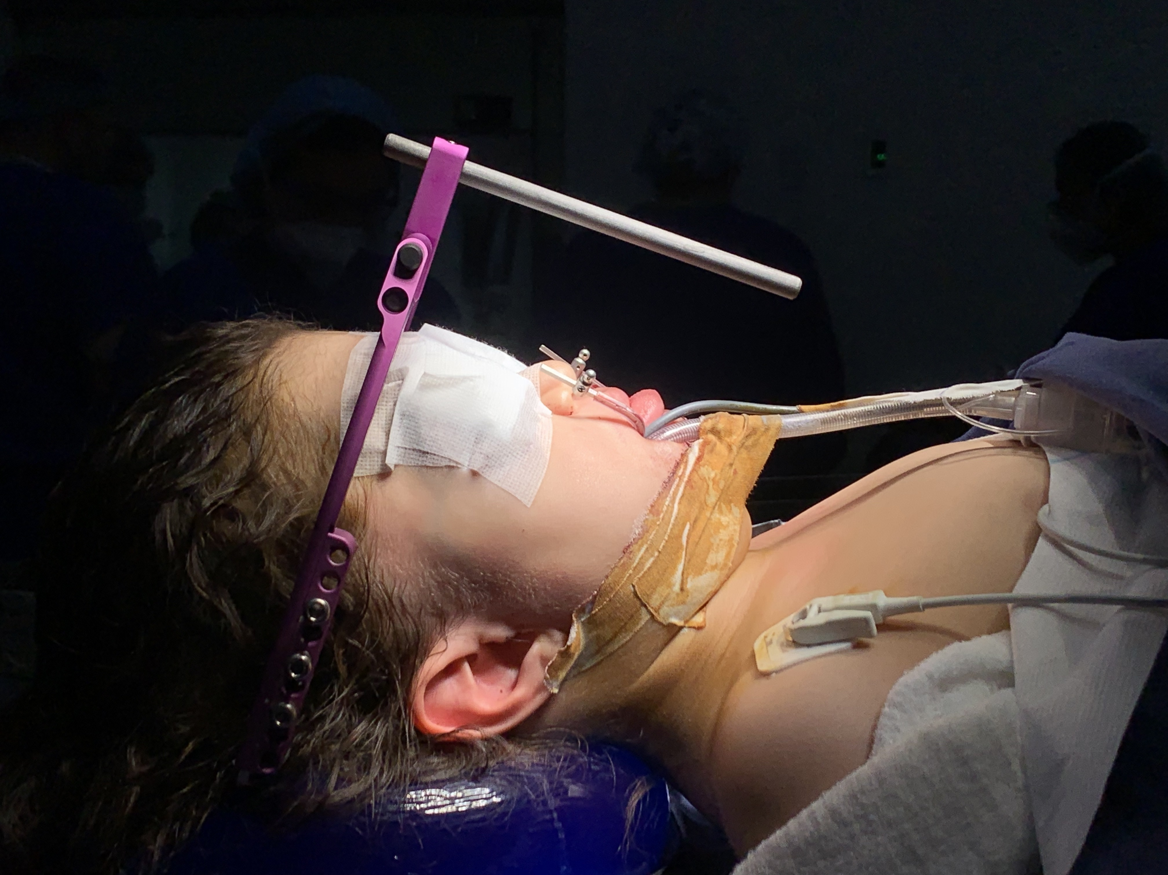
Publications
1. Dr. Nitesh Chhikara, Dr. Sarah Shaik, Dr. Sauravbhargava. Review on distraction Osteogenesis: A boon to maxillofacial reconstruction. IntJApplDentSci2018;4(2):44-48.
2. Imola MJ, Tatum SA. Craniofacial distraction osteogenesis. Facial Plast Surg Clin North Am. 2002Aug;10(3):287-301
3. Perez D, Ellis E 3rd, Vega OA. Distraction osteogenesis for craniomaxillofacial problems. Tex Dent J. 2011 Nov;128(11):1159-70
maxilofaciales.RevistaMédicaClínicaLasCondes,27(1),5–13.
4. ErazoC., C., RíosV., M., TroncosoO., E., & QuezadaR., G.(2016). Distracción posea del tercio medio facial en malformaciones cráneo-
5. Saunders, M. M., & Lee, J. S. (2008). The Influence of Mechanical Environment on Bone Healing and Distraction Osteogenesis. Atlas of the Oral and Maxillofacial Surgery
Clinics, 16(2), 147–158.
6. McCarthy, J. G., Schreiber, J., Karp, N., Thorne, C. H., & Grayson, B. H. (1992). Lengthening the human mandible by gradual distraction. Plast reconstr surg, 89(1), 1-8.
7. Polley, J. W., Figueroa, A. A., Charbel, F. T., Berkowitz, R., Reisberg, D., & Cohen, M. (1995). Monobloc craniomaxillofacial distraction osteogenesis in a newborn with severe
craniofacial synostosis: a preliminary report. The Journal of Craniofacial Surgery, 6(5), 421-423.


Biography
Dr. Andres Salazar, is a new maxillofacial surgeon recently graduated from Pontificla Xaverian University located in Bogota, Colombia. His principles based on his career are to prevent, diagnose and treat all disease of the maxillofacial complex esqueletal and soft tissues with the unique goal that is to give back quality of life to his patients. This workshop about the Middle Face Distraction has been done when Dr. Andres S. was a resident of four year guided by their professors Dr. Andres Duque and Dr. Jaime Jimenez who authorized to Dr. Andres Salazar to be the speaker of their clinical case done together.
Email: andres_salazar_005@hotmail.com

Notes/Comments:
Presenting author details
Full name: ANDRES SANTIAGO SALAZAR FELIX
Contact number: +57 314 877 1829
Mail id: andres_salazar_005@hotmail.com
Category: Oral presentation

