ASSESSMENT OF ANTIOXIDANT AND ANTIMICROBIAL ACTIVITIES OF ZIZIPHUS LEAVES EXTRACT AND ITS PHARMACEUTICAL APPLICATIONS
Richa Mishra,PHD
Department of Biochemistry, Dr. Ramamohar Lohia Avadh University, Ayodhya U.P. India

Abstract (300 word limit)
Ziziphus mauritiana, also known as Indian jujube and is a tropical fruit tree species belonging to the family Rhamnaceae. In India, there are 90 or more cultivars, varying in the habit of the tree; leaf shape; fruit form, size, color, flavor and keeping quality; and fruiting season. plant are used in the treatment of in fever, indigestion, liver disease, diarrhea, wound healing and jaundice and have various pharmacological properties. Ziziphus mauritiana is recognized for traditional uses in different areas such as its fruits are consumed globally. The aim of the present study were to measure the presence of different bioactive compounds in leaf of Ziziphus mauritiana plant and to explore its antioxidant potential by assaying free radical scavenging activity, superoxide anion radical scavenging activity and reducing power. The study was further carried out to assay the antimicrobial properties by disc diffusion method to ascertain its pharmaceutical application. The results of the present study showed the presence of high phytochemical constituents such as ascorbic acid, total phenolic, flavonoids and carotenoids in leaf. Methanolic leaf extract showed that it has significant antioxidant potential and antibacterial activity against pathogenic bacteria. Hence, results obtained in the present study suggest that leaves of Ziziphus can be used as a source for functional ingredients for nutraceutical/pharmaceutical drug industries to treat the diseases induced by the oxidative stress.
Keywords: Ziziphus mauritiana, Antioxidant, Antimicrobial, Pharmaceutical.

Image:-
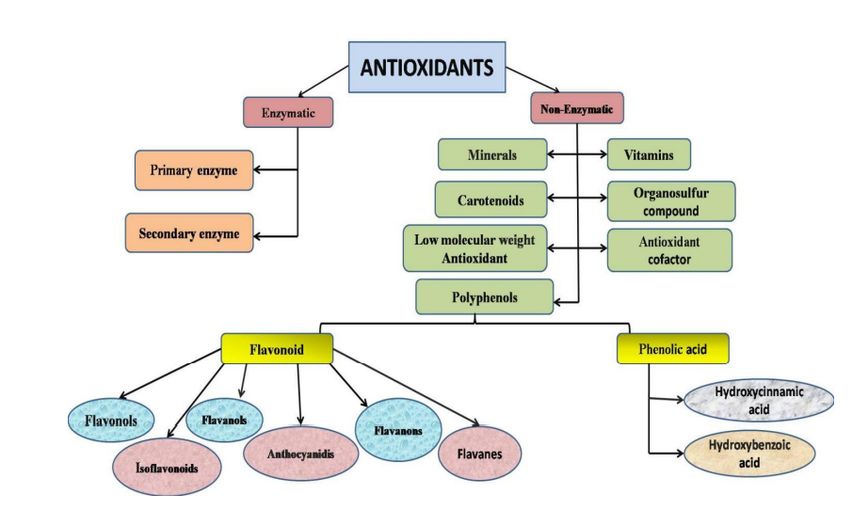
Fig: Classification of Antioxidant
Recent Publications (minimum 5)
- Pathak N, Singh P, Singh PK, Sharma S, Singh RP, Gupta A, Mishra R, Mishra VK and Tripathi M (2022) Biopolymeric nanoparticles based eective delivery of bioactive compounds toward the sustainable development of anticancerous therapeutics. Front. Nutr. 9:963413. doi: 10.3389/fnut.2022.96341
- Mechanistic insights of plant-microbe interaction towards drought and salinity stress in plants for enhancing the agriculture productivity. Plant Stress 4 (2022) 100073.
- Mechanistic insights of plant growth promoting bacteria mediated drought and salt stress tolerance in plants for sustainable agriculture, A Gupta, R Mishra, S Rai, A Bano, N Pathak, M Fujita… - International Journal of Molecular Sciences, 2022.

Biography (150 word limit)



Paste your Log o here
I Self Richa Mishra Persuing PhD in department of Biochemistry From Dr. Rammanohar Lohia Avadh University Ayodhya Uttar Pradesh (India U.P.). Currently working on the ‘‘Morphological, Biochemical and Molecular characterization of Ziziphus leaves species” and complete Analysis of antioxidant and antimicrobial activities of ziziphus leaves species.
Expected outcomes-
The Ziziphus species tree is one of the most useful horticultural medicinalplants in India. Its medicinal properties have been described in the ancient Sanskrit medical treatise Charaka Samhita. Several cultivars/accessions will be selected through different biochemical tests. The species considered the best also have the characteristics of the presence of biologically active compounds (Bioactive Compounds). The leaf extract will be expanded to take of its great potential for medically important biological activities. The genetic variation of ziziphus (ber) germplasm will be used for breeding programs, plants evolution research and conservation purposes.
Email: richa7087@gmail.com

Notes/Comments:
Presenting author details
Full name: Richa Mishra⃰⃰
Contact number: 7985001513
Mail id: richa7087@gmail.com
Category: (Oral presentation/ Poster presentation)
Oral Presentation

