A New Generation of Technology Platform for Biosimilars Production : “Available, Affordable, Sustainable”

Bertrand Merot, PhD, Bio-Sourcing SA, EU/BE Xavier-François Frapaise, MD, Pharma Consulting, EU/FR

Abstract

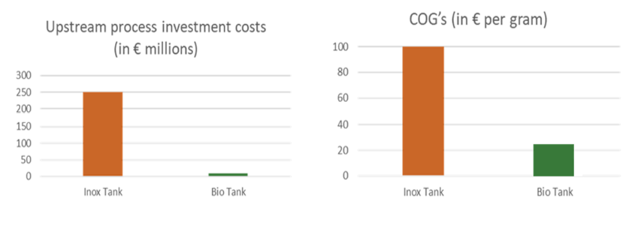
The biopharmaceutical industry faces huge production limitations in terms of volume and cost. The strong growth rate of biosimilars, the need to serve the Global Southern markets (LMIC countries) and the occurrence of pandemics, require production of large volumes of biotherapeutics, at ever lower costs than currently available biosimilars and in compliance with sustainable development objectives. The investments needed to create new bioproduction units using mammalian cell cultures (CHO) cannot meet this global health challenge.

As the ultimate objective is to give access to essential medicines to larger populations of patients, the production paradigm has to drastically evolve, using what nature has given us as the best bioreactor, namely leveraging the natural secretion of large amount of proteins in the milk of dairy animals.

Bio-Sourcing changes the Bioproduction design by developing a disruptive technology platform (BioMilk®) using dedicated and specialized transgenic goats and thanks to the company expertise in several breakthrough technologies including genome editing (CRISPR) and Nuclear Transfer (SCNT).

The Bio-Sourcing innovative approach leads to a drastic reduction in capital requirements and production costs, especially for large volumes (over several hundred Kg), as well as an improvement in the quality/efficiency of biopharmaceuticals through better glycosylation.

The technological approach developed by Bio-Sourcing has already given rise to biotherapeutics approved by regulatory bodies (FDA, EMA).

An additional benefit of this technology is a strong contribution to sustainable development, drastically reducing the carbon footprint.

Bio-Sourcing is already currently in the industrialization phase and has the potential to offer producers of biosimilars the possibility, in a context of cost pressure, to produce essential bioproteins for global unmet medical needs.
Image

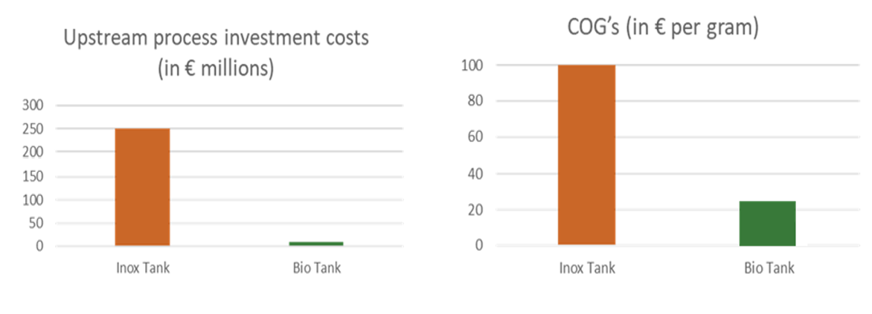
Recent Publications
- Chen Y, Lehmann A, Santos da Silva J (2019) What’s next for biosimilars in emerging markets ? McKinsey & Company, Pharmaceutical & Medical Products Practice.
- Aitken M, Kleinrock M, Pritchett J, (2023) Biosimilars in the United States 2023-2027. IQVIA Institute For Human Data Science.
- Pategou J,(2020) Africa’s Biosimilar Landscape : Outlook & Current Challenges. BIOSIMILAR DEVELOPMENT? Guest Clumn, June 2, 2020.
- Ma B, Osborn M (2021) Transgenic Animals for the Generation of Human Antibodies. Introduction to Antibody Engineering, # Springer Nature Switzerland AG 2021.
- Adalimumab, Infliximab and Etanercept Biosimilars Global Market Report, February 2023. RESEARCH AND MARKETS

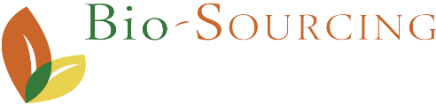


Founder & CEO Bio-Sourcing – Dr. Bertrand Merot: PhD in Genetics and MBA, Dr. Merot worked previously for LFB Biotechnologies, Oncodesign, Meristem Therapeutics, Limagrain where he held several managerial positions (CEO, CSO, Vice President). Dr. Merot has also been Board Member of France Biotech
Email: bertrand.merot@bio-sourcing.eu

Notes/Comments:

Presenting author details
Full name:
Contact number:
Twitter account:
Linked In account:
Session name/ number:
Category: Oral presentation Poster presentation

