Clinical risk factors analysis of Large-Volume contralateral central lymph node metastasis of unilateral papillary thyroid carcinoma
Yu zhang, PhD, China

Abstract (300 word limit)

Objective: To explore the clinical significance high risk clinical factors in predicting Large-Volume contralateral central lymph node metastasis (CCLNM) of unilateral thyroid papillary carcinoma (uPTC), and to explore the indications of Cont

CLNs dissection.

Methods: The pathological data of 259 patients that underwent thyroid surgery at affiliated Hangzhou First People’s Hospital Zhejiang University School of Medicine from January 2013 to October 2022 were collected and randomized into training and validation cohorts (7:3). Univariate and multivariate logistic regression analyses were used to determine the independent risk factors of CCLNM and Large-Volume CCLNM in PTC patients. Forest plot was plotted to visualize the prediction factors from the output of the multivariate regression analysis. A predictive nomogram for predicting CCLNM and Large-Volume CCLNM were constructed by logistic regression and validated by ROC curves, concordance index (C-index), calibration curve, and decision curve analyses (DCA). The existing data were compared with the original model.

Results: According to univariate and multivariate logistic regression analyses, male(P < 0.001, OR: 8.168, 95% CI:2.617-25.491)、age(P=0.011, OR: 0.948, 95% CI: 0.910-0.988)、capsule invasion(P =0.049, OR: 2.727, 95% CI: 1.003–7.412) , lateral lymph node metastasis(P = 0.003, OR: 5.110, 95% CI: 1.758–14.854) and tumor located in the lower pole(P = 0.035, OR: 2.972, 95%CI: 1.083–8.158) were independent risk factors of Large-Volume CCLNM in PTC patients; When the Youden index was the highest, the area under the curve (AUC) was 0.856 (P < 0.001, 95% CI: 0.764–0.948). The externally validated AUC was 0.780 (P < 0.001, 95% CI: 0.587–0.972). The specificity was 87.60%, and the sensitivity was 76.70%. The calibration curve and the decision curve indicated that the model had good diagnostic value. The C-indexes in the training and the external validation data sets were 0.836 and 0.849, respectively.

Conclusion: When male, age<45 years old, lateral neck lymph node metastasis, capsule invasion and lesion location at the lower pole are the high risk factors for LV-CCLNM in uPTC. It is strongly recommended to perform preventive contralateral central lymph node dissection.

Image

Clinical predictive model of large-volume contralateral central lymph node metastasis in papillary thyroid carcinoma patients.

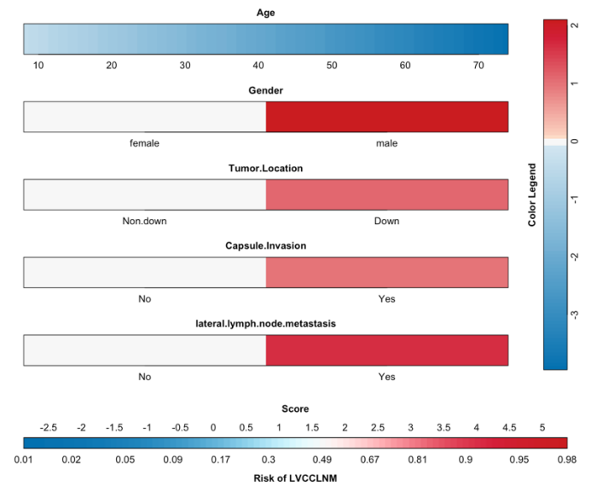
Recent Publications (minimum 5)
- Yan S, Zhao W, Wang B, et al.(2018) Standardization of simple auxiliary method beneficial to total endoscopic thyroidectomy on patients with PTC,based on retrospective study of 356 cases [J]. Endocrine;61(1):51–7.
- Haugen BR, Alexander EK, Bible KC, et al. (2016) 2015 American Thyroid Association Management Guidelines for Adult Patients with Thyroid Nodules and Diferentiated Thyroid Cancer: the American Thyroid Association Guidelines Task Force on Thyroid Nodules and Diferentiated Thyroid Cancer. Thyroid; 26:1–133.
- Sun W, Zheng B, et al.(2020) Meta-analysis of risk factors for CCLNM in patients with unilateral cN0 PTC. Endocr Connect.11;9(5):387-395.
- Leboulleux S, Rubino C, Baudin E, et al.(2005) Prognostic factors for persistent or recurrent disease of papillary thyroid carcinoma with neck lymph node metastases and/or tumor extension beyond the thyroid capsule at initial diagnosis. J Clin Endocrinol Metab; 90(10):5723-9.
- Randolph GW, Duh QY, Heller KS, et al.(2012) American Thyroid Association Surgical Affairs Committee’s Taskforce on Thyroid Cancer Nodal Surgery. The prognostic significance of nodal metastases from papillary thyroid carcinoma can be stratified based on the size and number of metastatic lymph nodes, as well as the presence of extranodal extension. Thyroid;22(11):1144-52.

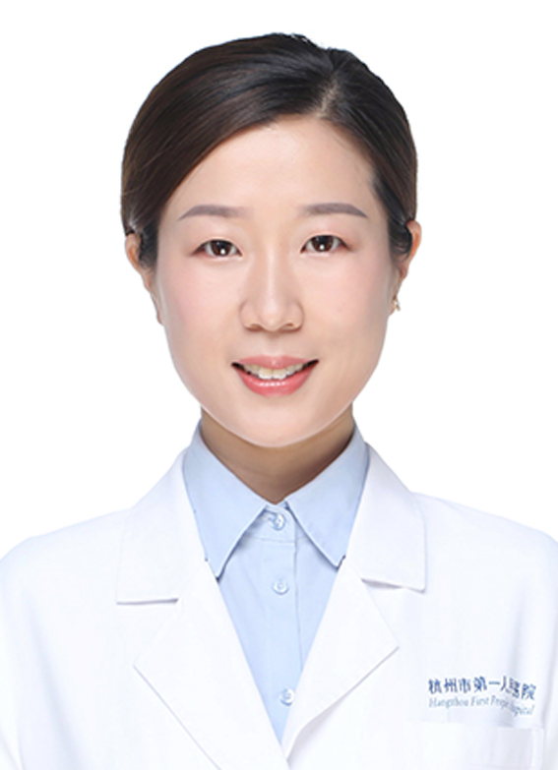Biography (150 word limit)

Dr. Yu zhang's research focuses on the clinical and molecular pathogenesis of thyroid tumors, parathyroid diseases, breast tumors, etc. So far, he has been engaged in clinical diagnosis, treatment, scientific research, teaching and science popularization of common tumor diseases, especially the diagnosis, treatment and research of thyroid tumors. He has strong clinical diagnosis, treatment and scientific research capabilities. He has now participated in a number of scientific research projects at the provincial, departmental and bureau levels, and issued nearly 10 scientific research papers (including 6 SCI) as the first author.
Email: zhangyunjmu@126.com

Notes/Comments:

Presenting author details
Full name: Yu zhang
Contact number: +86-15105815199
Twitter account:
Linked In account:
Session name/ number:
Category: (Oral presentation/ Poster presentation): Oral presentation

