Euglycemic diabetic ketoacidosis and Covid-19 management in a term pregnant patient; a case report.

- Fatemeh Mohammadzade, Metabolic Disorders Research Center, Golestan University of Medical Sciences, Gorgan, Golestan, Iran. Orcid ID: 0000-0003-4785-2262, msoheila66@yahoo.com.
- Behnaz Khodabakhshi. Infectious Diseases Research Center, Golestan University of Medical Sciences, Gorgan, Iran. Orcid ID: 0000-0003-0456-9192, behkhoda@yahoo.com.
- Elahe Amiri. Metabolic Disorders Research Center, Golestan University of Medical Sciences, Gorgan, Golestan, Iran. Orchid ID: 0000-0002-3139-0852, dr.amiri.gynecologist@gmail.com.
- Amir Bigdeli. Department of Nephrology and Hypertension, Sayyad Shirazi Hospital, Golestan University of Medical Sciences, Gorgan, Iran. Orcid ID: 0000-0002-8523-4468, amir000817@gmail.com.
- Fahimeh Abdollahi. Pulmonary Ward, Department of Internal Medicine, Sayyad Shirazi Hospital, Golestan University of Medical Sciences, Gorgan, Iran. Orchid ID: 0000-0001-9226-3710, fahimehabdollahi@gmail.com.
- Alireza Fatemi. Ischemic Disorder Research Center, Golestan University of Medical Sciences, Gorgan, Iran. Orcid ID: 0000-0001-9305-9615. Seyedalireza.fatemi@gmail.com
Corresponding author: Alireza Fatemi, Ischemic Disorder Research Center, Golestan University of Medical Sciences, Gorgan, Iran. Orcid ID: 0000-0001-9305-9615. Seyedalireza.fatemi@gmail.com

Abstract (300 word limit)
Covid-19 can have detrimental effects on pregnancy, and pregnant women with this infection are at higher risk for developing ketoacidosis. In this case report, we report a 35-year-old female patient with gestational diabetes mellitus infected with Covid-19 with early manifestations of ketoacidosis such as fatigue, tachycardia and productive cough during term pregnancy and urinary ketone bodies and lower limit normal blood glucose concentrations at the admission.
Keywords: Pregnancy, Ketoacidosis, Covid-19, Euglycemic, Gestational diabetes.

Image
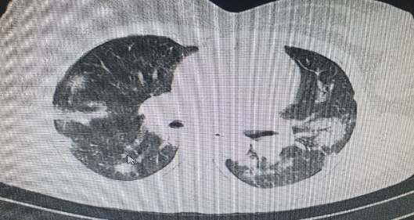

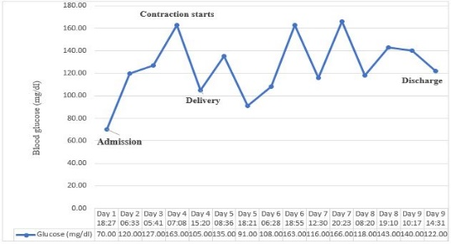

Recent Publications (minimum 5)
- A systematic review and meta-analysis for association of Helicobacter pylori colonization and celiac disease FI Amlashi, Z Norouzi, A Sohrabi, H Shirzad-Aski, A Norouzi, A Ashkbari, ... Plos one 16 (3), e0241156, 2021
- Diabetic ketoacidosis and Covid-19 management in a term pregnant patient; A case report F Mohammadzade, B Khodabakhshi, E Amiri, A Bigdeli, F Abdollahi, ... Clinical Case Reports 10 (12), 2022
- Electrocardiogram Changes Before and After Surgery in Patients Underwent Coronary Artery Bypass Graft Surgery M Zahedi, S Tabrizi, A Fatemi Journal of Gorgan University of Medical Sciences 24 (1), 47-51, 2022
- Heterotopic Pregnancy After In Vitro Fertilization; A Successfully Treated Case Report S Livani, A Fatemi Gene, Cell and Tissue 8 (4), 2021
- Ovarian Vein Thrombosis or Spontaneous Ureter Rupture? A Case Report A Fatemi, S Livani BMH Medical Journal - ISSN 2348–392X 8 (No 2: April-June 2021), 95-98, 2021

Biography (150 word limit)
I am Alireza Fatemi, a medical intern and a medical researcher In fields of internal medicines.


constructivists create new pathways for improving healthcare. She has built this model after years of experience in research, evaluation, teaching and administration both in hospital and education institutions. The foundation is based on fourth generation evaluation (Guba& Lincoln, 1989) which is a methodology that utilizes the previous generations of evaluation: measurement, description and judgment. It allows for value-pluralism. This approach is responsive to all stakeholders and has a different way of focusing.
Email: seyedalireza.fatemi@gmail.com
Paste your Logo here

Notes/Comments:

Presenting author details
Full name: Alireza Fatemi
Contact number: +989353742861
Twitter account: -
Linked In account: Alireza Fatemi
Session name/ number: -
Category: Oral presentation

