Interrelationship of Prognostic factors Tumour Budding, Biomarkers and Microenvironment in management of breast cancer

Nandini Manoli

JSS Academy of Higher Education and Research, India

Statement of the problem
Breast being the most common type of cancer in women, breast cancer accounts for 14% of cancers in Indian women. It is reported that with every four minutes, an Indian woman is diagnosed with breast cancer.
Breast cancer is on the rise, both in rural and urban India. A 2022 report of Breast Cancer statistics recorded 1,78, 361 (26.3%) new registered cases and 90,408 reported deaths.
The management of these cases depends on various prognostic markers
Other latest prognostic markers besides, Modified Masood’s scoring of FNAC breast, Histopathology, Bloom Richardson scoring, lymphovascular invasion, lymph node status is Tumor budding(TB). TB is a study wherein clusters of tumor cells present in the invading edge of stroma (4 to 5 cells) are evaluated. This study was inspired from the work done by Radhika Agarwal et.al.
Biomarkers are both helpful in management and prognosis of breast malignancy; they are the regular nuclear, cytoplasmic and angiogenic markers. The biomarkers like ER, PR, HER2/NEU, Ki 67 are all important for diagnosis and treatment of breast malignancies.
The biopsies of the malignant breast cases are further evaluated for biopsy size, relation with tumor grade, lymphovascular invasion (LVI) Lymph node status, and their relation with tumor budding (TB), so as to decide the prognosis of breast cancer patients.
There is now increased recognition of the importance of the tumour microenvironment, including tumour necrosis, host local inflammatory responses or tumor infiltrating lymphocyte (TIL) and tumour stroma, in cancer progression and survival. The assessment of ratio of inflammatory cells to tumour cells is done by Klintrup Makinen score (KM score)
We are trying to see the association of TB with the microenvironment (KM score), as an prognostic factors in management of breast cancer patients.

Methodology & theoretical orientation
The total numbers of cases by FNAC were 290 cases from January 2019 to August 2020
The total numbers of benign cases were 219 accounting for 75.51% of cases
The total numbers of malignant cases were 71 cases accounting for 24.49%
The total number of benign cases with Histopathology correlation were 58 accounting for 54.71%.The total number of malignant cases with histopathology correlation were 48 accounting for 45.29% of cases.

Tumour budding: It is the presence of 1-5 cell clusters seen in the stroma close to the main tumor. There are various methods to access the tumor grading by counting the tumor buds in HPF. The method adopted by us is the one proposed by Dr. Radhika Agarwal et.al., wherein the maximum number of buds seen by 20x are counted in a field. The tumor is divided into high grade tumor budding if number of bud are more than 10 and low grade tumor bud if they are less than 10. Tumour budding was observed in 40 malignant breast cases both histopathology and core biopsy cases were included.
Also, the relationship of TB with other prognostic factors like tumour size, biomarkers like ER, PR, and Ki 67, Angiogenic Markers, tumour grade, Lymphovascular invasion, lymph node metastasis, and KM score will be discussed.
A study on 50 breast cancer cases, from January 2021 to June 2021, which underwent either radical mastectomy or core biopsy, tries to compare the tumour budding and lymphocytic infiltrate in the tumour microenvironment by a method of assessment called the Klintrup Makinen score (KM SCORE)
It helps to establish the importance of these newer prognostic factors, so as to improve the survival of the patients .

Findings
TB total number of malignant breast cases were 40 including both big size biopsies and core biopsies.
TB high grade -22(55%)of cases TB low grade -18(<10) accounting for 45% of cases. Thus, the breast cases with high grade, TB were more indicating that more number of cases had metastatic potential and a poorer prognosis.
The total number malignant breast included for comparison of TB and KM scoring for microenvironment study were 50 cases which included big biopsies and core biopsies
In total number of 27 cases, tumour budding <10 with K M score were with score 2 (11) followed by score 3 (9) and score1 (6) and score 0 (1).
In total number of 23 cases, tumour budding >10 with K M score were with score 1 (11) followed by score 0 (10), score2 (2) and score 3 (0). This shows that TB & KM score are opposite and inversely proportional.
TB < 10 has better prognosis which correlates well with high KM score 2 and score 3. Similarly, TB >10 score has bad prognosis and correlates with maximum being with score 1 and score zero KM score.
Thus both T.B & KM score do have a good correlation.

They both can be good prognostic factors for Breast malignancies.

Fig1

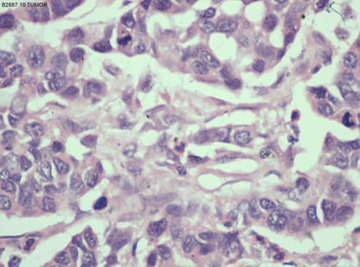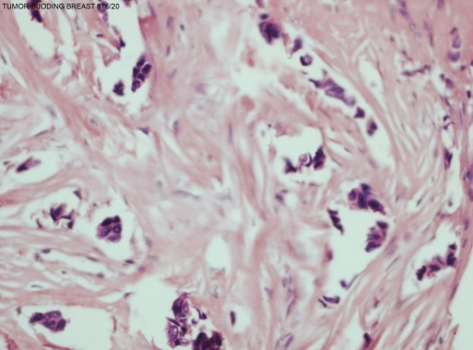
Tumour budding, (H&E, 20x)
Malignant breast tumour (H&E, 10x)

Fig2
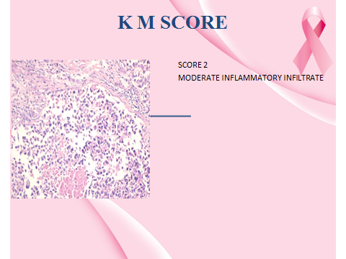
Klintrup Makinen score (KM SCORE) for relationship between TIL and breast cancer.

Conclusion
There is a strong relationship with prognostic markers like tumour budding and other prognostic markers like tumour size, Lymph vascular invasion, lymph node metastasis, biomarkers, and KM score. It plays an important role in management of breast cancer.

References
1. B. N. Kumarguru, Anikode S. Ramaswamy, Shahanuma Shaik1, Aruna Karri2, Venugopal Sandeep Srinivas3,B. M. Prashant4Tumor budding in invasive breast cancer An indispensable budding touchstone Indian J Pathol Microbiol 2020;63(Special):S117-22
2. Salhia B, Trippel M, Pfaltz K, Cihoric N, Grogg A, Ladrach C, et al. High tumor budding stratifies breast cancer with metastatic properties.Breast Cancer Res Treat 2015;150:363 71.
3. Liang F, Cao W, Wang Y, Li L, Zhang G, Wang Z. The prognostic value of tumor budding in invasive breast cancer. Pathol Res Pract 2013;209:269 75.
4. Gujam FJA, McMillan DC, Mohammed ZMA, Edwards J, Going JJ. The relationship between tumor budding, the tumor microenvironment and survival in patients with invasive ductal breast cancer. Br J Cancer
2015; 113:1066 74.
5. F J A Gujam*, 1, 2, D C McMillan1, Z M A Mohammed3, J Edwards2 and J J Going The relationship between tumour budding, the tumour microenvironment and survival in patients with invasive ductal breast cancer British Journal of Cancer (2015) 113, 1066–1074.
6. ZMA Mohammed*, 1,2, JJ Going3, J Edwards3, B Elsberger3, JC Doughty4 and DC McMillan1 British Journal of Cancer (2012) 107, 864–873.
7. F J A Gujam*,1, J Edwards2, Z M A Mohammed1, J J Going3 and D C McMillan1 The relationship between the tumour stroma percentage, clinicopathological characteristics and outcome in patients with operable ductal breast cancer British Journal of Cancer (2014) 111, 157–165.
8. Olivier De Wever and Marc Mareel* Journal of Pathology J Pathol 2003; 200: 429–447

Biography

Dr. Nandini N. M, Professor, JSS Medical College, Mysore, is attached as a teaching faculty from the past 25 years in the department of pathology.she has finished her MBBS from JNMC BELGAVI, MD from Mysore Medical College and Research Institute. She has worked in the field of cytology of cervix and breast. She has attended and given talks at many national and international conferences in countries like U.K, USA, Singapore and Netherland. She has worked on liquid based cytology, cell block technique and has come up with indegenious methods. She has severeal publications and books to her credit written on cervical and breast cancer.

Field of interest
Cytology and diagnosis of cervical and breast cancer.

