Diagnosis of Neuropathic Corneal Pain: Utility of Artificial Intelligence for Assessment of a Novel Biomarker via In Vivo Confocal Microscopy
Pedram Hamrah, MD, Cornea Service, Department of Ophthalmology, Tufts Medical Center, Tufts University School of Medicine, Boston, MA, United States

Abstract (300 word limit)
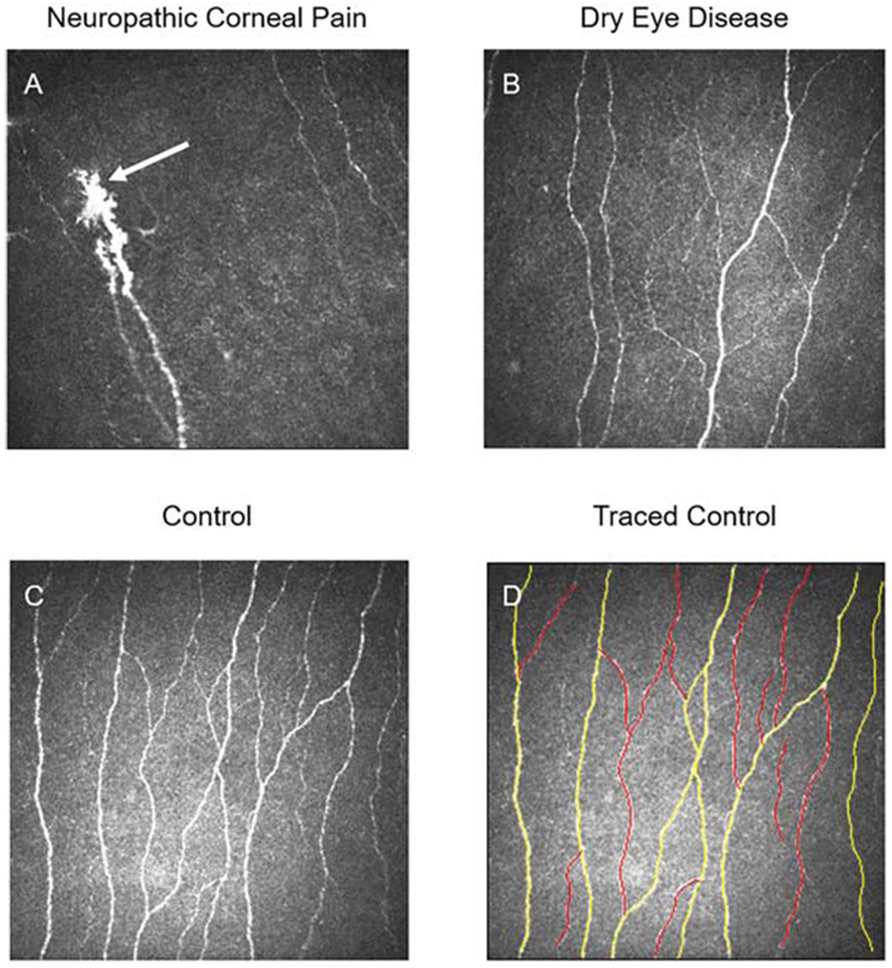
Figure 1. Representative in vivo confocal microscopy (IVCM) images of patients and controls to demonstrate dendritiform cell (DCs) changes. A) Presence of DCs in a patient with neuropathic corneal pain. B) DC density in a patient with dry eye disease shows a marked increase in comparison with normal controls. C) DCs are present as bright hyperreflective cell bodies in a normal control subject.

Statement of the Problem: The diagnosis of neuropathic corneal pain (NCP) is challenging, as it is often difficult to differentiate from conventional dry eye disease (DED). We have recently identified a potential novel biomarker by corneal in vivo confocal microscopy (IVCM), utilizing morphological nerve changes. The purpose of this study is to describe analytical and biological validation of this biomarker, and the develop utilize artificial intelligence for fully automated analysis of images in a rapid and consistent fashion. Methodology & Theoretical Orientation: A database of 500,000 IVCM images was used to confirm that the presence of microneuromas is a biomarker for NCP by comparing the sensitivity and specificity of identification of NCP patients via microneuromas to other IVCM parameters. Inter- and intra-observer precision was assessed, and descriptive statistics of the IVCM datasets was performed to determine the minimum number of images necessary for high precision of microneuroma detection. Biological validation of microneuromas was then performed, correlating IVCM results to clinical. An artificial intelligence (AI) program was developed and validated for automated identification of microneuromas to allow rapid and wide-scale adoption by clinicians. Findings: Analytical validation confirmed that the presence of microneuromas was a biomarker distinguishing NCP from DED, with good inter- and intra-observer precision. The AI system program had high sensitivity and specificity. Our model showed excellent discriminative ability to detect microneuromas (AuROC: 0.97) and the ability to generalize to data from a new institution (AuROC: 0.90). Conclusion & Significance: The AI system had a very high AUC for detecting microneuromas. The deep neural network shows great promise in identifying microneuromas associated with NCP, allowing for the standardization of IVCM image analysis. Our study suggests that artificial intelligence can rapidly evaluate IVCM images, while maintaining a high degree of accuracy.

Image
Recent Publications (minimum 5)
1. Qazi Y, Hurwitz S, Khan S, Jurkunas UV, Dana R, Hamrah P. Validity and Reliability of a Novel Ocular Pain Assessment Survey (OPAS) in Quantification and Monitoring of Corneal and Ocular Surface Pain. Ophthalmology. 2016,123:1458-1468. PMC5512896
2. Cruzat A, Qazi Y, Hamrah P. In Vivo Confocal Microscopy of Corneal Nerves in Health and Disease. Ocul Surf. 2017,15:15-47. PMC5512932
Ocul Surf. 2017,15:139-151. PMID 27816571
3. Dickmann G, Goyal S, Hamrah P. Neuropathic Corneal Pain. Approaches for Management. Ophthalmology. 2017,124:S34-S47. PMC5743225
4. Moein HR, Akhlaq A, Dieckmann G, Abbouda A, Pondelis N, Salem Z, Müller RT, Cruzat A, Cavalcanti BM, Jamali A, Hamrah P. Visualization of microneuromas by using in vivo confocal microscopy: An objective biomarker for the diagnosis of neuropathic corneal pain? Ocul Surf. 2020,18:651-656. PMID: 32663518
5. Bayraktutar BN, Atocha V, Farhad K, Soto O, Hamrah P. Autoantibodies Against Trisulfated Heparin Disaccharide and Fibroblast Growth Factor Receptor-3 May Play a Role in the Pathogenesis of Neuropathic Corneal Pain. Cornea. 2022 Oct 17. doi: 10.1097/ICO.0000000000003142. Online ahead of print. PMID: 36256257

 Biography

Dr. Pedram Hamrah is a clinician-scientist focusing his research on neuropathic corneal pain (NCP), neurotrophic keratopathy (NK) and dry eye disease. Dr. Hamrah trained at Schepens Eye Research Institute, Harvard Medical School, where his research resulted in findings that refuted a previous long-standing belief that the cornea is immune privileged due to the absence of bone marrow-derived cells resulting in a paradigm shift in corneal immunology. He has since focused on the area of corneal neuro-immune cross-talk, NCP, and NK, and has been spearheading diagnosis and treatment of NCP. His research has been supported by numerous NIH, foundation and industry grants. He has authored over 170 peer-reviewed articles, and has been the recipient of numerous awards, including the Claes Dohlman Society Award, the Senior Achievement Award from the American Academy of Ophthalmology and the was awarded Gold Fellow at the Association for Research in Vision and Ophthalmology.
Email: pedram.hamrah@tufts.edu

Notes/Comments:

Presenting author details
Full name: Pedram Hamrah, MD
Contact number: +1-617-636-5720
Twitter account: N/A
Linked In account: https://www.linkedin.com/in/pedram-hamrah-b747341/
Session name/ number:
Category: (Keynote presentation)

