DESIGNING THE ROUTE OF ADMINISTRATION OF COLCHICINE FOR PEDIATRIC PATIENTS BY OPEN SYSTEM PHARMACOLOGY
Prof. Abesh Das,
Department of Pharmaceutics, India

Abstract
Colchicine is a plant alkaloid derived from the bulb-like corms of the Colchicum autumnale (family: Colchicaceae). It is the drug that comes under the classification of an anti-gout agent because it shows anti-inflammatory activity by reducing swelling in the tissue. We see that normally 0.6 mg oral solid dosage forms are used for the treatment whereas the half-life of the drug is 26-32 hours approved by FDA. Colchicine is metabolized by CYP3A4 in the liver and de-methylated and formed two major metabolites (2-O-demethylcolchicine and 3-O-demethylcolchicine), and one minor metabolite (10-O-demethylcolchicine). All the pharmacokinetics and pharmacodynamics data are studied and incorporated into the Open System Pharmacology (PK-Sim) Software and we designed an in-silico model of 0.1 mg Colchicine suspension. The characteristics of the suspension are 10 µm diameters, polydisperse in nature and the administration protocol is once daily. It was discovered that AUC- 0.02 µmol×min/l, MRT- 19.25 hr., T_{max}-1.15 hr., and half-life-17.61 hr. of the formulation. For paediatric patients, the oral solid dosage form is difficult to swallow so the suspension is a more convenient dosage form. The drug requirement is less because body surface area and weight are less in the case of paediatric patients. In-silico study is more convenient because they are less cost-effective, as well as they prevent the wastage of drug.
Keywords: Colchicine, Anti-gout agents, Anti-inflammatory drugs, Pharmacokinetics, Pharmacodynamics, In-silico study, Open System Pharmacology, PK-Sim Software.
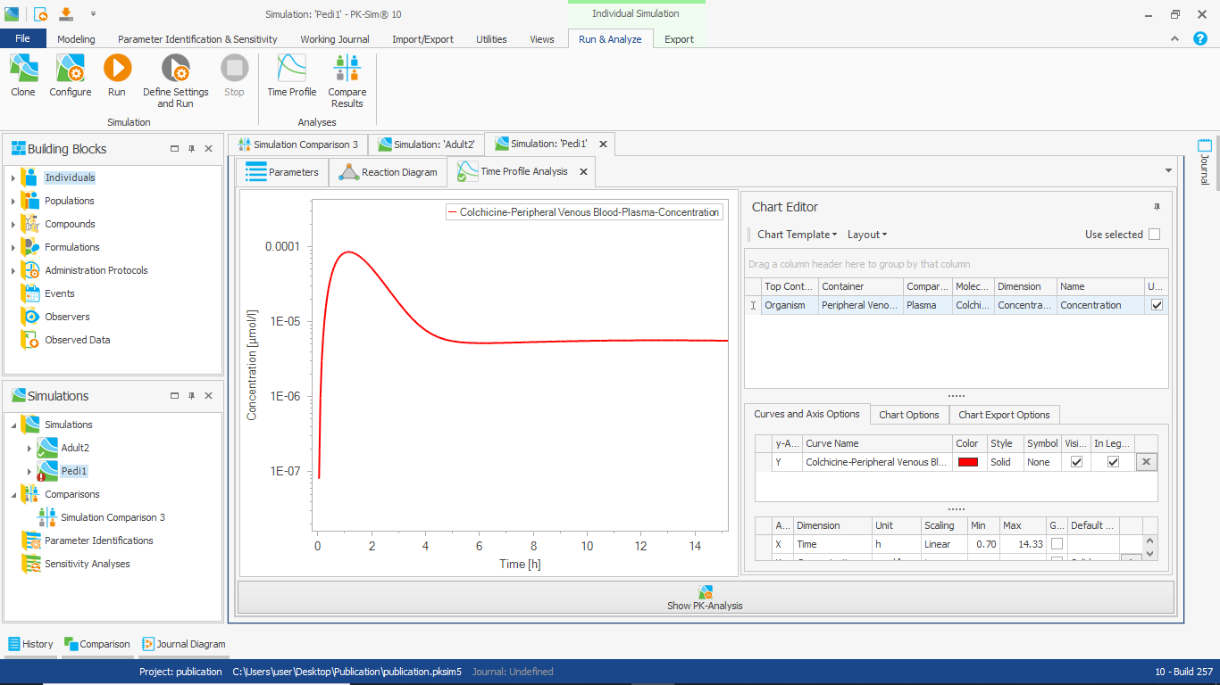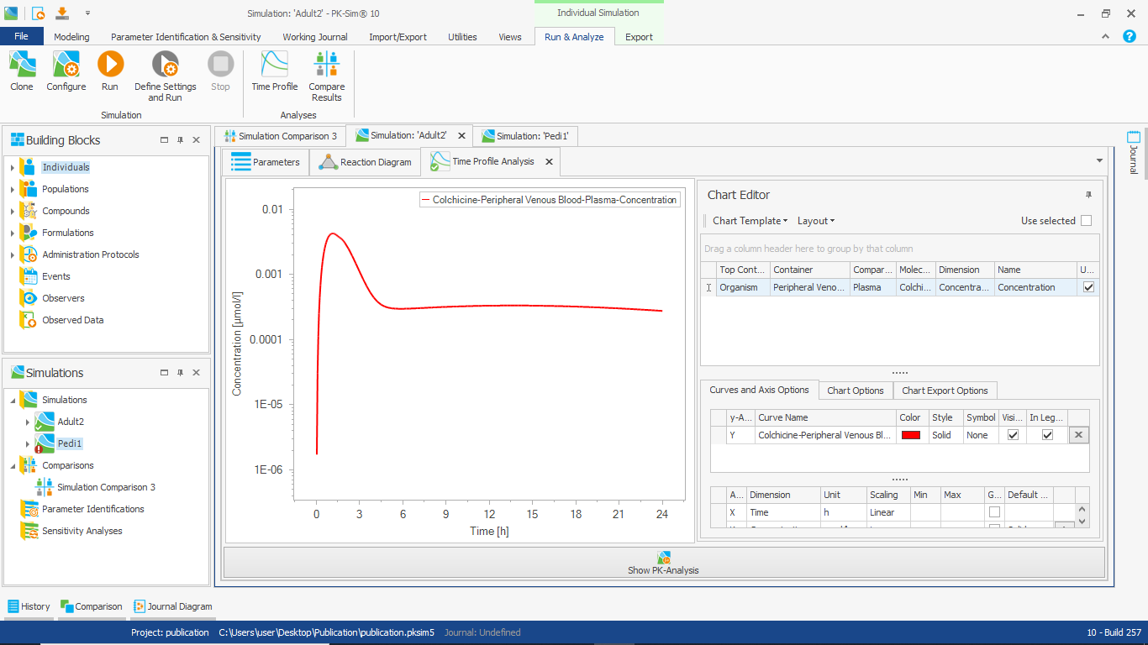
Figure 2: Time profile analysis concentration vs time of drug colchicine in adults.
Figure 1: Time profile analysis concentration vs time of drug colchicine in pediatrics.

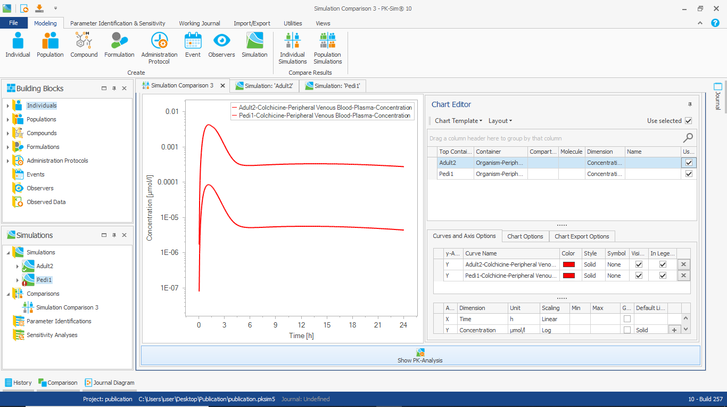
Figure 3: Time profile analysis concentration vs time of drug colchicine in pediatric vs adults.
Recent Publications
- Publication of research paper ‘Evaluation of Anthelmintic and Antimicrobial of the extract of the
- root of the plant Jasminum multiflorum’ doi.org/10.22270/jddt.v10i4.4219 .

- 2. Publication of Physiologically Based Pharmacokinetic Modeling of Paclitaxel and Prediction of Pharmacokinetic parameters after its Targeted Delivery to Brain, Liver, and Lungs.
- 3. Publication of Designing the Route of Administration of Colchicine for Pediatric Patients by Open System Pharmacology.

- 4. Publication of Physiologically-based Pharmacokinetic profiling of Ciprofloxacin after administration through Intravenous and Pulmonary routes.
- 5. Participated in a Webinar on “X-Ray Crystallography: An Interdisciplinary Science”


My Abesh Das and so far I have completed my Batchelor’s Degree from MAKAUT and after that, I have completed my Masters’s from the renowned university that is Guru Nanak Institute of Pharmaceutical Science and Technology. So far I have worked with various paper.
Email: abesh666@gmail.com

