Seaweeds Waste Biomass for a Clean and Sustainable Environment
Nour Shafik El-Gendy

Egyptian Petroleum Research Institute (EPRI), Nasr City, Cairo, Egypt
October University for Modern Sciences and Arts (MSA), 6th of October City, Giza, Egypt

Abstract

Millions tons of seaweeds waste biomass is annually produced all over the world. Such waste biomass is not economically reused, damaging our shorelines, affecting touristic activities and negatively impacting coral reefs, aquatic life and biodiversity. That consequently, negatively impacts the achievements of the sustainable development goals. Valorization of such wastes is a feasible process to reach a sustainable and clean environment. It can be successfully applied for; (1) production of valuable products; e.g. nano-materials, biocides, green- catalyst for biodiesel production and photo-catalytic degradation of different pollutants, (2) wastewater treatment, (5) production of different kinds of biofuels as complementary and/or alternative to ptero-fuels. Thus, valorization of such aquatic wastes with the concept of reaching zero-waste and achieving the circular economy is a promising criteria for accomplishing the three pillars of sustainability; economy, society and environment.

Recent Publications
- 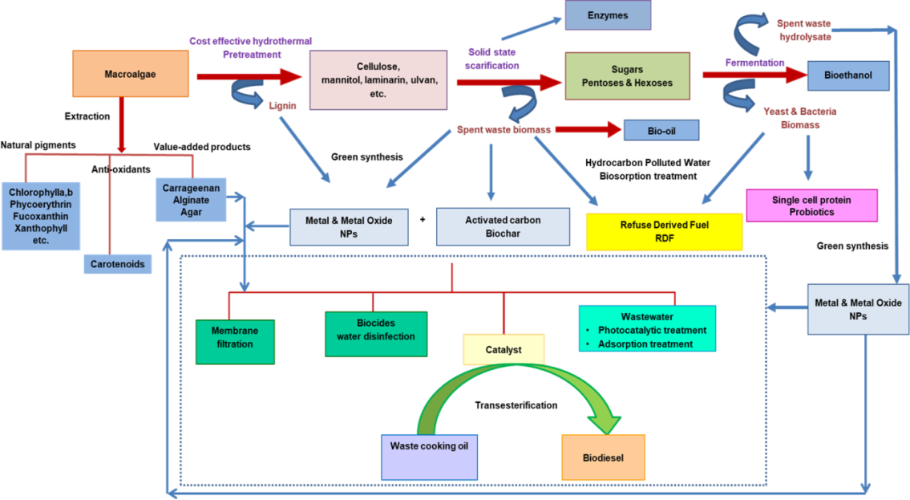A.R. Ismail, H.Kashtoh, M.A. Betiha, S.A. Abu Amr, K.-H. B. & N.Sh. El-Gendy (2022) “Valorization of waste cooking oil into biodiesel via Bacillus stratosphericus lipase amine- functionalized mesoporous SBA-15 nanobiocatalyst” International Journal of Chemical Engineering https://doi.org/10.1155/2022/7899996..
- H.N. Nassar, A.M. Rabie, S.A. Abu Amr & N.Sh. El-Gendy (2022)
“Kinetic and statistical perspectives on the interactive effects of recalcitrant polyaromatic and sulfur heterocyclic compounds and in-vitro nanobioremediation of oily marine sediment at microcosm level” Environmental Research 209, 112768.
- H.N. Nassar, W.I.M. El-azab & N.Sh. El-Gendy (2022) “Sustainable ecofriendly recruitment of bioethanol fermentation lignocellulosic spent waste biomass for the safe reuse and discharge of petroleum production produced water via biosorption and solid biofuel production” Journal of Hazardous Materials 422,126845
- A.F. Al-Sadek, B.K. Gad, H.N. Nassar & N.Sh. El-Gendy (2021) “Recruitment of long short-term memory for envisaging the higher heating value of valorized lignocellulosic solid biofuel: A new approach” Energy Sources, Part A: Recovery Utilization & Environmental Effects https://doi.org/10.1080/15567036.2021.2007179
- N.Sh. El-Gendy & Hussein N. Nassar (2021) “Biosynthesized magnetite nanoparticles as an environmental opulence and sustainable wastewater treatment” Science of the Total Environment 774, 145610.

Image


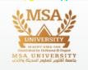

Biography
Dr. Nour Shafik El-Gendy is a Professor in the field of Environmental Sciences, Sustainable development, Clean Energy and Nano-Biotechnology. El-Gendy published 10 chapters, 9 books and 124 research papers, and supervised 29 MSc and PhD theses. She is also an editor and reviewer in 88 and 184 international journals, respectively. She participated also as PI, Co-PI or research member in research projects concerning with; biovalorization of wastes, solid waste management, bioethanol from lignocellulosic wastes; biofuels from algae, application of nanobiotechnology in upgrading of petroleum and bioremediation of polluted environment. El-Gendy is in international collaboration with many international universities and research institutes. Dr. El-Gendy established 4 ongoing research schools; Petroleum and Environmental Biotechnology, Environmental Nanobiotechnology, Biofuels, and Valorization of Solid Waste Biomass. El-Gendy is a member in many national and international associations and organizations concerned with petroleum industry, environmental health and sciences, sustainable development, water desalination, wastewater treatment, biofuel standards, nanotechnology, and environmental biotechnology.
Email: nourepri@yahoo.com

Notes/Comments:

Presenting author details

Full name: Nour Shafik El-Gendy Contact number: +201004510006 Mail id: nourepri@yahoo.com
Category: Virtual Invited Keynote Presentation

