Incidence of neonatal sepsis following prolonged rupture of membranes among patients admitted at the nicu of jose r. Reyes memorial medical center
Niko Miguel Z. Pasatiempo, Md Philippines
Grace Devota Go, M.D. Philippines

Abstract (300 word limit)
Neonatal mortality is a global burden and a significant number of neonatal deaths are attributed to early onset sepsis. Prolonged rupture of membranes is an important risk factor for the development of early onset neonatal sepsis (EONS).
This is a prospective cohort study which aimed to identify the incidence of early onset neonatal sepsis following prolonged rupture of membranes among patients admitted at the NICU of Jose R. Reyes Memorial Medical Center.
Results: Out of 105 neonates with maternal history of prolonged rupture of membranes of > 18hours in this study, incidence of neonatal sepsis was reported at 39% with a total of 41 neonates; 3 of them or 7.31% had culture proven sepsis. 64 neonates did not develop clinical signs consistent with sepsis. Majority of neonates in this study were born to term (>37 weeks) pregnancy at 89%, male sex outnumbered females with ratio 2:1, the birth weight of neonates is more than 2500g at 59%, majority were appropriate for gestational age at 83%. Most neonates were delivered via normal spontaneous delivery at 71%. With regards to WBC count, 77.14% belongs to the bracket of 9,000 – 20,000 WBC count with mean WBC count of 15,839. In Neutrophil Count, 61.90% had less than 60,000 with mean neutrophil count of 53,978. In Platelet Count, majority had more than or = 150,000 with 93.33%. Bacterial isolates found in one patient, Staphylococcus epidermidis and two patients with growth of Enterobacter cloace.
Conclusion: Prolonged rupture of membranes was found out to be significantly associated among mothers with history of maternal fever. Also, low birth weight (< 2500g) neonates was found out to be significantly associated with development of sepsis among newborns with prolonged rupture of membranes. Elevated WBC and elevated neutrophil counts were found out to be significant characteristics of neonates with sepsis.

Image
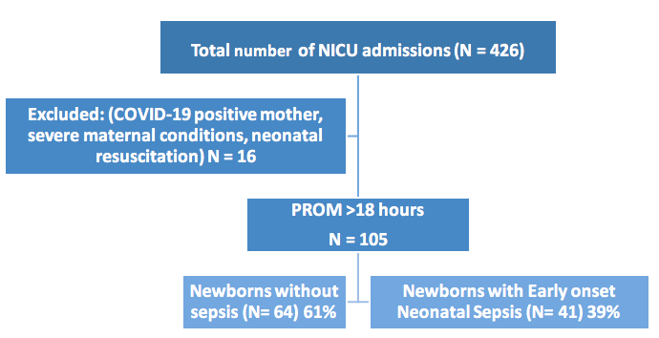


Paste your Logo here
Biography (150 word limit)
Dr Niko Miguel Pasatiempo underwent Pediatrics residency training in a government hospital in The Philippines wherein majority of pediatric patients are indigenous. He is passionate in taking care of well and sick children in hospital setting and mostly in community setting. Currently, he is deployed in a remote rural area of his country, providing medical service to the underserved and disadvantaged children, with regard to their health and welfare services.
Email: nikomiguelp@gmail.com

Notes/Comments:

Presenting author details
Full name: NIKO MIGUEL Z. PASATIEMPO
Contact number: +639166165922
Category: (Poster presentation)

