Lithium-ion battery anode properties of Li₄Ti₅O₁₂ nano sized powders prepared by hydrothermal synthesis

SALOUA MERAZGA, MRA, CRTSE CENTER, ALG
FATIMA BOUDEFFAR.ING, CRTSE CENTER, ALG
MALIKA BEROUAKEN, MRA, CRTSE CENTER, ALG
MOURED MEBARKI, DR, CRTSE CENTER, ALG
KATIA AYOUZ, MRA, CRTSE CENTER, ALG
BADIS RAHAL, MRA, CRTSE CENTER, ALG
NOURREDINE GABOUZE, DR, CRTSE CENTER, ALG

Abstract

The spinel (LTO) is an prime alternative to replace carbon anode in the commercialized Lithium-ion battery (LIBs).

Nano-sized Li4Ti5O12 powders with were synthesized by a Hydrothermal process and annalead at 800°C. The scanning electron microscopy(SEM) images shows that the morphology of LTO powders sizes in the range 70nm. X-ray diffraction (XRD) pattern confirm the formation of Li4Ti5O12 crystalline phase at 800 °C.

. The electrochemical properties of synthesizer nanopowders are investigated for use as an anode active material for lithium-ion batteries by galvanostatic techniques in Li-half cells, obtaining reversible discharge capacity of 173.8 mAh/g at 0.1C even upon 100 cycles. This is suitable for use as a high-power anode material for lithium-ion batteries.

Keywords: titanium dioxide, LTO, cathode, hydrothermal, lithium-ion battery.

- Cellulose-assisted combustion synthesis of Li4Ti5O12 adopting anatase TiO2 solid as raw material with high electrochemical performance. Journal of alloys and compounds, 477(1-2), 665-672. (2009)
- Kim, C. S., Moom, B. K., Park, J. H., Choi, B. C., & Seo, H. J.. Solvothermal synthesis of nanocrystalline TiO2 in toluene with surfactant. Journal of Crowth, 257(3-4), 309-315. (2003)
- Gauthier, N., Courrèges, C., Goubault, L., Demeaux, J., Tessier, C., & Martinez, H. Influence of the positive electrode on Li4Ti5O12 (LTO) electrode/electrolyte interfaces in li-ion batteries. Journal of the Electrochemical Society, 165(13), A2925.( 2018).

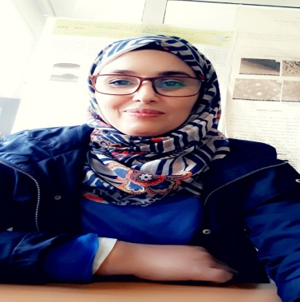Biography

SALOUA MERAZGA has received her PhD from Constantine in Thin Films. Now, She is a master of research A at CRTSE center. Her research is concentrated on the field of elaboration and characterization of powders and thin films of Mg and porous silicon for hydrogen storage application and hydrothermal synthesis powders for Lithium batteries cathodes.
Email: merazgsala@yahoo.fr

Presenting author details
Full name: Merazga saloua
Contact number: +21350521031
Twitter account:
Linked In account: https://www.linkedin.com/in/saloua-merazga-ph-d-b584b362/
Session name/ number:
Category: Oral presentation

