Diastema Closure; TREATMENT OPTIONS

Dr.Abu-Hussein Muhamad

Practice limited to Children's Dentistry

DDS, MSc D, MSc, M Dent Sci (Paed Dent), FICD

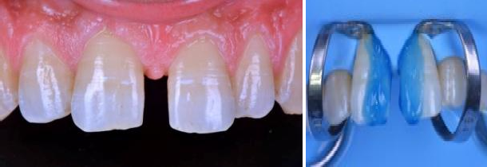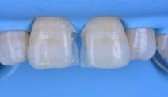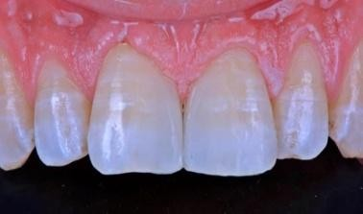
Closing midline diastemas with composite can be a challenge with achieving proper width, marginal staining, gingival emergence profiles and overhangs. Matrix bands can produce long flat contacts and wedges may lead to unsightly black triangles. This live, step-by-by step interactive presentation focuses on Dr. Abu-Hussein M. simplified technique that quickly establishes ideal width, proximal contact and contour without removing any tooth structure and requiring minimal finishing. Participants will also learn and perform polishing and surface texturing that will further produce predictably natural-looking long term restorations.

Who Should Attend This Course:
- General Esthetic Dentists
- RRDH (Dental Hygienists with a designation to perform Restorative procedures)

Course Outcomes & Hands-On Learning Objectives

- Learn how to use the pull-through technique for tight diastema contacts;
- Finishing and polishing technique to prevent white lines;
- Learn the ideal technique for shade selection.

Biography

Name: .ABU-HUSSEIN MUHAMAD
Country: Greece

Email: abuhusseinmuhamad@gmail.com
Ph No: 6980114292

-DDS 1986 ,DPD(Drodont)Dentistry for Children1988
-International Short-Term Programme in Orthodontics1994,6WEEKS Aarhus,Denmark
-Postgraduate taught course (two-years) in Oral Biology/Pathology, Dental Faculty, University of Athens 1998

-Master of Biostatistics,School Mathematics/Medicine,Athens2001
Postgraduate Bioesthetic Dentistry. OBI,International Faculty
-Diploma. Roth/Williams Center for Functional Occlusion

