Barriers to Quality Oral Health Care among Elderly (Geriatric) Patients in a southwestern Nigerian state.

Presenter; Balogun A.O, BDS,FMCFD

Statement of the problem: Nowadays, people are not only living longer but also retaining their natural teeth into old age. The oral health treatment needs of elderly people can be complex because of reduced mobility, compromised physical and mental states amongst others. These make oral hygiene and treatment more difficult. Despite their increased need, the uptake of dental care by elderly people is characteristically poor and unmet needs may be high due to barriers to oral health as shown by previous studies. This study therefore set out to investigate the specific barriers in our environment. Methodology and theoretical Orientation: A cross- sectional study in which multistage sampling was used to enroll 500 patients, aged 65 years and above who were attending selected health care centers in Oyo State. A structured interviewer administered questionnaire and modified WHO clinical assessment form were used to determine their oral health status. Findings: Mean age was 74 ± 10 years with more female respondents (51.0%).Mean DMFT of 5 and CPITN of 2 indicated that there was a need for dental care among the participants. Less than a tenth (8.6%) of the study population had accessed dental care in the past 12 months. Fear of pain constituted the barrier with highest ranking among the respondents in this study (62.0%). Frightening dental instruments and noise from dental instruments were some of the factors preventing the elderly from seeking oral health care in Oyo State. Conclusion and Significance: Though oral health care access is available in the public sector, the study found that there were unmet dental treatment needs among the elderly due to some financial and personal barriers experienced.
Recent publications:

- Gopalakrishnan A, Kahu E, Jones L, Brunton P. Access and barriers to oral health care for dependent elderly people living in rest homes. Gerodontology. 2019 Jun;36(2):149-55.
- Janto M, Iurcov R, Daina CM, Neculoiu DC, Venter AC, Badau D, Cotovanu A, Negrau M, Suteu CL, Sabau M, Daina LG. Oral Health among Elderly, Impact on Life Quality, Access of Elderly Patients to Oral Health Services and Methods to Improve Oral Health: A Narrative Review. Journal of Personalized Medicine. 2022 Feb 28;12(3):372.

- Ribeiro GR, Costa JL, Ambrosano GM, Garcia RC. Oral health of the elderly with Alzheimer's disease. Oral surgery, oral medicine, oral pathology and oral radiology. 2012 Sep 1;114(3):338-43.
- Masood M, Newton T, Bakri NN, Khalid T, Masood Y. The relationship between oral health and oral health related quality of life among elderly people in United Kingdom. Journal of dentistry. 2017 Jan 1;56:78-83.
- Gaszynska E, Szatko F, Godala M, Gaszynski T. Oral health status, dental treatment needs, and barriers to dental care of elderly care home residents in Lodz, Poland. Clinical interventions in aging. 2014;9:1637.

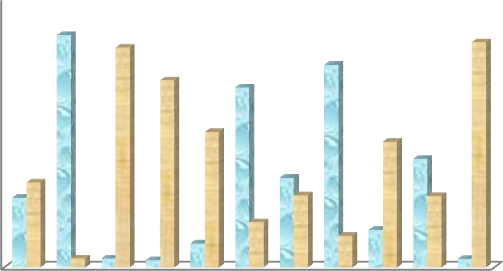500
No. of responses of the participants

400

300

No. of Positive responses

200

100
No of Negative responses

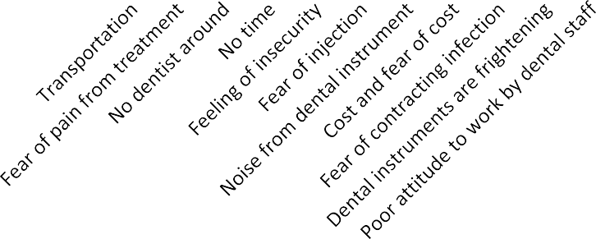
0

Figure 1:Barriers to dental and oral care in the elderly

Biography of the presenter
Balogun Abimbola is a researcher whose interest is on oral health delivery to the elderly. Oral health care must be accessible to every segment of the population so as to bridge the gap between the need for care and the amount of care being sought. In order to achieve this, the barriers preventing elderly people from accessing the oral health care services must be put into consideration and access to oral health in the elderly need to be accorded utmost priority.
Date of Birth: 5th October, 1976 Nationality: Nigeria
Gender: Female Address:
Marital Status: Married Tel: 07066785708
State of Origin: Oyo E-mail: josbalo510@gmail.com
Religion: Christianity

EDUCATION:
- National Postgraduate Medical College Of Nigeria:
Fellowship of Medical College Family Dentistry (FMCFD) 2015
- University of Ibadan : Bachelor of Dental Surgery 2003
- Wesley College of Science, Elekuro, Ibadan (SSCE) 1994
WORK HISTORY
Consultant Family Dentist, University College Hospital, Ibadan 09/2019 to date

