3D CLEANING : CLINICAL APPROACHES
Wahiba Lagmou, DDS, MSC, Moroccan Academy of endodontics, Morocco

Abstract
Image

To promote root canal disinfection and debris removal, effective irrigant delivery and agitation are prerequisites, helping to improve and achieve a successful endodontic treatment.
Several different systems of irrigant activation are available to improve endodontic disinfection, integrating new technologies, coupled with enhanced techniques and materials.
With all these systems, the practitioner should quantify the need and aim of these different approaches depending on each case.
For this purpose, our presentation aims to describe the current and future views on disinfection, while concluding effective clinical approaches to improve the cleaning of the endodontic space and their debridement efficacy, and help everyday clinical practice.

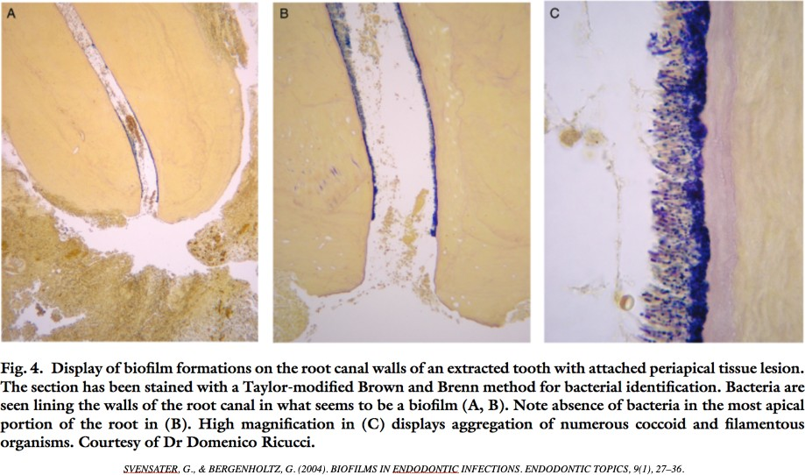

Recent Publications (minimum 5)
- Yogesh Damade , Ramchandra Kabir , Sunanda Gaddalay, Sharvaree Deshpande, Sonali Gite, Sandip Bambale, Nileshkumar Dubey (2020) Root canal debridement efficacy of heated sodium hypochlorite in conjunction with passive ultrasonic agitation: An ex vivo study . J Dent Res Dent Clin Dent Prospects; 14(4): 243-248
- Plotino et al. (2021) Evaluation of smear layer and debris removal by stepwise intraoperative activation (SIA) of sodium hypochlorite. Clinical Oral Investigations,, Vol: 25 (1), p: 237-245,
- ABOUZAID K, DHAIMY S. (2021); Efficacy of Sonic Versus Ultrasonic Irrigation in Debris Removal from the Root Canal System: A Systematic Review. Oral Health Dental Sci. 5(3); 1-13.
- ABOUZAID K, DHAIMY S. (2021) Antibacterial Efficacy of Sonic Versus Ultrasonic Irrigation of the Root Canal System: A Systematic Review. Oral Health Dental Sci. 2021; 5(4); 1-14.
- ELNAGHY AM, MANDORAH H, ELSAKA SE. (2017) Eﬀectiveness of XP-Endo Finisher, EndoActivator and File agitation on debris and smear layer removal in curved root canals: a comparative study. Odontology, 105: 178-183

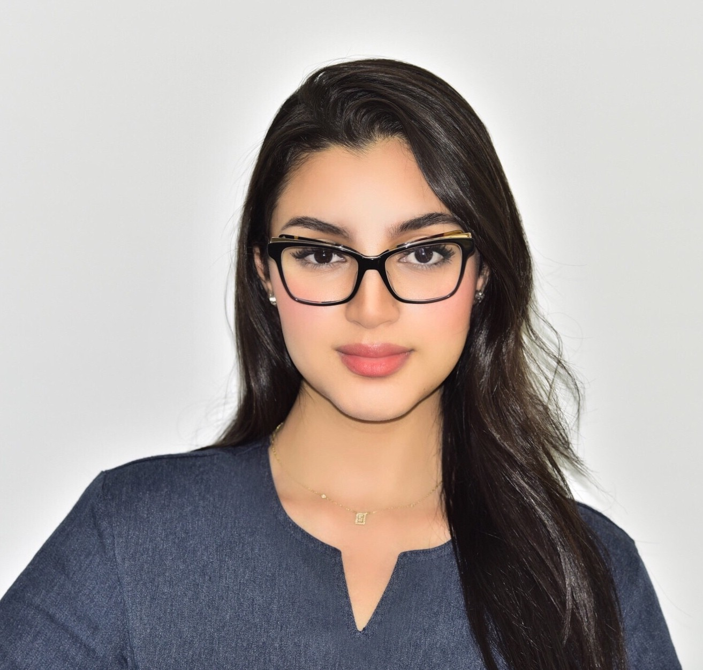
Biography

Dr Lagmou Wahiba obteined her Doctorate in dental medecine in the School of Dentistry University Hassan II,Casablanca, Morocco. She then obteined a Postgraduate university degree in advanced endodontics from Universita degli study di Genova in Genoa, Italy. Dr. Wahiba also has a Certificate of competency in advanced endodontics From the Moroccan Academy of endodontics And a Certificate of competency in prosthodontics From the Moroccan Academy of prosthodontics. She presented different lectures in different congresses.
Dr Wahiba is the Secretary general and the Academy Training coordinator of the Moroccan Academy of endodontics and was the Secretary general of the 6th Pan Arab Endodontic Conference 2020 which occurred in Marrakech, Morocco.

Email : wahibalagmou@gmail.com

Notes/Comments:

Presenting author details

Full name: Lagmou Wahiba Contact number: +212634437142 Mail id: wahibalagmou@gmail.com Category: Oral presentation

