Aetiology of tooth wear and treatment options
Ali Ghareeb Altamimi BDS, MclinDent, M Pros (Edin)

Abstract (300 word limit)

The presence of tooth wear condition does not reflect only the individual’s status of his oral health but also the development of the dental care system available to the patient. the survival of teeth for a long time in society we live in is different from one generation ago, which marks an unprecedented era where the number of remained dentition for elderly has increased: patients aged 65 to 74 years old had an average of at least five more of their dentitions in 2014 compared to 1997. Also, an increase in tooth wear incidence is reported in the young adult population, suggesting a new strategy/approach of preventive dental measures. Tooth surface loss is a non-carious and multifactorial condition with at least one or more factors contributing to its primary aetiology. The tooth surface loss aetiology should be recognized to draw a comprehensive treatment plan that suits the patient’s needs. The terms attrition, abrasion, abfraction and erosion have been used to define tooth surface loss and dental biomaterials. These terms describe clinical manifestations of morphological changes of teeth during underlying events.
Image
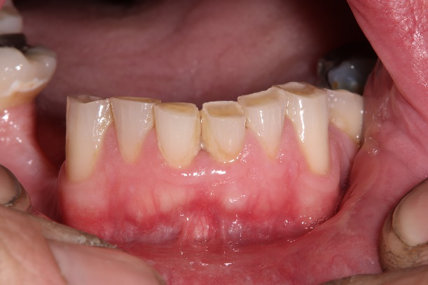
Recent Publications (minimum 5)
- Baelum, V. et al. 2007. A global perspective on changes in the burden of caries and periodontitis: implications for dentistry. Journal of oral rehabilitation 34(12), pp. 872–906; discussion 940.
- Fejerskov, O. et al. 2013. A functional natural dentition for all--and for life? The oral healthcare system needs revision. Journal of oral rehabilitation 40(9), pp. 707–722.
- Steele, J.G. et al. 2012. Adult Dental Health Survey 2009: transformations in British oral health 1968-2009. British dental journal 213(10), pp. 523–527.
- Sterenborg, B.A.M.M. et al. 2018. Impact of tooth wear on masticatory performance. Journal of dentistry 76, pp. 98–1015.
- Varma, S. et al. 2018. The management of tooth wear with crowns and indirect restorations. British dental journal 224(5), pp. 343–347.

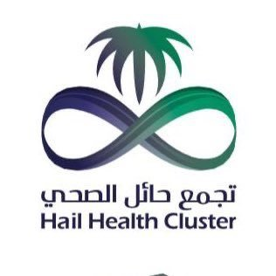

 Biography (150 word limit)
Ali AL-Tamimi is consultant in Prosthodontics at Haíl Dental hospital and Ministry of Health in Saudi Arabia, Assistant Professor of Prosthodontics at University of Ha’il and Registered Prosthodontist in Saudi Arabia. He is a graduate of the King Saud University and received BDS degree And Master of clinical dentistry from Cardiff University. He holds the membership of Prosthodontics from the Royal College of Surgeons of Edinburgh.
Email: ag.altamimi@gmail.com

Notes/Comments:

Presenting author details
Full name: ag.altamimi@gmail.com
Contact number: 00966542917772
Mail id: ag.altamimi@gmail.com
Category: Oral presentation

