Evaluation of the Efficacy of Injection Platelet-rich fibrin(I-PRF) in Accelerate Alignment and Leveling and pain perception
Ali Ghssan Rokia, PhD, Orthodontics and Dentofacial Orthopedics, Syria

Abstract (300 word limit)
Background: The long duration of orthodontic treatment is one of the factors that reduce the desire of patients to undergo orthodontic treatment. Many methods have been devised to accelerate the orthodontic movement .The injection of platelet rich fibrin(I-PRF) is one of the modern methods, whose role is still unknown in accelerating dental movement and reduction in the duration of orthodontic treatment.
Objectives. the aim of this study is to evaluate the effectiveness of injection I- PRF to accelerate alignment and leveling of the upper anterior teeth and reduce the time required for treatment and pain perception during the first week of the alignment and leveling process.
Material and Methods: The sample consisted of 18 patients (11 famales,7 males), who needed the alignment and leveling of upper anterior teeth, The patients were randomly assigned to 2 groups: the study group would be injected platelet rich fibrin (I-PRF) and a control group for which only brackets would be applied. The treatment progress was evaluated at 3 time stages, and the studied variables were the alignment and leveling Improvement .The pain parameters of each patient were evaluated for both groups during the first week of the alignment and leveling process by application of the (VAS) at the durations of (2 hours, 6 hours, 1 day, 2 days, 7 days)
Results. The results of the study showed that platelet rich fibrin injection I-PRF was ineffective in accelerating the alignment and the leveling process(P >0.05) PRF injection can reduce pain perception in orthodontic patients, overall (P<0.05), with an effect size of approx. 53±0.13%. The biggest effect was observed 2 hours after exposure (P<0.1) which showed a 50% reduction in pain in the PRF group.
Conclusions. Injection platelet rich fibrin I-PRF is ineffective in accelerating orthodontic movement. PRF injection can be an effective alternative for decreasing pain perception levels.

Paste your Logo here

Image

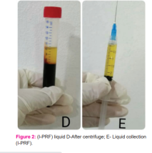

Recent Publications (minimum 5)
- Ashkenazy S, Ganz FD. The Differentiation Between Pain and Discomfort: A Concept Analysis of Discomfort. Pain Manag Nurs 2019;20:556-62.
- Miron RJ, Kobayashi MF, Hernandez M, Kandalam U, Zhang Y,Ghanaati S, et al. Injectable platelet- rich fibrin (I-PRF): Opportunities in regenerative dentistry? Clin Oral Investig 2017 Nov;21(8):2619-2627.
- Pereira CP, Pereira JR, Dick BD, Perez A, Flores-Mir C. Factors associated with patient and parent satisfaction after orthodontic treatment: a systematic review. Am J Orthod Dentofacial Orthop 2015Oct; 148(4):652-9.
- Kau CH, Kantarci A, Shaughnessy T, Vachiramon A, Santiwong P, de la Fuente A et al. Photobiomodulation accelerates orthodontic alignment in the early phase of treatment. Prog Orthod 2013 Sep 19;14:30.
- Choukroun J, Adda F, Schoeffler C, Vervelle A. Une opportunité en paro-implantologie: Le PRF. Implantodontie 2001;42:55-62.

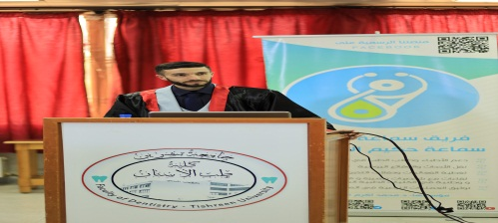
Biography (150 word limit)
Ali Rokia enjoys his experience in the field of orthodontics and oral health. Work has been working for a long time to accelerate orthodontic treatment after conducting research for a long period of time with the aim of shortening the duration of treatment and reducing the softness of the material for patients. We look forward to conducting more future research in order to employ our experience

Email: aliandalus2017@gmail.com

Notes/Comments: No Comments

Presenting author details
Full name: Ali Ghassan Rokia
Contact number:+963937969646
Mail id: aliandalus2017@gmail.com
Category: (Oral presentation/ Poster presentation)

