Oral Health & Dental Science

Isolated Case of nonsyndromic hyperdontia in maxillary jaw
Ammer haloum.
Correspondence: Ammer haloum, faculty of dentistry, university of kalamoon, Deratiah, Syria, aamer.haloom.dent@gmail.com, Tel: +963981259115.
Citation: Ammer Haloum. Isolated Case of nonsyndromic hyperdontia in maxillary jaw, Oral Health Dental Sci.

Abstract

Hyperdontia is defined as an extra deciduous or permanent tooth in any of the dental arch quadrants, often detected during routine dental X-ray or CT scan and clinical examination or incidentally, early diagnosis protect the patients of clinical problems of hyperdontia, it can be erupted or remain impacted, the supernumerary teeth is asymptomatic, but some patient complains of pain and discomfort due to location of supernumerary teeth, malocclusion or esthetic affect, the etiology is unknown, but it is often associated with complex syndromes, in addition to occurring in isolated cases (nonsyndromic). In this case report I highlight of isolated case of hyperdontia in a 23-year-old male, asymptomatic diagnosis incidentally.

Keywords
Hyperdontia, Supernumerary teeth, Maxillary fourth molar, abnormalities of tooth number.

Introduction
hyperdontia is defined as odontogenic structure for a dentition with extra deciduous or permanent tooth in dental arch, the additional tooth is termed supernumerary, it can be found almost any region in the oral cavity. The supernumerary teeth may have features of the group it may belong, molar, premolars, anterior teeth, may like correspondence in size, shape and orientation to the teeth which it is associated.
they may be seen in primary or permanent dentition which may be unilateral or bilateral. occur as isolated cases but more frequently as clinical symptom of some syndromes. Hyperdontia according to the researchers it occurs more often in the maxilla than in the mandible (8:1), Especially in anterior or premaxillary region. Affect M < F (2:1), Associated with 49 genetic syndromes known to human. The prevalence of hyperdontia has been reported in several studies with variation between different ethnic group, According to Anthonappa et al. the prevalence ranged from 1.2 to three percent. [‎1]
However, these ranges dissimilar according the racial differences, age of patient, varying study protocols diagnostic criteria.
The supernumerary teeth can be classified depending to the location or position, and shape of the tooth, The most common supernumerary tooth is mesiodens, that situated near of midline between the maxillary central incisors, usually located palatal to the permanent incisors, either erupted or impacted, the mesiodens is conically shaped crown and short root. The second common supernumerary tooth is paramolar that situated near the maxillary second and third molars, some authors reported as a maxillary fourth molar, the tooth erupted buccal or lingual to the erupted molar, which can be fully development or microdont. When the tooth erupted behind or distal to the third molar and the tooth is rudimentary, the term distomolar is used.
Mesiodens is the most prevalent form of supernumerary teeth in permanent dentition that occurs as a result of genetic and environmental factors and hyperactivity of dental lamina. Males are affected two folds than the females. [‎2]

Aetiology
The aetiology of hyperdontia is still not fully understood, but there are several theories may explain the cause such as genetic factor, dichotomy of tooth germs, dental lamina hyperactivity theories, unclear environmental and atavism but the atavism theory has been largely discounted. most literature supports the dental lamina hyperactivity theory. The supernumerary teeth may be single or multiple, unilateral or bilateral, erupted or unerupted. In the multiple supernumerary teeth usually, it is related to a complex syndrome such as Gardner syndrome that caused by a mutation in the adenomatous polyposis coli (APC) gene on chromosome 5 and cleidocranial dysplasia that affecting the face, skull and clavicles linked to a defect in a gene known as RUNX2. Hyperdontia is less common in Fabry disease and Ehler-danlos syndrome. [‎3-‎4]
Herein, I reported an isolated case of asymptomatic maxillary hyperdontia in a male patient.

Case Report
A 23-year-old male consulted the faculty of dentistry because of mild pain of upper right first molar.

History of present illness
The patient complained of 1-week history of mild pain when he eating. The patient denied any history of systemic symptoms, the treatment was RCT for the upper first molar and full crown, however, the hyperdontia was detected by accident

Clinical examination
On clinical examination all the 32 tooth was erupted except the supernumerary tooth that located distal to the upper left third molar (distomolar) on the OPG, Occlusion was stable and there was no movement in teeth.
The supernumerary tooth was found in maxilla and it was impacted, his facial appearance was normal, there was no swelling or malocclusion.

Radiographic examination (OPG)
There was a supernumerary tooth located distal to the upper left molar, according to the classification the supernumerary tooth was (distomolar). The tooth dimensions are about 8 mm, and about 5.5 mm wide.
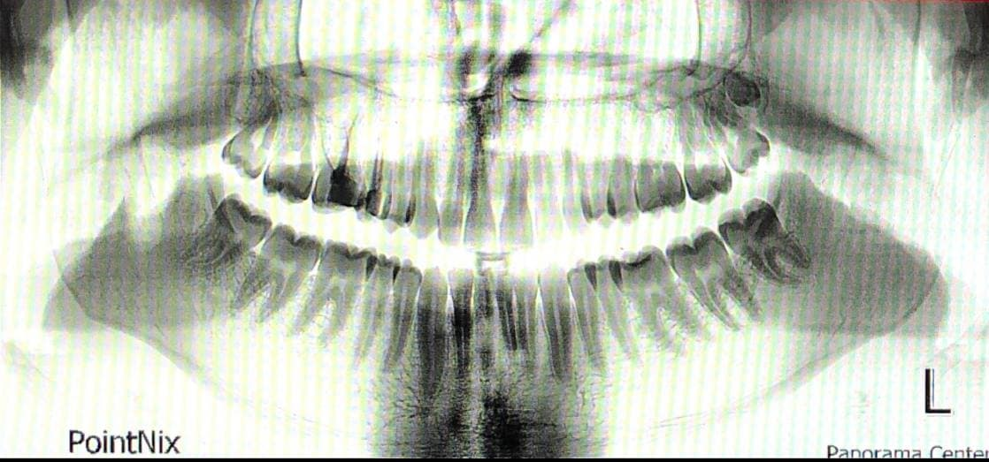
Figure 1 Orthopantomogram (OPG) showing the supernumerary tooth located distal to upper left third molar.
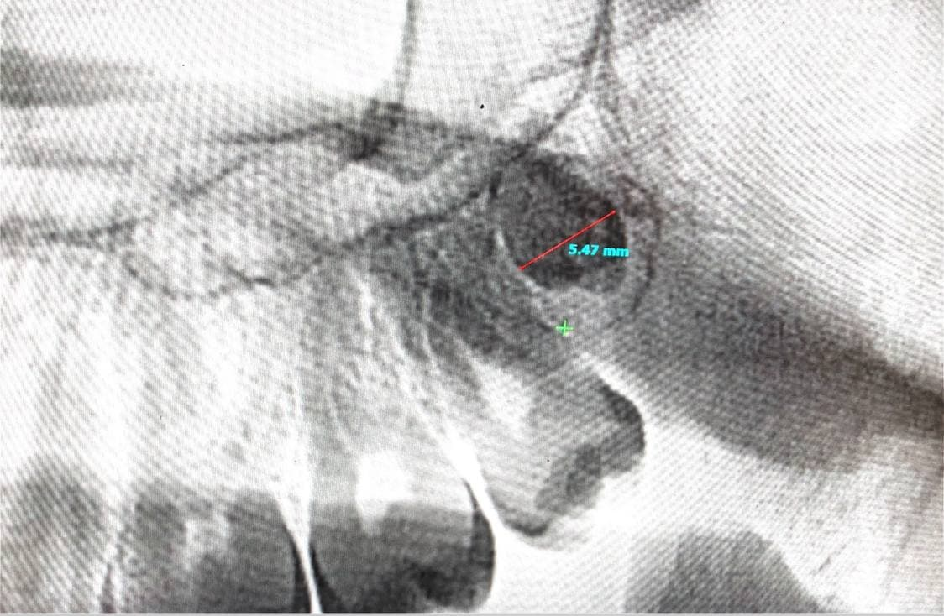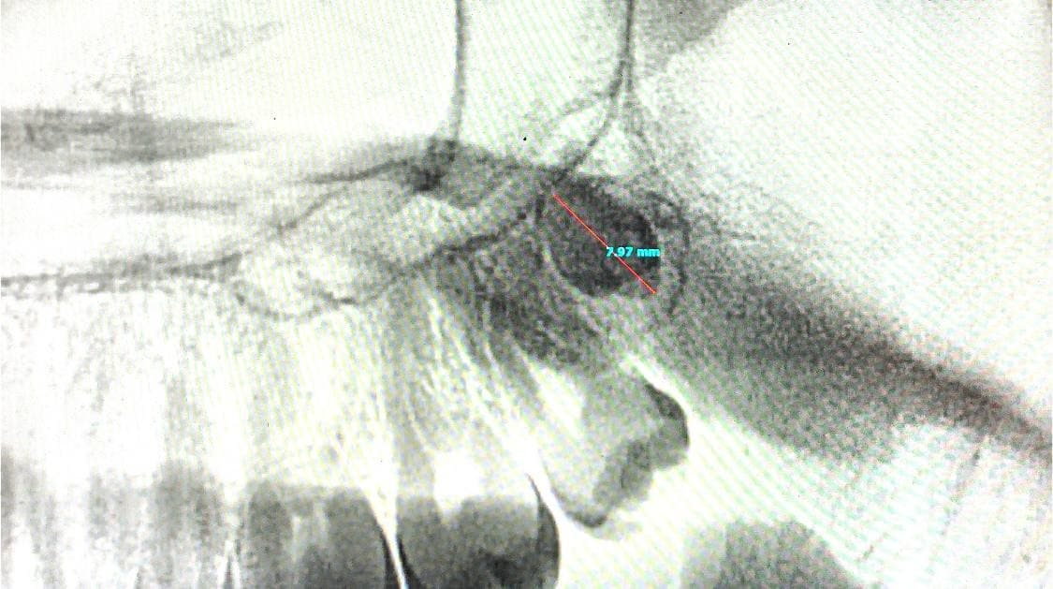
Figure 2 orthopantomogram (OPG) showing the dimensions.

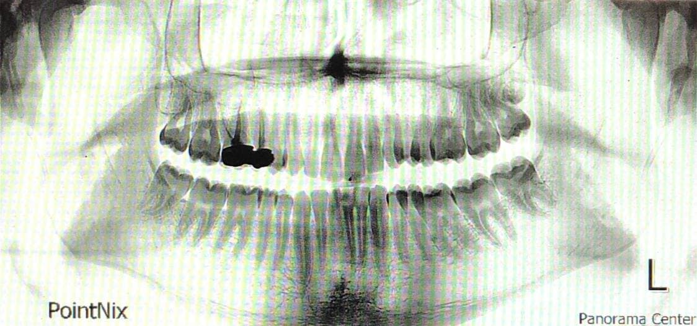
Figure 3 Orthopantomogram (OPG) showing follow up after 6 months.
The supernumerary tooth after 6 months begins to erupt and push up the third molar and the distal root is curved due to eruption of the supernumerary tooth.

Discussion
Hyperdontia or the supernumerary teeth is defined as teeth exceed of normal dental formula regardless of their location or morphology, the hyperdontia can occur in healthy patient with no symptomatic and no complex syndrome.
Tay et al. reported that 74 to 93 percent of the maxillary anterior supernumeraries were accompanied with a disruption of some kind of eruption and occlusion of the permanent incisors. [‎5]
Kurt et al. reported the presence of distomolar in this population was found to be 0.32%. In total, 55 distomolar teeth were detected in 45 patients. All distomolars were found in maxilla and majority of them were impacted (n=51, 92.7% of the distomolars). 19 distomolars were found bilaterally in nine cases (0.06%). In one patient, two distomolars were detected in the maxilla in which one in left and the other in the right side. [‎6]
The prevalence of mesiodens was estimated as 0.1%. Males were more frequently affected than females in the ratio of 2.3:1. Of the 83 mesiodens, 48.2% were conical, 31.3% were tuberculate and 20.5% were incisor like, 22.9% were inverted, and 68.7% were fully impacted. The number of mesiodens was one in 36 cases (61.0%), two in 22 cases (37.3%) and three in one case (1.7%). The mean age at the time of diagnosis of the mesiodens was 9.5 years. [‎7]
In addition, it has been suggested that the dental lamina hyperactivity theory is most acceptable by authors.

Conclusions
The hyperdontia, especially distomolar are unfamiliar, it is important to get x-ray every 6 months to make sure that the supernumerary tooth it doesn’t cause any problems such as malocclusion, overcrowding or delayed eruption of permanent teeth.
Hence, early diagnosis and proper treatment planning for such uncommon cases is necessary to avoid further complication and a long-term follow up is essential in these cases.

References

- Anthonappa, R. P., King, N. M., & Rabie, A. B. (2013). Prevalence of supernumerary teeth based on panoramic radiographs revisited. Pediatric dentistry, 35(3), 257–261.
- Dr. K Srinivasan, Dr. S Chitra. Mystery behind hyperdontia: Report of two cases. Int J Appl Dent Sci 2015;1(5):05-09
- Langlais, R. P. (2021). Color Atlas of Common Oral Diseases 4th (forth) edition [E-book].
- Rushworth, B., & Kanatas, A. (2020). Oxford Handbook of Clinical Dentistry (Oxford Medical Handbooks) (7th ed.) [E-book]. Oxford University Press.
- Tay F, Pang A, Yuen S. Unerupted maxillary anterior supernumerary teeth: report of 204 cases, J Dent Child. 1984; 289-94.

