Thyroid Enlargement after Administration Of Long-Acting Gonadotrophin Agonist In Management Of Fibroids

Lim Shu Hui, MBBS MRCOG, KK Women’s and Children’s Hospital

Celene Hui, MBBS MRCOG FAMS, KK Women’s and Children’s Hospital

Abstract (300 word limit)

Introduction

Uterine fibroids are the most common benign tumors in women. Management options include pharmacological, interventional radiological, MRI-guided focused ultrasonography and surgery. Gonadotrophin-releasing hormone agonists (GnRH-a) can be used to decrease fibroid volume. Common side effects of GnRH-a administration include hot flashes, irritability, breast tenderness, and pain at injection site. This case report documents thyroid enlargement as a possible effect of GnRH-a administration.

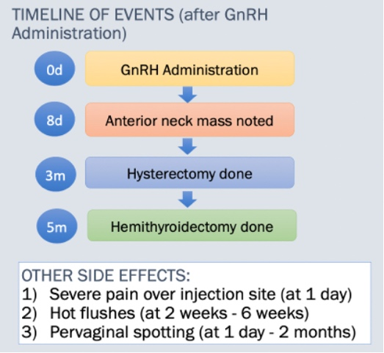
Fig 1: Timeline of events after GnRH administration

Case Report
A 43 year old lady presented with a 13.3 x 12.8 x 9.2cm anterior fibroid. Her hysterectomy was postponed, hence a single dose of intramuscular leuprolin acetate 11.25mg was administered as a temporizing measure for her symptoms. This decreased fibroid volume by 27.5% to 11.6 x 9.6 x 10.2cm, comparing radiological measurements of the fibroid on presentation with the measurements taken 2 months after the injection. 8 days after GnRH-a administration, the patient visited the general practitioner complaining of a 5cm anterior neck mass (Fig 2).
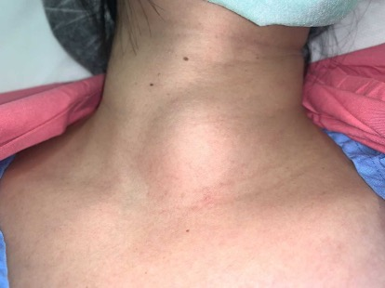
Fig 2: Anterior neck mass
Investigation showed multiple nodules on thyroid ultrasound (Fig 3), but normal thyroid function.

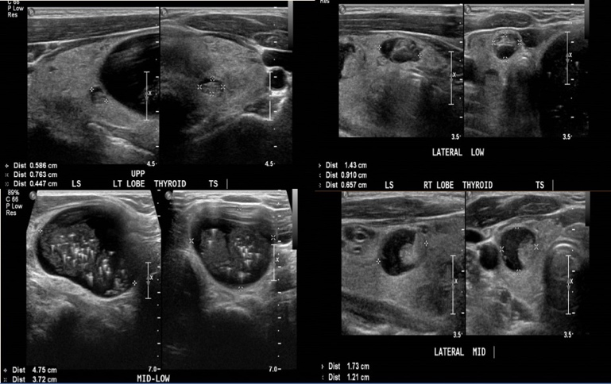

Fig 3: Thyroid ultrasound

She underwent a left hemithyroidectomy 5 months after GnRH-a administration in view of persistent globus sensation from the mass. Final histology demonstrated benign multinodular goiter. Thyroid function remained normal prior to the hemithyroidectomy.

Discussion/Conclusion
It is postulated that fluctuations in serum gonadotropin and sex hormones induced by GnRH-a may trigger thyroid dysfunction or aggravate underlying thyroid disease. This is proposed to be due to the fall in estrogen inducing an immune rebound and worsening preexisting subclinical or mild autoimmune disease, mirroring postpartum thyroiditis. The association between GnRH-a and thyroid dysfunction remains controversial, as no studies in current literature can establish a cause-and-effect relationship. More good quality clinical studies are required to prove a direct relationship between GnRH-a and thyroid disease. However, it may be prudent for physicians to screen for underlying thyroid disease before administration of GnRH-a.

Recent Publications (minimum 5)
- Kasayama S, Miyake S, Samejima Y. Transient Thyrotoxicosis and Hypothyroidism Following Administration of the GnRH Agonist Leuprolide Acetate. Endocrine Journal. 2000Dec;47(6):783–5.

- Amino N, Hidaka Y, Takano T, Tatsumi K-I, Izumi Y, Nakata Y. Possible Induction of Graves Disease and Painless Thyroiditis by Gonadotropin-Releasing Hormone Analogues. Thyroid. 2003;13(8):815–8.

- Eyal O, Rose SR. Autoimmune thyroiditis during leuprolide acetate treatment. The Journal of Pediatrics. 2004;144(3):394–6.

- Han EJ, Song HD, Yang JH, Park SY, Kim SH, Yoon HK, et al. Thyroid Dysfunction Associated with Administration of the Long-Acting Gonadotropin-Releasing Hormone Agonist. Endocrinology and Metabolism. 2013Sep13;28(3):221.

- Yilmaz N, Hancerliogullari N, Kara M, Engin-Ustun Y. Is gonadotropin-releasing hormone agonist usage really leading to thyroid dysfunction? Interventional Medicine and Applied Science. 2019Nov;:1–3.

- Amino N, Tada H, Hidaka Y, Izumi Y. Postpartum Autoimmune Thyroid Syndrome. Endocrine Journal. 2000;47(6):645–55.

- Amino N, Tada H, Hidaka Y. Postpartum Autoimmune Thyroid Syndrome: A Model of Aggravation of Autoimmune Disease. Thyroid. 1999;9(7):705–13.

Biography

Dr Lim Shu Hui is a Senior Resident in Obstetrics and Gynaecology practicing in KK Women’s and Children’s Hospital. She graduated with Bachelor of Medicine and Bachelor of Surgery (MBBS) from Yong Loo Lin School of Medicine in 2016, and entered the residency program under Singhealth, Ministry of Health Holdings in 2018. She became a member of the Royal College of Obstetricians and Gynaecologists in 2021.

Presenting author details
Full name: Lim Shu Hui
Contact number: +6596873293
Email: limshuhui92@gmail.com
Session name/ number: Gynaecology
Category: Poster presentation

