Development of a bioactive ingredient based on rice bran fermented by lactic bacteria for its application in bread
J. Mañes*, C. Luz, L. Musto, A. Moreno and G. Meca, J. Calpe
Faculty of Pharmacy, University of Valencia, Spain

Abstract

Rice bran is one of the main by-products of the rice industry. In order to foster the development of the circular economy, the food industry is interested in looking for a possible application to revalorize this by-product. Because of it composition, rice bran can be a good substrate for lactic acid bacteria fermentation. Biopreservation is a natural method for food preservation that has been widely studied with the aim of improving safety, preserving quality and extending the shelf life of food products. In this study, two strains of lactic acid bacteria (LAB) 5H1 and 5L were fermented in different rice bran- media formulated. Then the media were characterized by determining pH, lactic acid, phenyl lactic acid, total polyphenols and antioxidant activity, and finally its antifungal activity was evaluated. Subsequently, the ingredient based on fermented rice bran powder was developed. The bioactive ingredient obtained was characterized and introduced into the bread formulation at different concentrations (10 and 20%) to evaluate the impact on the technological properties and shelf life of the bread products. Technological parameters during fermentation and after baking were evaluated, such as fermentation height, water activity or specific volume. Finally, the ability of the ingredient to act as a biopreservative for bread products was evaluated by inoculating the breads with spores of Aspergillus flavus and Penicillium nordicum to assess their growth and mycotoxin production. The characterization of the ingredient carried out showed a good potential to be used in the preparation of breads, due to its chemical properties and its biopreservative capacity. Finally, the bread studied showed an increase in shelf life of 2 days compared to the control samples, as well as a reduction in Aflatoxin production of 95.8-96.6% using the bioactive ingredient based on rice bran fermented at 10 and 20% respectively.

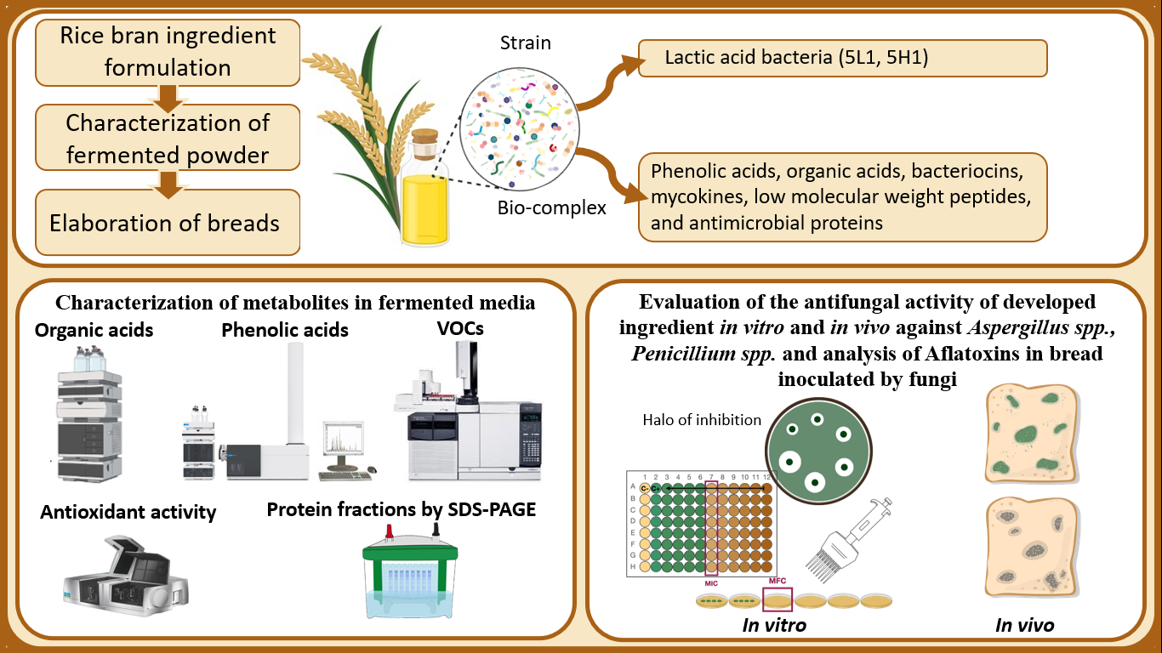
Recent Publications

- Dopazo V, Illueca F, Luz C, Musto L, Moreno A, Calpe J, Meca G. (2023). Evaluation of shelf life and technological properties of bread elaborated with lactic acid bacteria fermented whey as a bio-preservation ingredient. LWT 114427.
- Escrivá L, Agahi F, Vila-Donat P, Mañes J, Meca G, Manyes L. (2021). Bioaccessibility Study of Aflatoxin B1 and Ochratoxin A in Bread Enriched with Fermented Milk Whey and/or Pumpkin. Toxins (Basel) 14(1):6.
- Izzo L, Luz C, Ritieni A, Quiles J, Mañes J, Meca G (2020). Inhibitory effect of sweet whey fermented by Lactobacillus plantarum strains against fungal growth: A potential application as an antifungal agent. J Food Sci. 85(11):3920-3926.
- Nazareth TM, Luz C, Torrijos R, Quiles JM, Luciano FB, Mañes J, Meca G (2019). Potential Application of Lactic Acid Bacteria to Reduce Aflatoxin B1 and Fumonisin B1 Occurrence on Corn Kernels and Corn Ears. Toxins (Basel) 12(1):21.
- Denardi-Souza T, Luz C, Mañes J, Badiale-Furlong E, Meca G (2018). Antifungal effect of phenolic extract of fermented rice bran with Rhizopus oryzae and its potential use in loaf bread shelf-life extension. J Sci Food Agric. 98(13):5011-5018.

Biography

Jordi Mañes is full Professor of Nutrition and Bromatology of the Public Health Department of the University of Valencia (Spain) after 30 years, now director of Food Sciences Doctorate and coordinator of Erasmus exchange. Was Vice-Dean (6 years) and Dean (6 years) of the Faculty of Pharmacy and member of the Scientific Committee of the Spanish Agency for Food Safety and Nutrition (5 years). He has participated in more than 200 scientific articles and close to 200 conference communications, mostly internationally disseminated. My research work has dealt with the determination of anthropogenic and natural contaminants in food, and my research in recent years has been focused on the mitigation of mycotoxins and toxigenic fungi in food through biocompatible methods and sustainable nutrition, especially using lactic acid bacteria fermentations on waste products from the food industry. Specifically, I direct the project “Biopreservation of sliced bread with fermented whey against mycotoxins and toxigenic fungi. Safety of use in the presence of carotenoids”.

