Circular Economy of Packaging and Relativity of Time in Packaging Life Cycle

Ilija Sazdovski¹, Dragana Bojovic², Laura Batlle-Bayer¹, Ruben Aldaco³, María Margallo³, Harrison Tetteh⁴, Rita Puig⁴ and Pere Fullana-i-Palmer¹
¹UNESCO Chair in Life Cycle and Climate Change ESCI - UPF; Passeig Pujased 1, 08003 Barcelona Spain
²Barcelona Supercomputing Center; Plaça Eusebi Güell, 1-3, 08034 Barcelona, Spain
³Department of Chemical and Biomolecular Engineering. University of Cantabria. Avda. De los Castros, s/n, 39005, Santander, Spain
⁴Department of Industrial and Building Engineering. University of Lleida. Av. Pla de la Massa, 8, 08700 Igualada, Spain

Abstract
The circular economy paradigm aims to improve the use of material and decrease the negative impacts of the life cycle of products on the environment. In line with the broad variety of conceptualizations and definitions used to describe the circular economy, there are also numerous circularity indicators available in the literature. However, the lack of any unique definition and commonly accepted indicators for circularity are key limitations for comparing life cycle assessments (LCA) of products through the lens of circularity. This paper applies the three variables that define the value creation principles in the widely accepted definition of circularity provided by the Ellen MacArthur Foundation: material, energy and time. We show that including time in the LCA methodology is vital for improving the accuracy of traditional LCA models, especially for products such as packaging that have a relatively short usage time in the technosphere compared to their recycling time. For this purpose we develop a formula that includes the time necessary for obtaining the secondary material needed for the production of $"n+1"$ product. The paper shows that we need to consider the production of additional packaging products and that the quantity of these products depends on the time needed for recycling in the waste management system. This aspect has traditionally been neglected when developing comparative LCAs between systems that serve the same function. The proposed approach to packaging LCA contributes to an important scientific debate over the allocation of credits and burdens between several consecutive life cycles of a product.

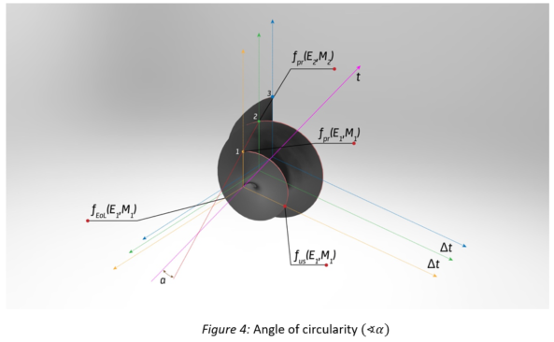

Recent Publications
- Arfelis S., Sazdovski I., Irene M., Lair V., (2023). Life cycle assessment on calcium zincate production methods for rechargeable batteries. Science of the total environment. Volum: 866. https://doi.org/10.1016/j.scitotenv.2022.161094;
- Sazdovski, I., Bojovic, D., Batlle-Bayer, L., Aldaco, R., Margallo, M., Fullana-i-Palmer, P., (2022), Circular Economy of Packaging and Relativity of Time in Packaging Life Cycle, Resource Recycling and Conservation, 184, DOI: 10.1016/j.resconrec.2022.106393 ;
- Sazdovski, I., Bala, A., Fullana-i-Palmer, P., (2021), Linking LCA literature with circular economy value creation: A review on beverage packaging, Science of the Total Environnent, 771:145322, DOI : 10.1016/j.scitotenv.2021.145322;
- Delgado-Aguilar, M., Puig, R., Sazdovski, I., Fullana-i-Palmer, P., (2020), Polylactic Acid/Polycaprolactone Blends: On the Path to Circular Economy, Substituting Single-Use Commodity Plastic Products; Materials (ISSN 1996-1944; CODEN: MATEG9, DOI: https://doi.org/10.3390/ma13112655;
- Bozhikaliev, V., Sazdovski I., Adler, J., Markovska, N. (2019), Techno-economic, social and environmental assessment of biomass based district heating in a bioenergy village, Journal of Sustainable Development of Energy, Water and Environmental Systems, Vol. 7, Issue 4, pp. 601-614; DOI: http://dx.doi.org/10.13044/j.sdewes.d7.0257;

Biography

Ilija Sazdovski pursues his PhD thesis, directed by Dr Pere Fullana i Palmer at the UNESCO Chair in Life Cycle and Climate Change ESCI-UPF. His thesis, aims develop and apply the life cycle assessment methodology to packaging waste management. The PhD Candidate studies the determinants that reinforce or weaken the hierarchy of waste management, including prevention, preparation for reuse, recycling, other types of recovery and, finally, the elimination of waste. Holds a master degree in Ecological economics and B.Sc in Mathematics and Physics. Sazdovski is a member of the International Association of Energy Engineers and between 2012 and 2018 he was part of the Scientific Advisory Board of the Conference for Sustainable Development of Energy, Water and Environmental Systems. He is experienced Project Manager with a demonstrated history of working in the development sector as International Expert in MRV hired by United Nations and GIZ.

